School Name
Mathematics Test 2017
Year 10 |  | Non-Linear Relations | Non Calculator
Skills and Knowledge Assessed:  - Graph simple non­linear relations with and without the use of digital technologies and solve simple related equations (ACMNA296)  - Explore the connection between algebraic and graphical representations of relations such as simple quadratics, circles and exponentials using digital technology as appropriate (ACMNA239)  - 10A Describe, interpret and sketch parabolas, hyperbolas, circles and exponential functions and their transformations (ACMNA267) |  |  | Name_________________
Section 1 Short Answer Section
Write all working and answers in the spaces provided on this test paper.

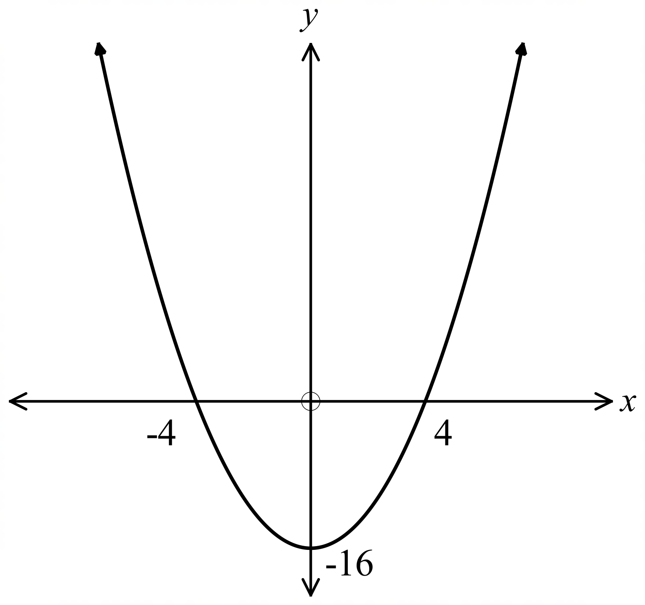What equation could describe the graph shown?

………………………………………………

……………………………………………....

………………………………………………

……………………………………………….
Give the equation of the graph shown.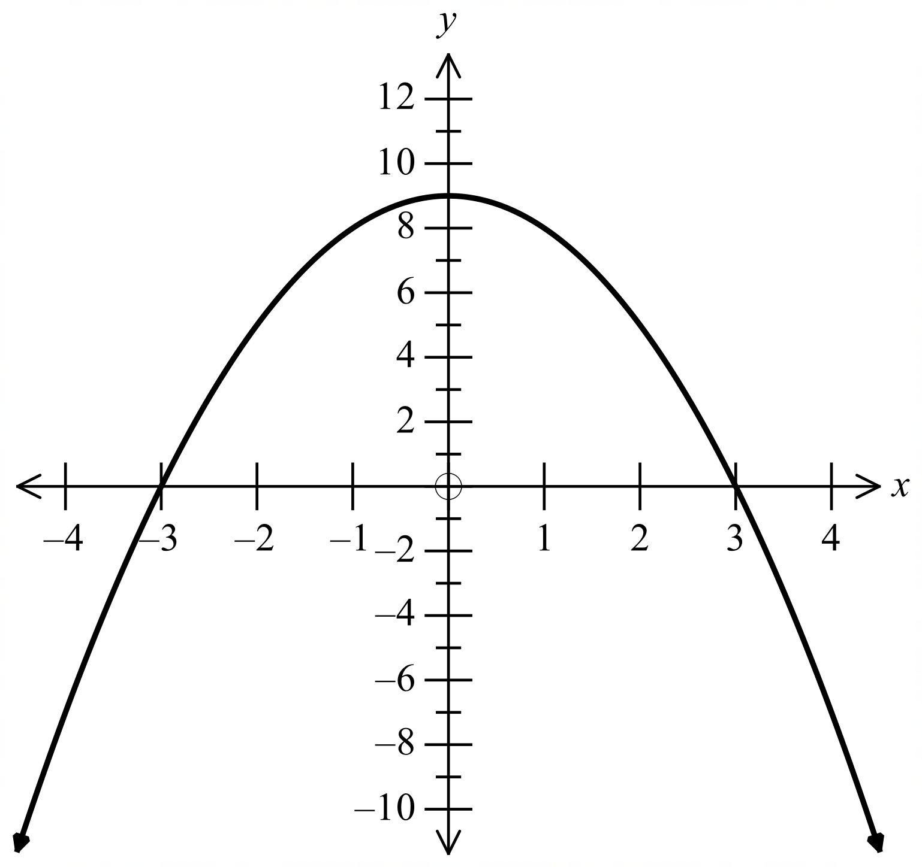

………………………………………………

……………………………………………....

………………………………………………

……………………………………………….
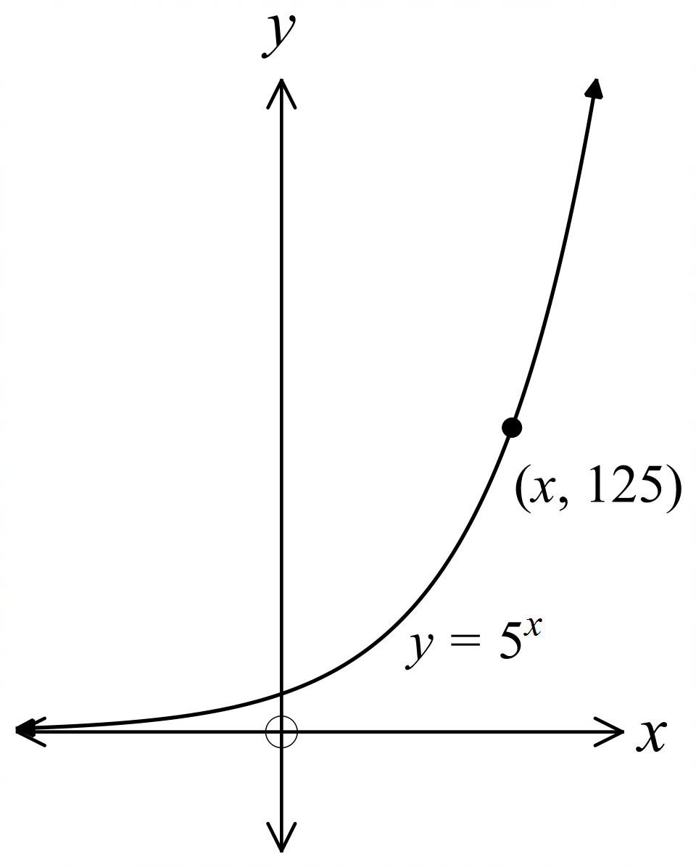The equation of the graph shown is 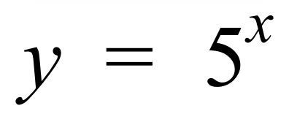.
The graph passes through the point 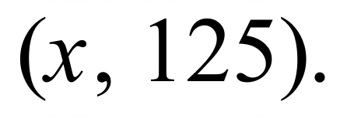

What is the value of x ?

………………………………………………

……………………………………………….

………………………………………………

……………………………………………….

The graph shown has as its equation: 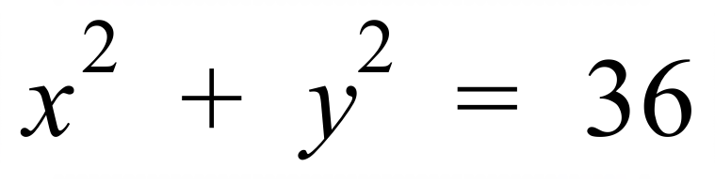 .
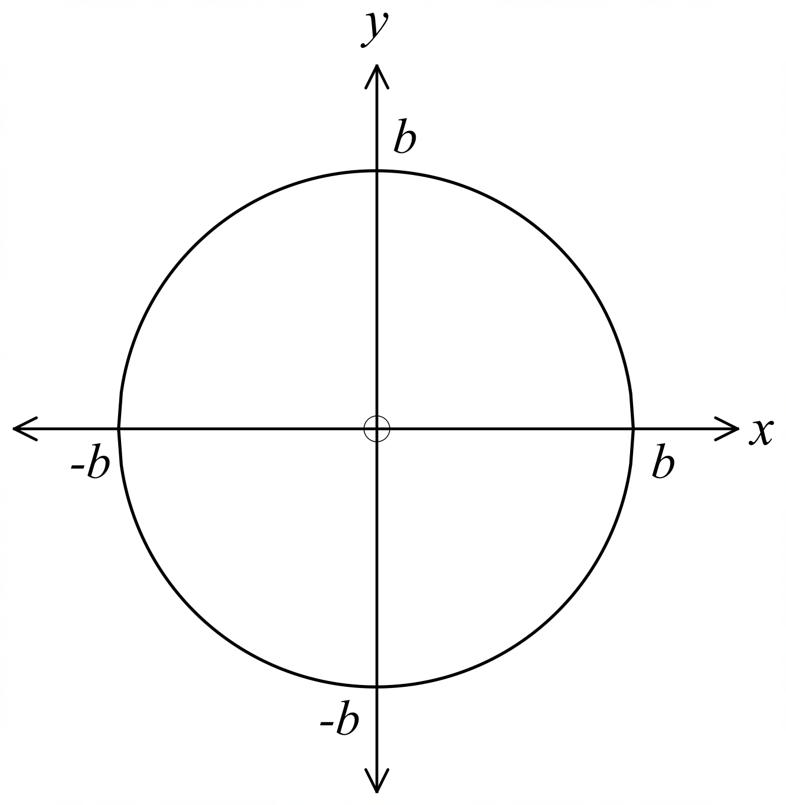
What is the value of b?

………………………………………………

……………………………………………….

………………………………………………

……………………………………………….

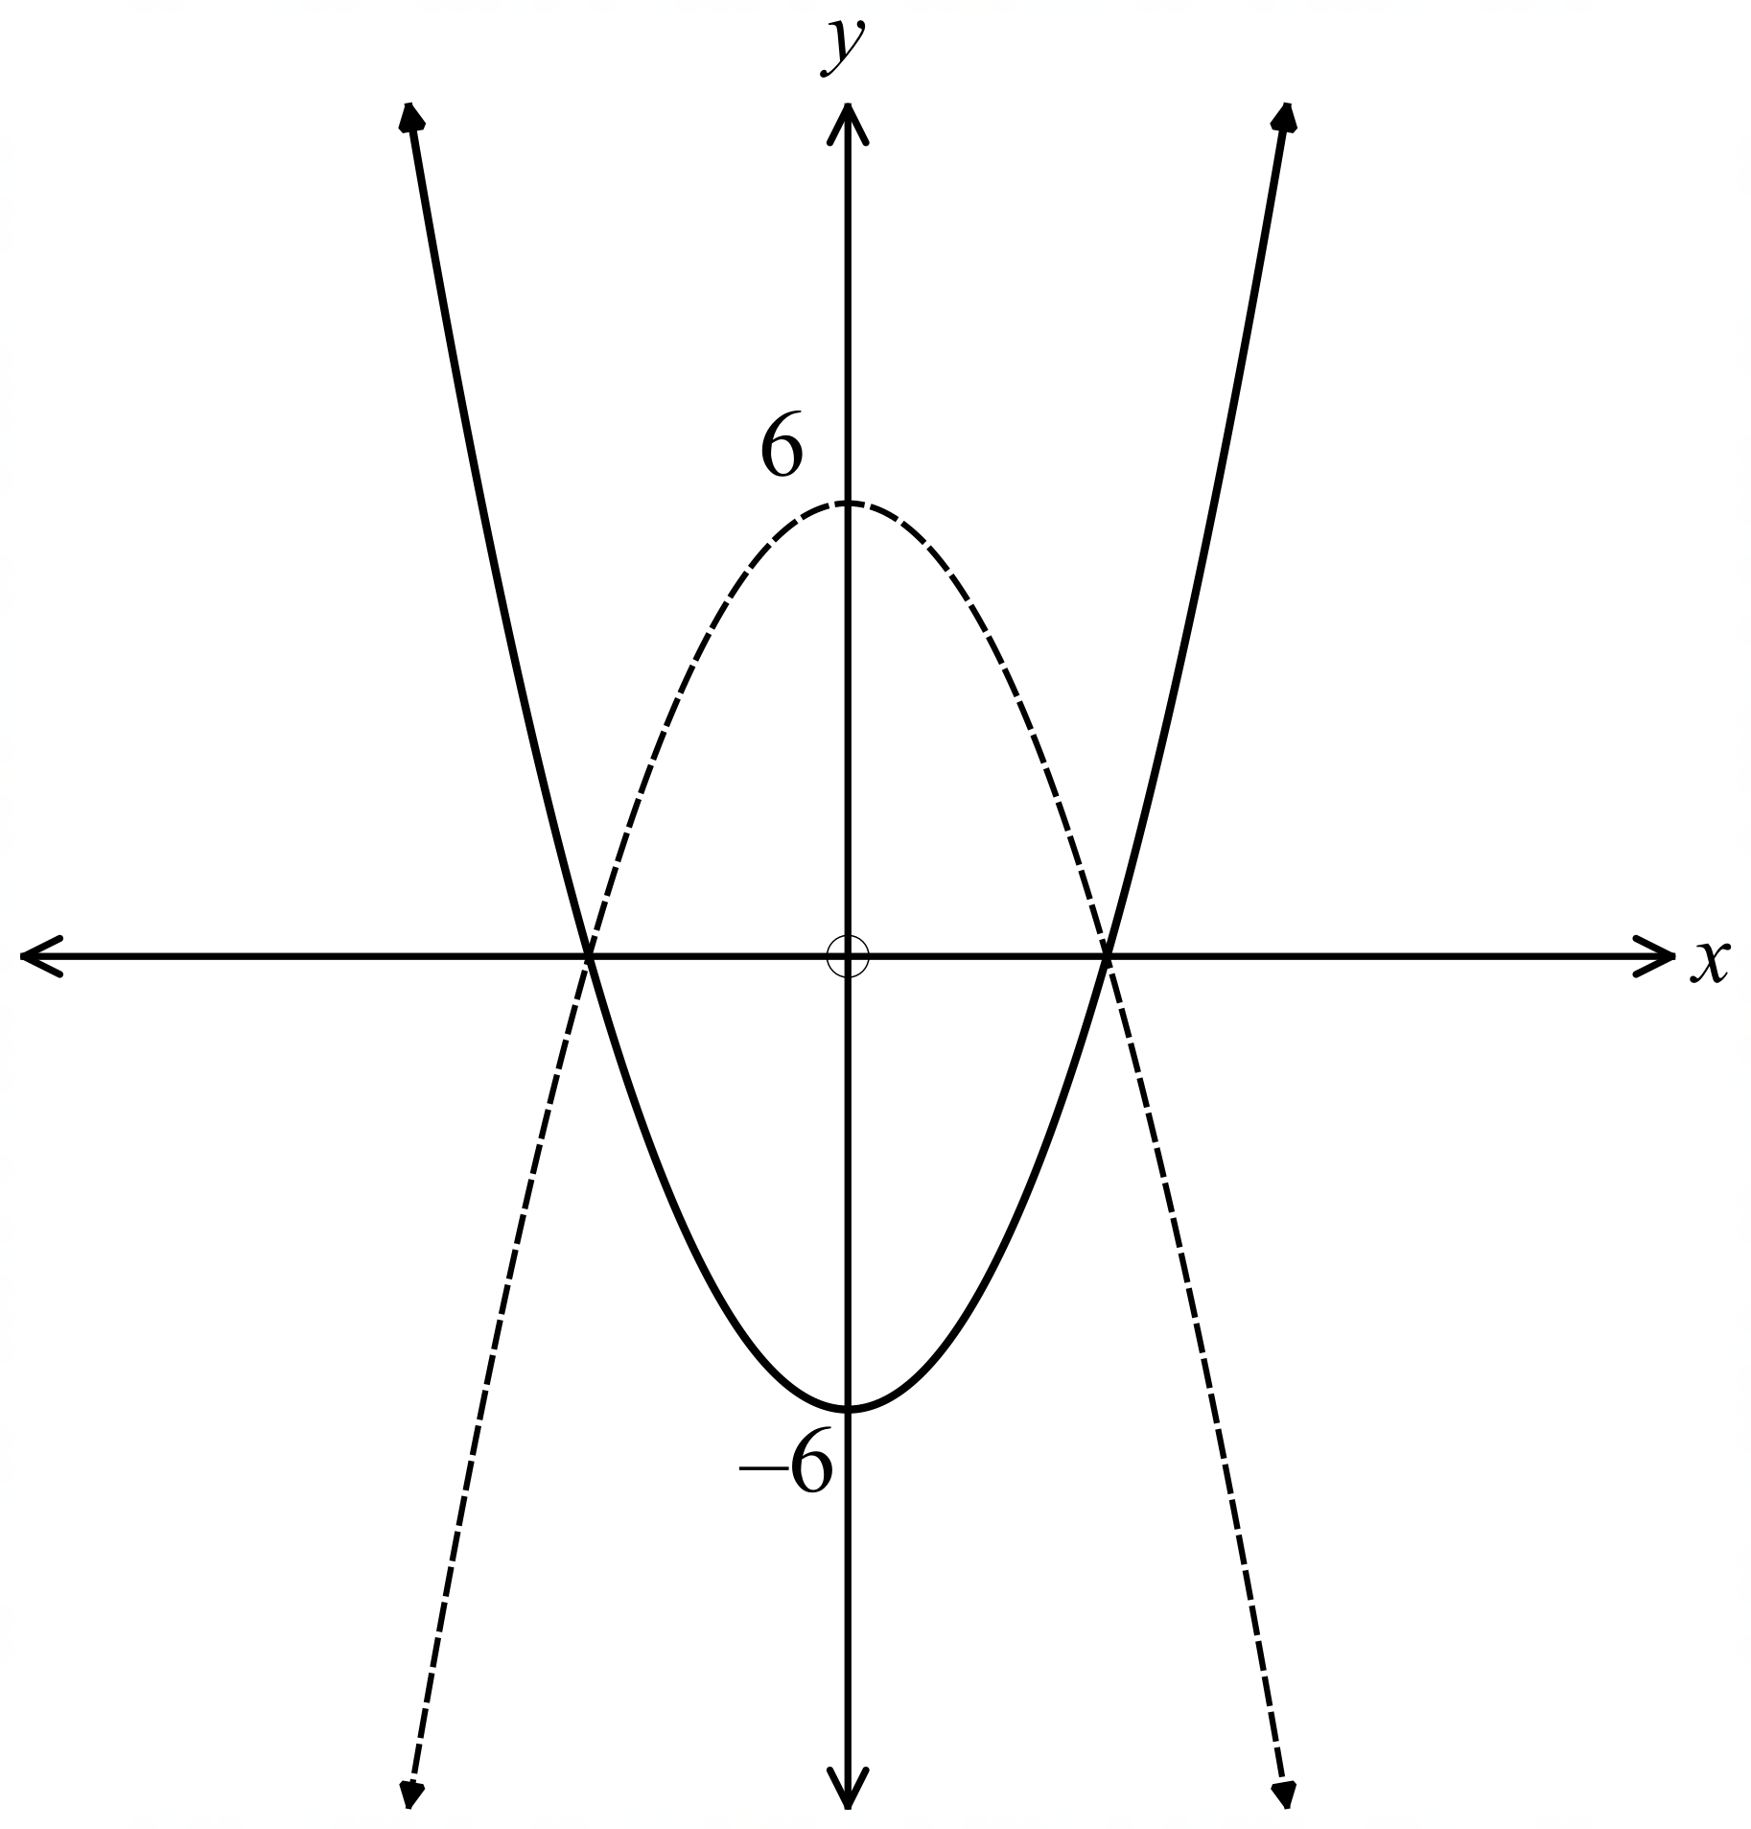The graphs of 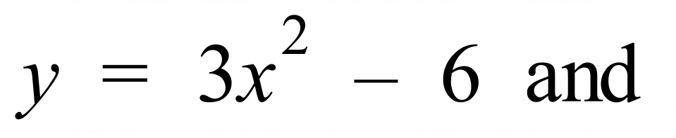 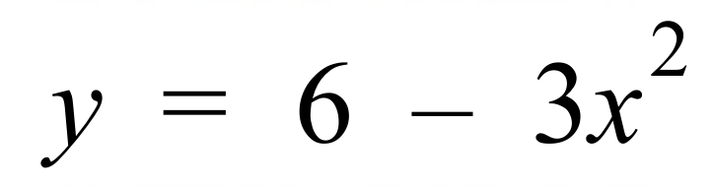 are shown.
One is drawn with a broken line and one with an unbroken line.
Describe which graph is which and explain why you made this decision.

…………………………………………………..

…………………………………………………..

………………………………………………….

………………………………………………….

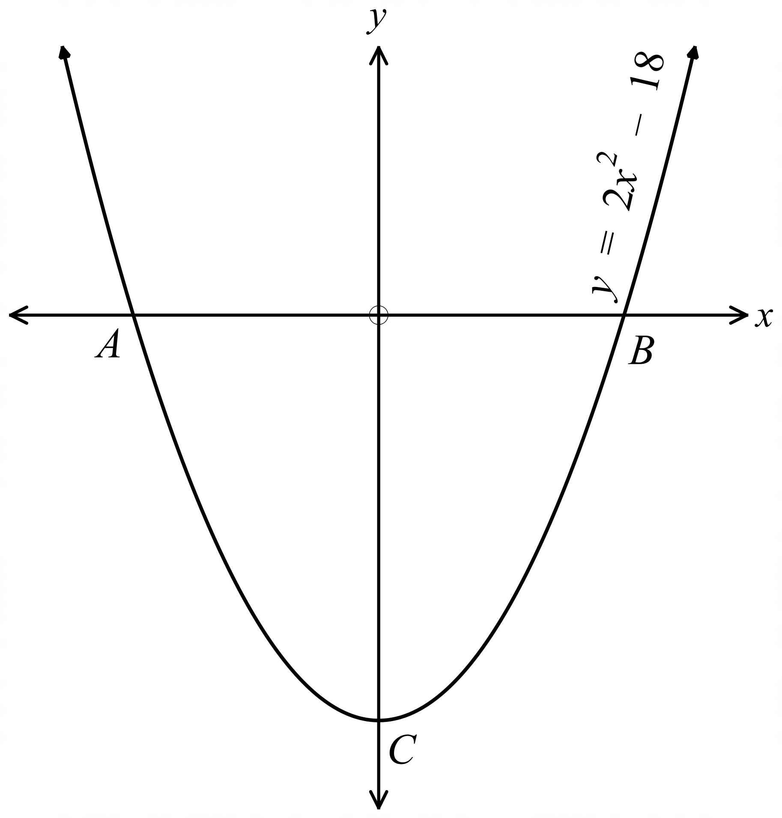The graph of 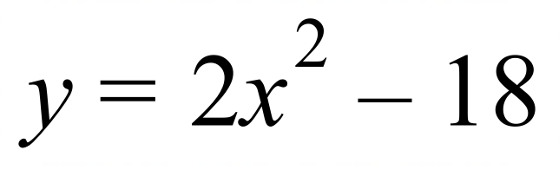 is shown.
What are the coordinates of the y intercept C?

…………………………………………

………………………………………….

………………………………………….

What are the coordinates of the x intercepts A and B for the curve in Question 6?

…………………………………………………………………………………….

………………………………………….………………………………………….
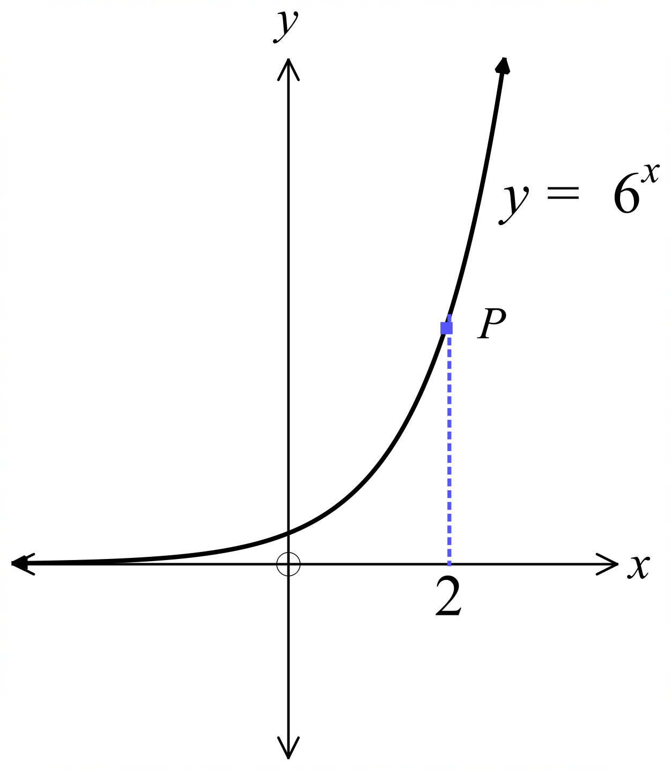The graph of 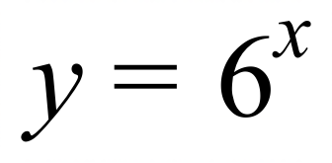 is shown.
What are the coordinates of the point P?

………………………………………………

……………………………………………….

………………………………………………

……………………………………………….

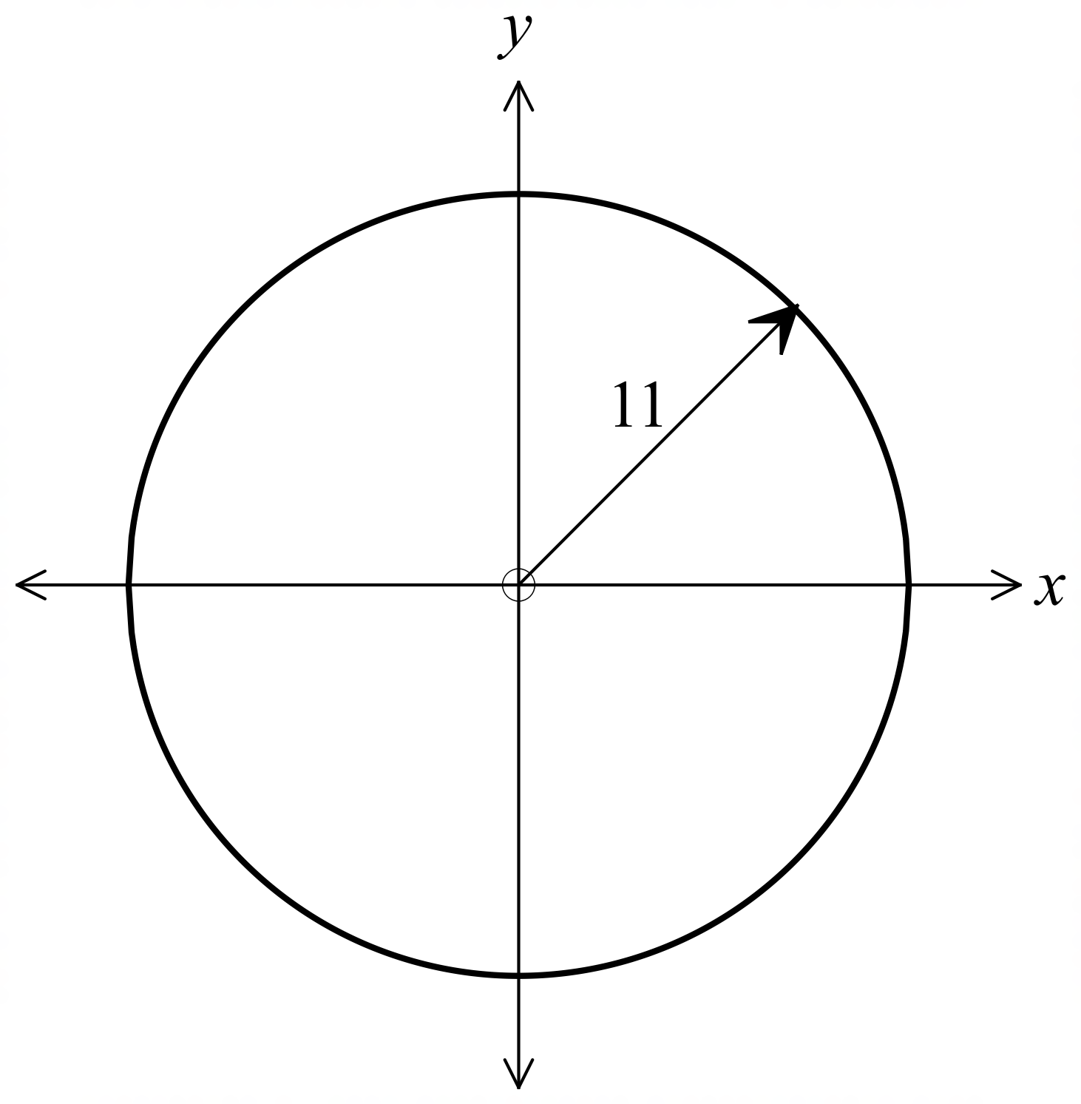What is the equation of the circle shown?

………………………………………………

……………………………………………….

………………………………………………

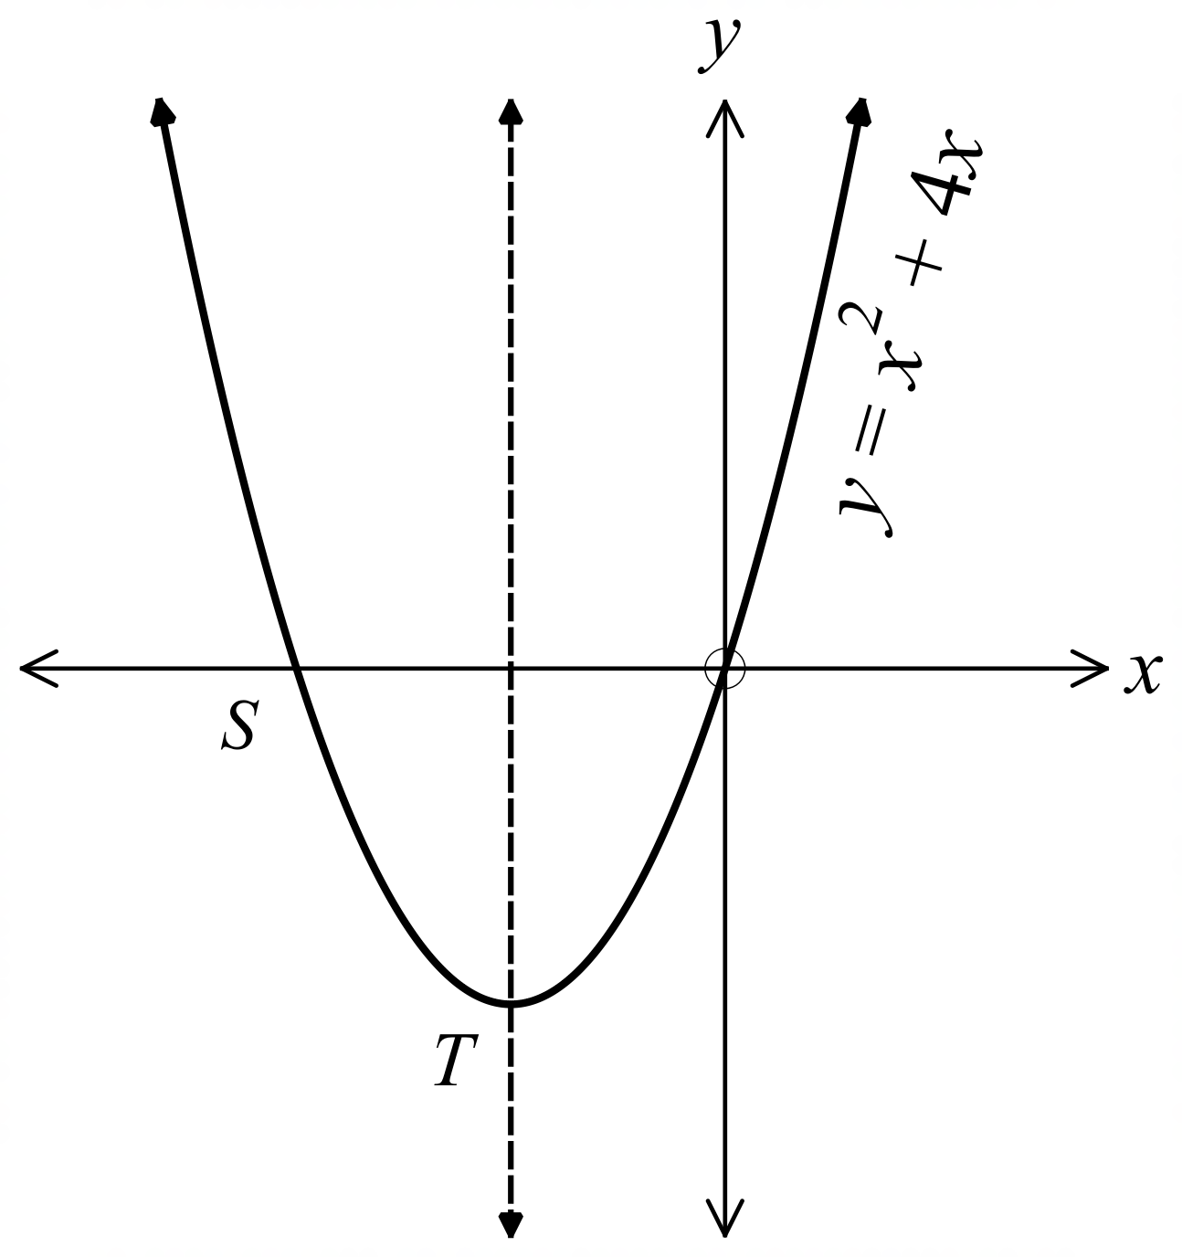The graph of 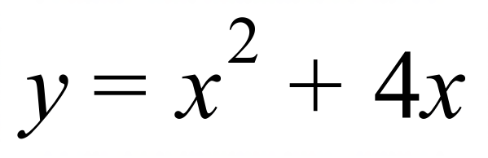 is shown.
The dotted line is its axis of symmetry.

What are coordinates of the x intercept S?

…………………………………………

………………………………………….

………………………………………….

In the graph in question 10, what are coordinates of the vertex T?

……………………………………………………………………………………

………………………………………….…………………………………………

………………………………………….…………………………………………
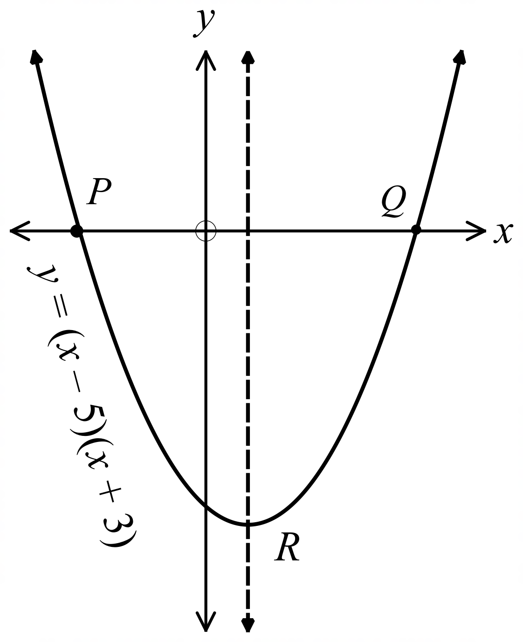The curve below has equation 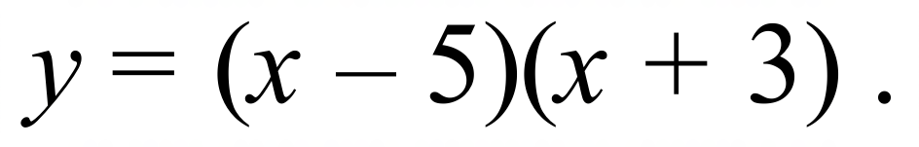
The axis of symmetry is shown by the dotted line.
What are the coordinates of the points P and Q ?

………………………………………………

……………………………………………….

………………………………………………

………………………………………………

In the graph in question 12, what are coordinates of the vertex R?

……………………………………………………………………………………

………………………………………….…………………………………………

………………………………………….…………………………………………
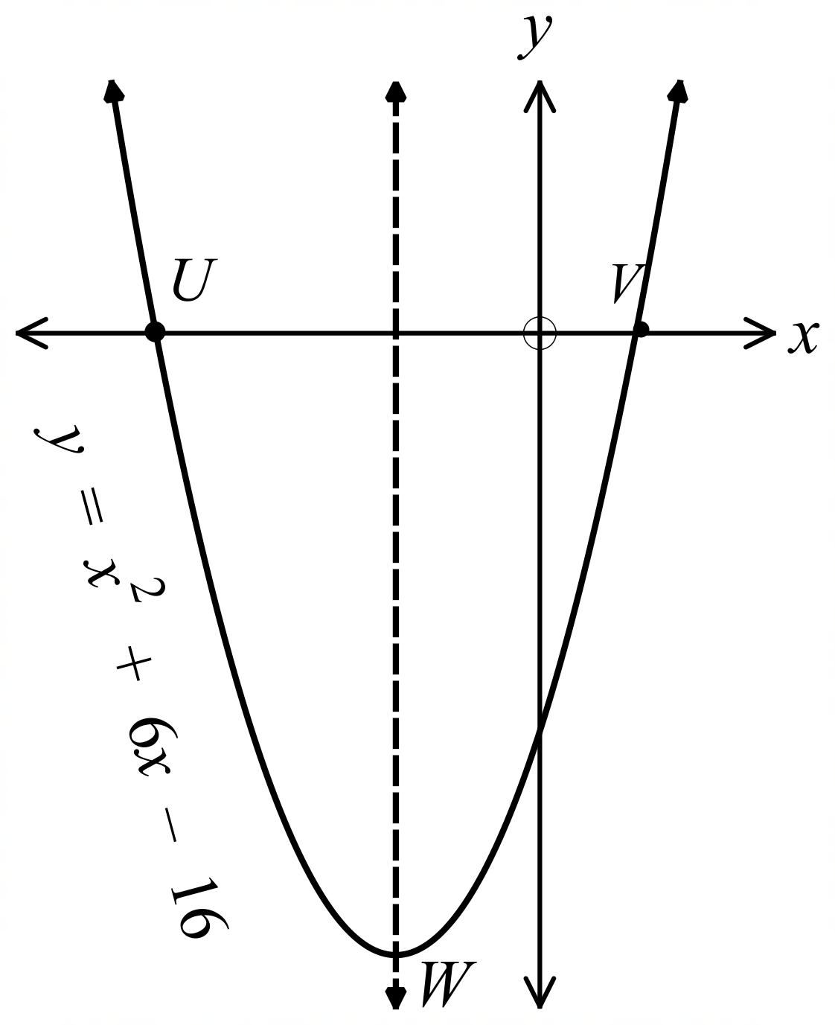The curve below has equation 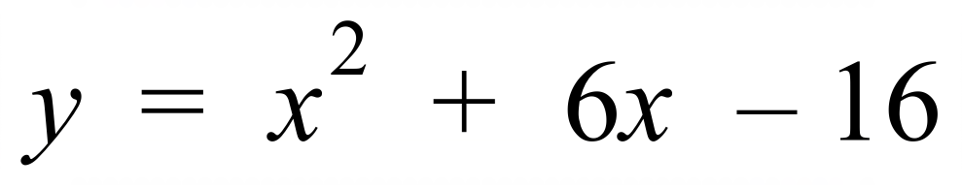.
The axis of symmetry is shown by the dotted line.
What are the coordinates of the points U and V ?

………………………………………………

……………………………………………….

………………………………………………

………………………………………………

In the graph in question 14, what are coordinates of the vertex W?

……………………………………………………………………………………

………………………………………….…………………………………………

………………………………………….…………………………………………
The intercepts on the x and y axes are shown for the parabola below.
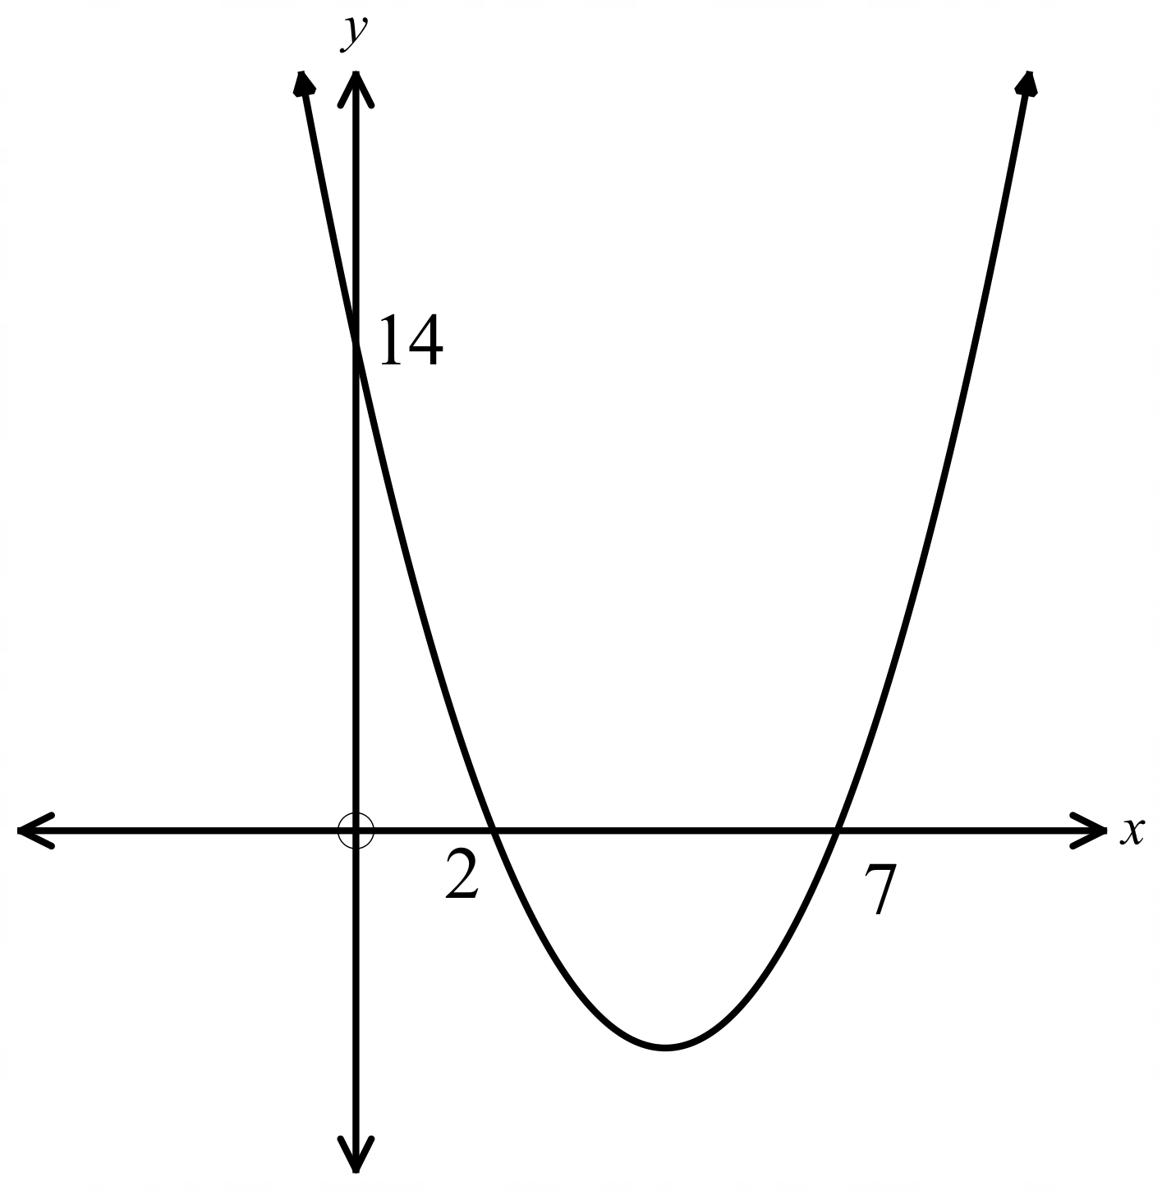
What is the equation of the parabola?

………………………………………………

……………………………………………….

………………………………………………

……………………………………………….

………………………………………………

………………………………………………

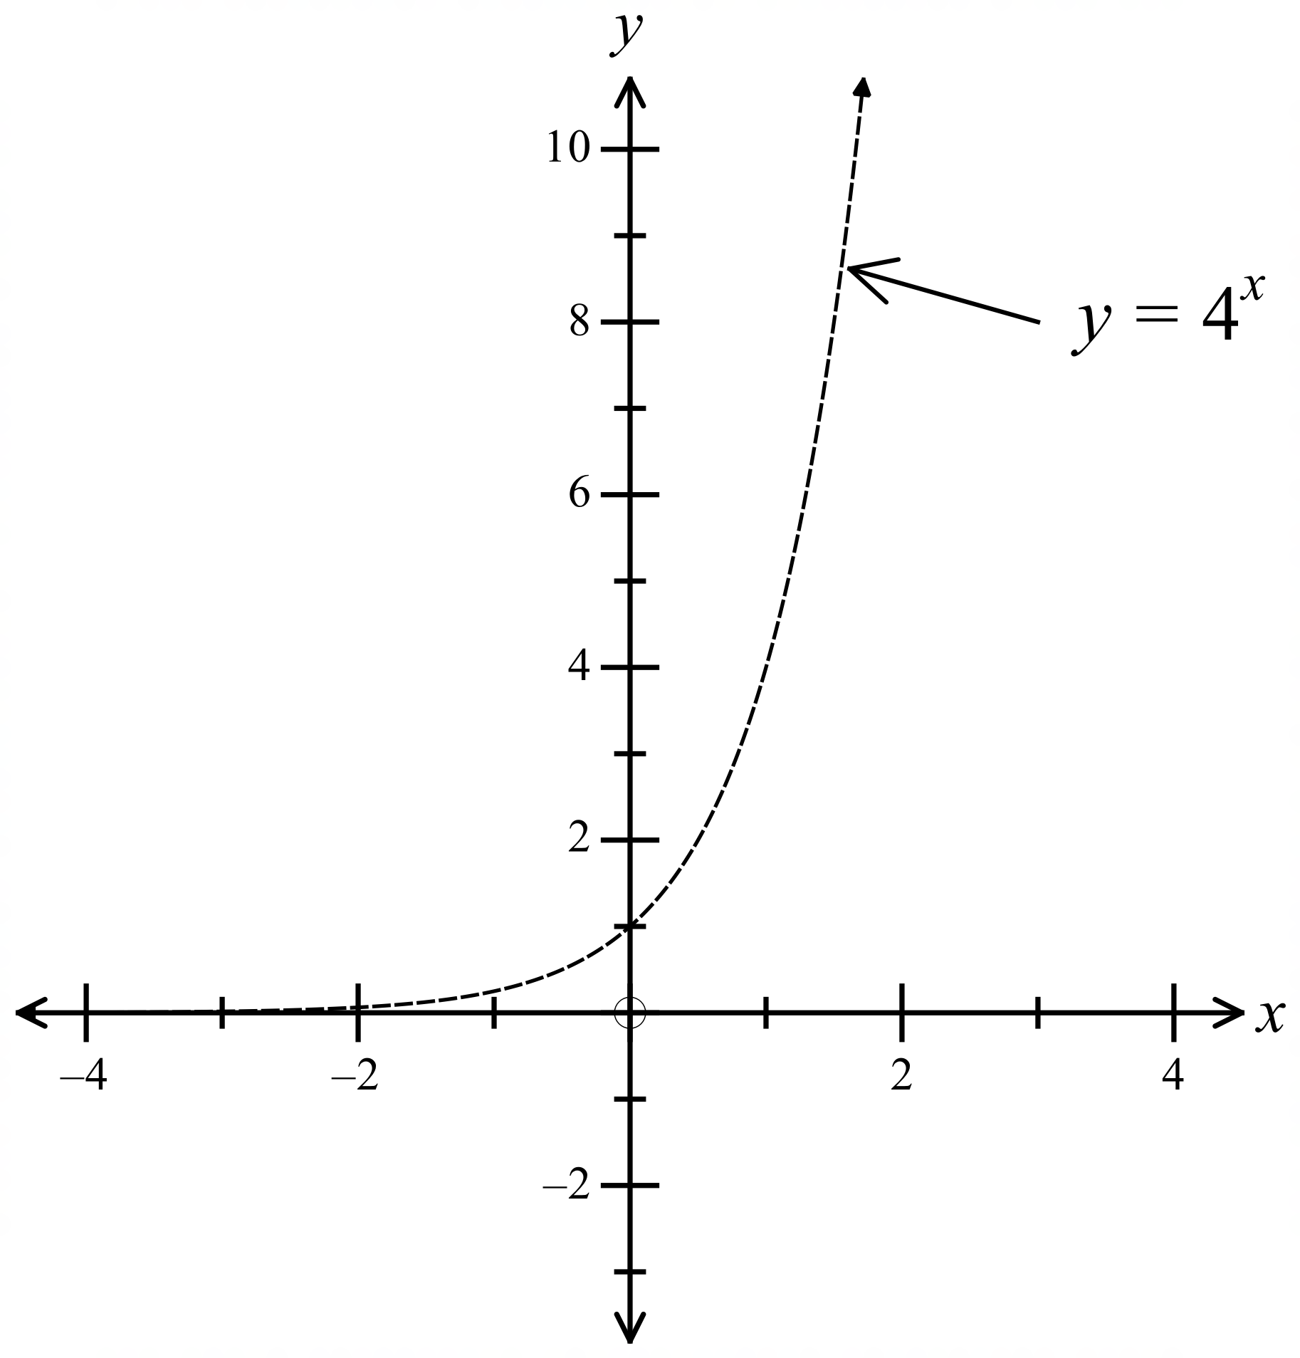The graph of 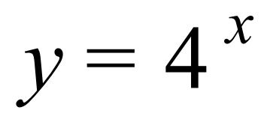 is shown.
Draw a quick sketch, on the same set of axes, of 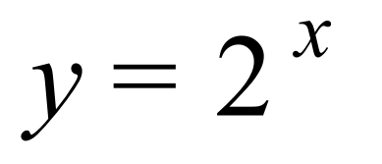

……………………………………………

…………………………………………….

………………………………………………

What is the centre and radius of the circle which has an equation of 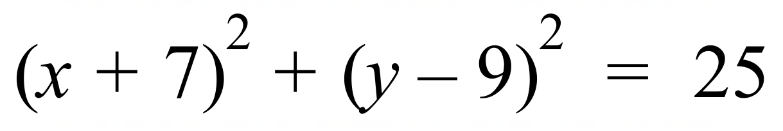

……………………………………………………………………………………………….

……………………………………………………………………………………………….

School Name
Mathematics Test 2017
Year 10 |  | Non-Linear Relations | Calculator Allowed
 |  | Non-Linear Relations | Name_________________
Section 2 Multiple Choice Section
Mark all your answers on the accompanying multiple choice answer sheet, not on this test paper. You may do any working out on this test paper. Calculators are allowed for this section.

Which graph below could have an equation of 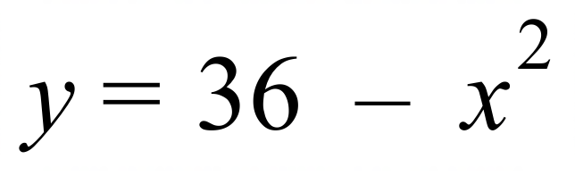 ?

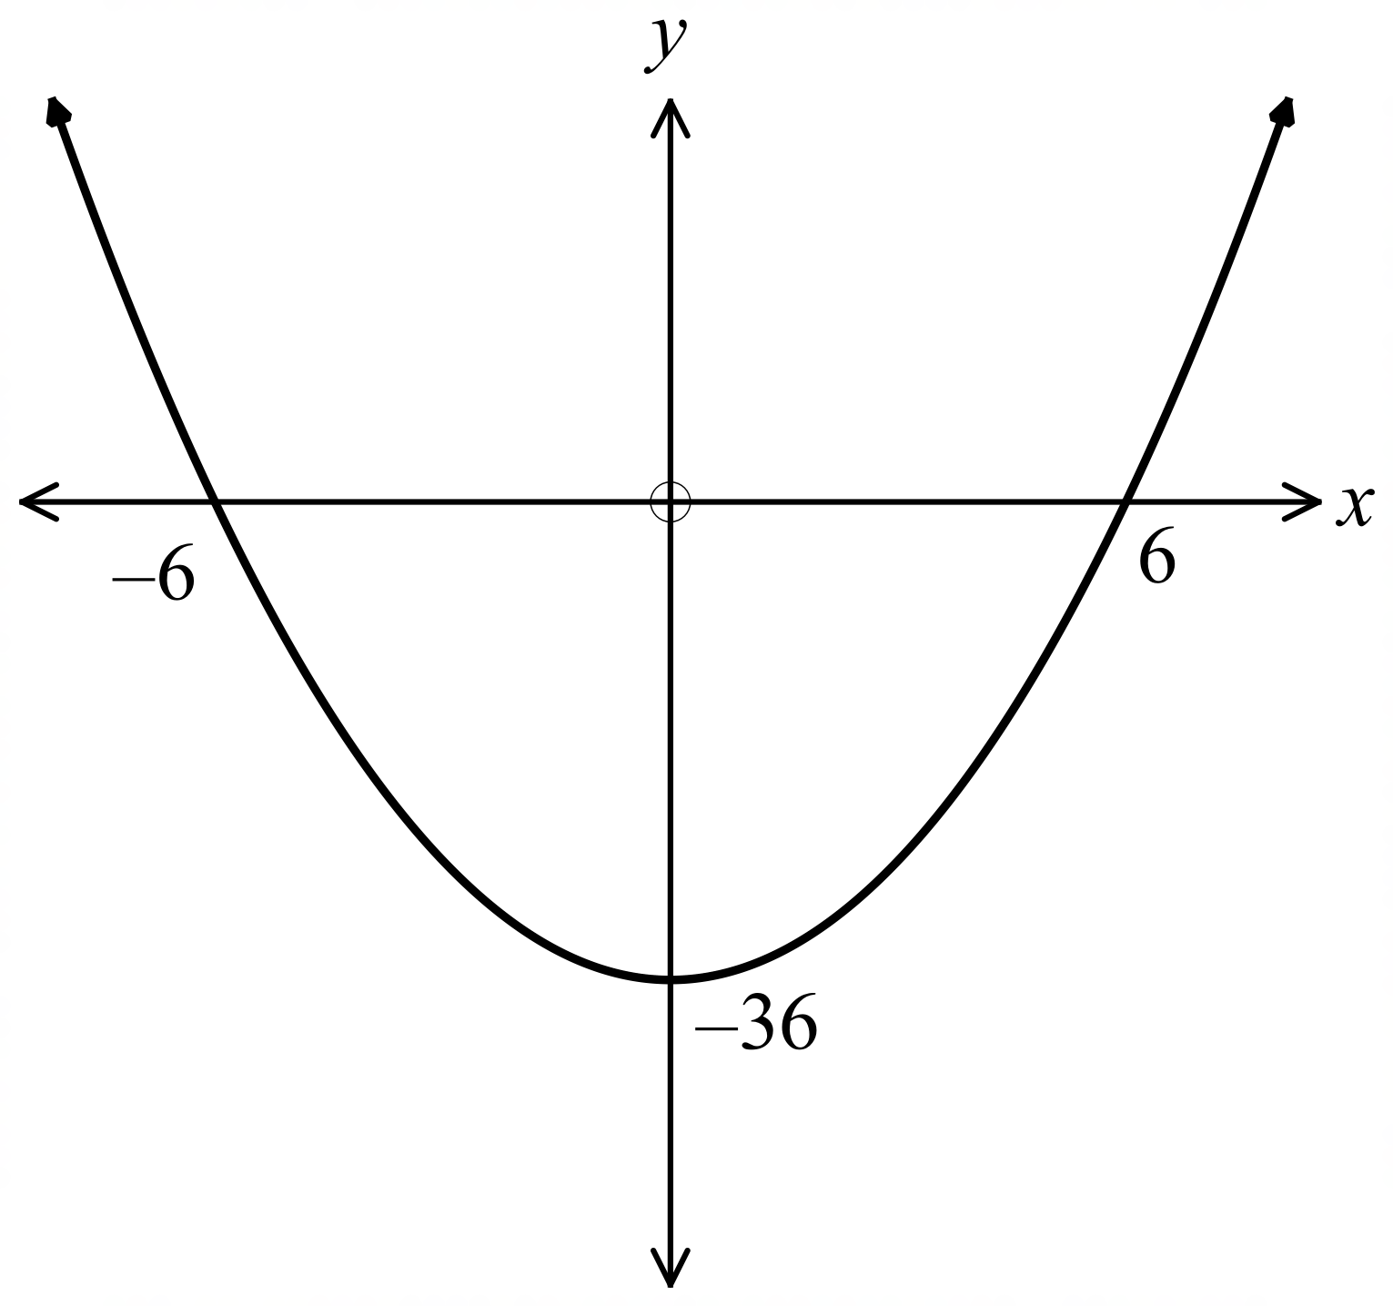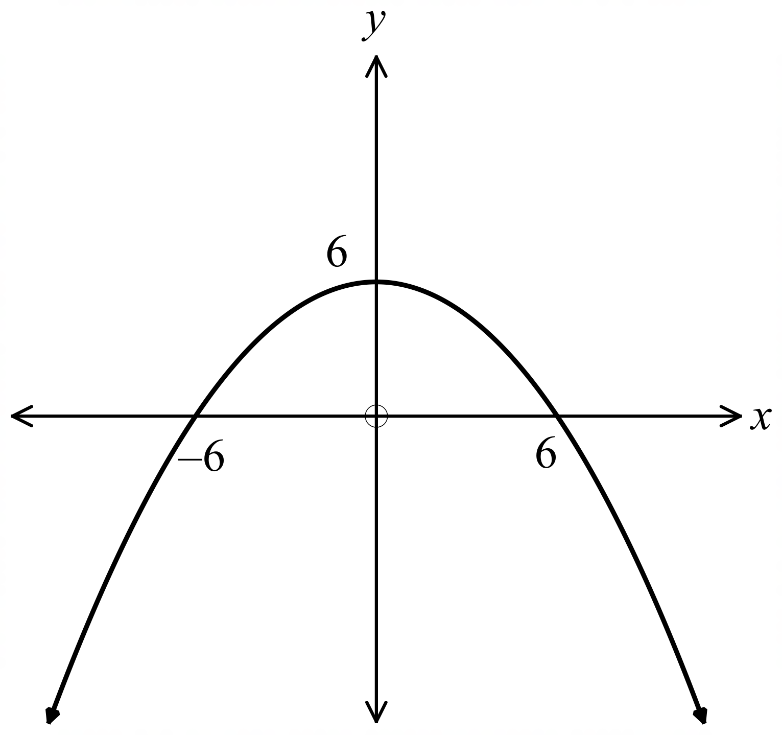A. B.

C. D.
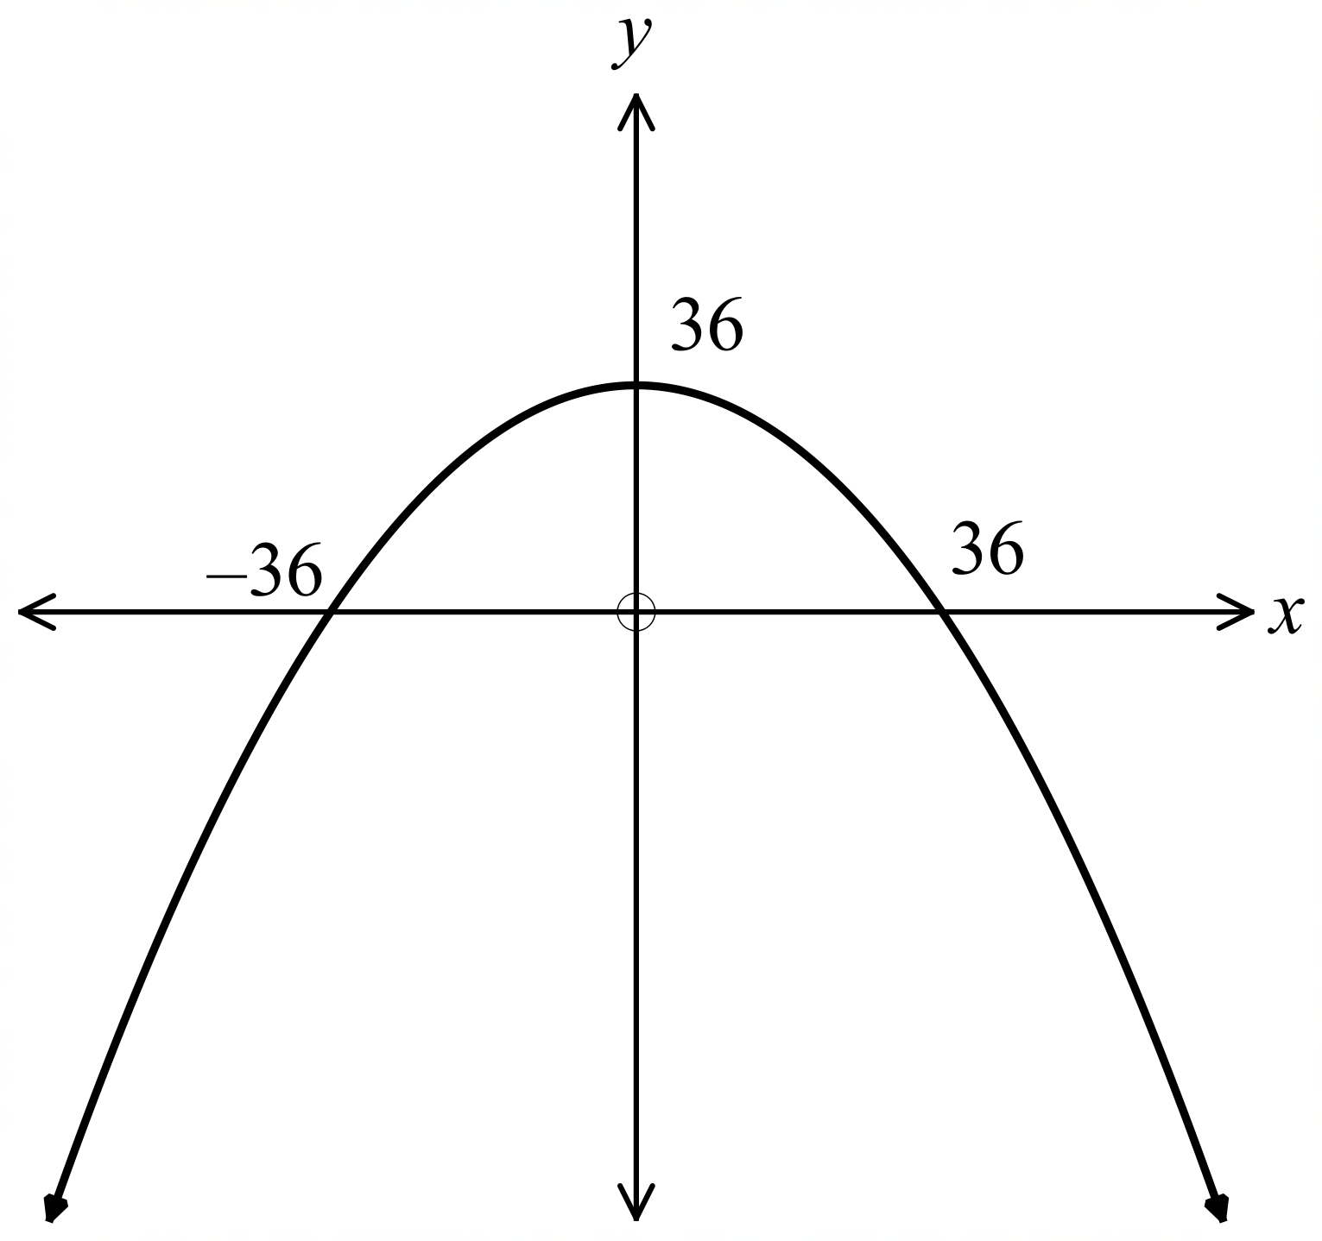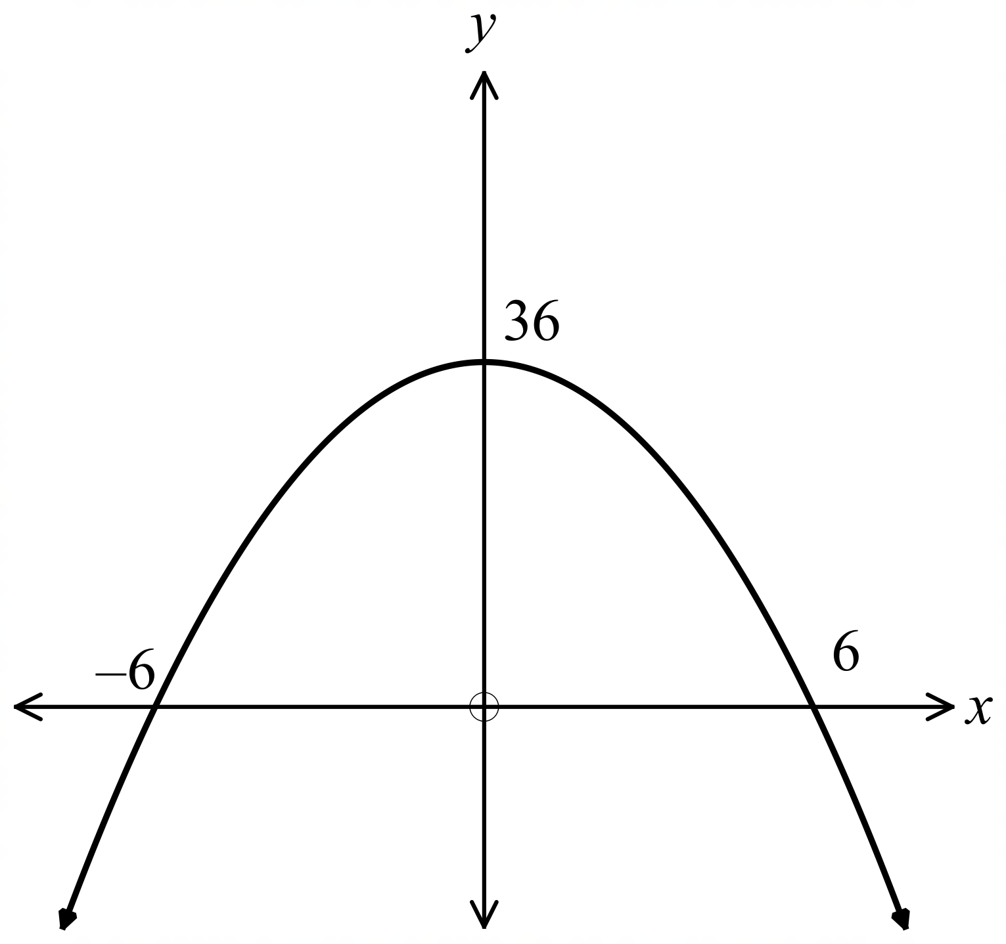

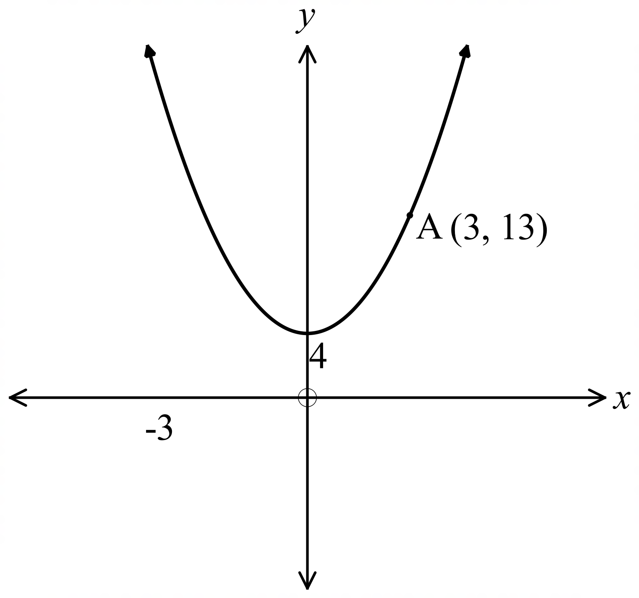The parabola shown, passes through the point (3, 13).
Which equation could describe the parabola?

A. 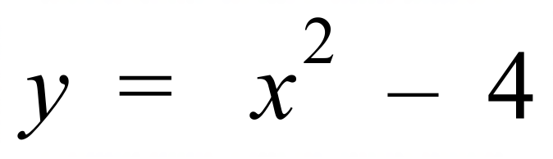
B. 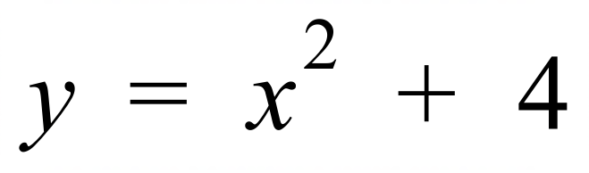
C. 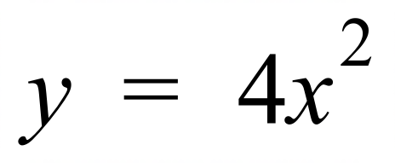
D. 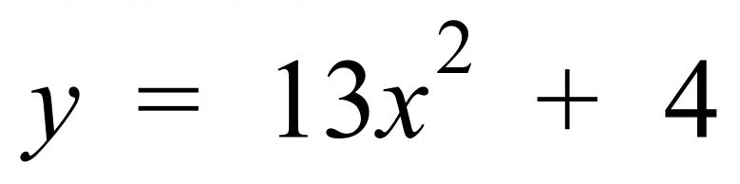

Which equation could represent a circle?

A. 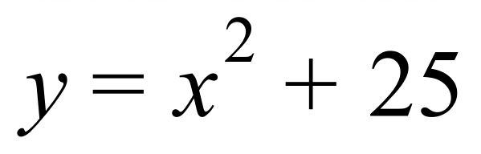 B. 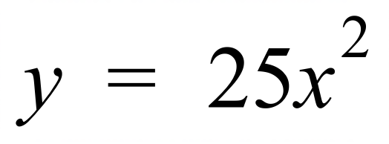 C. 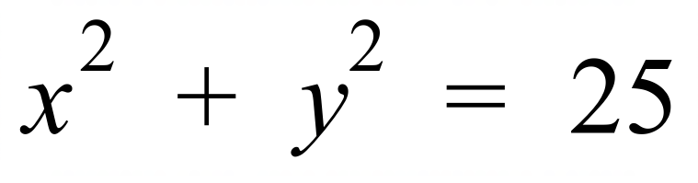 D. 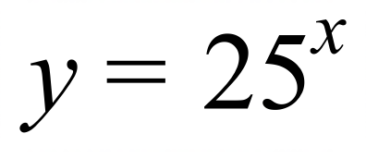
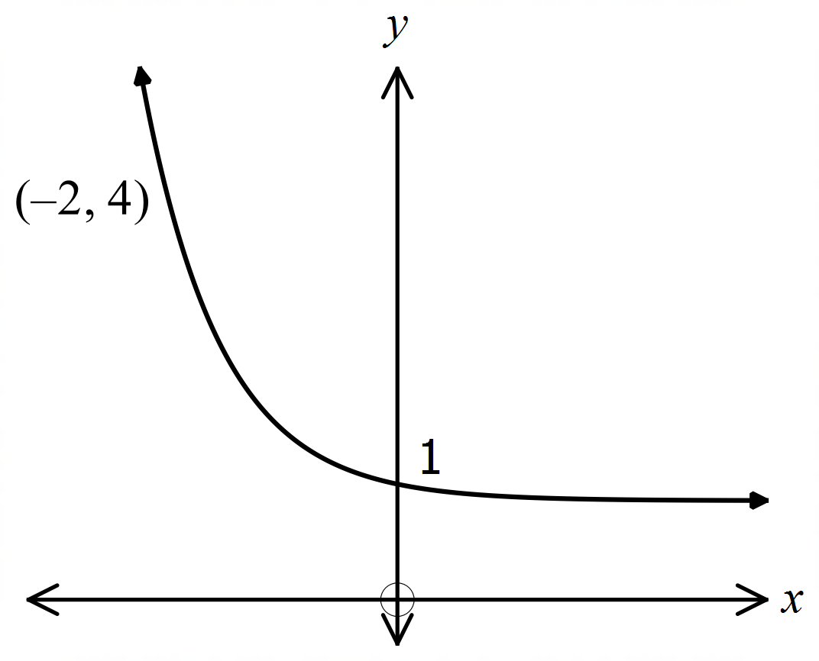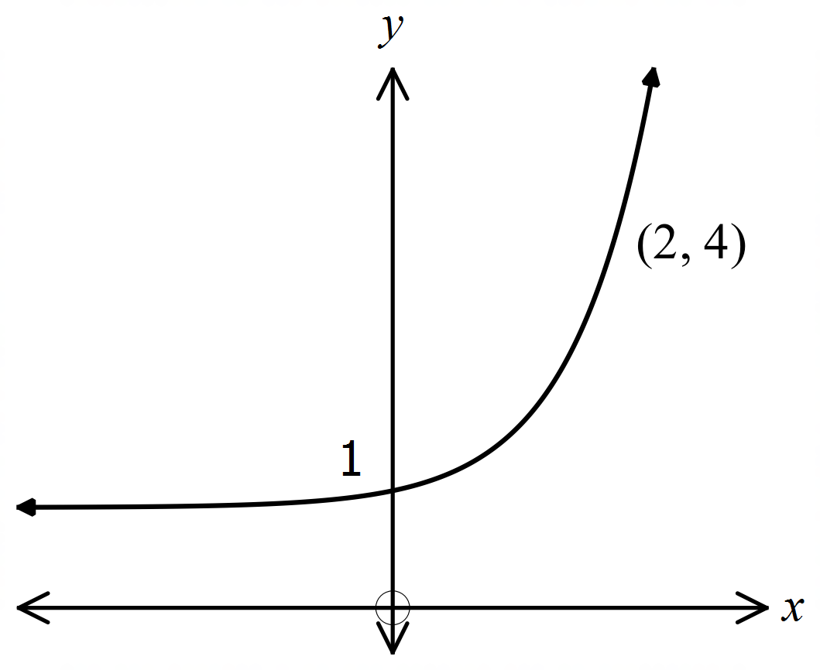 A. B.

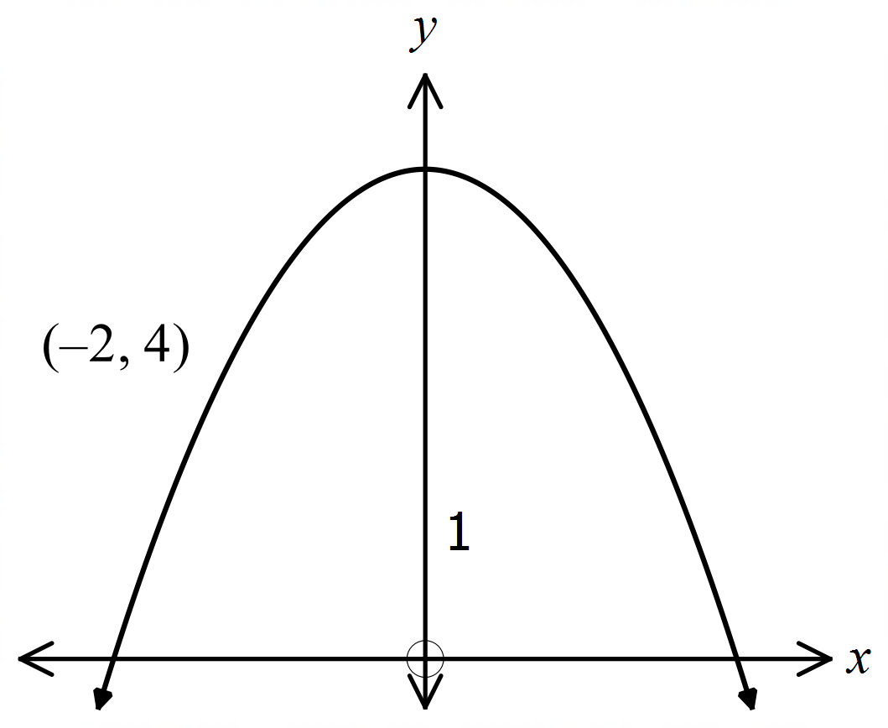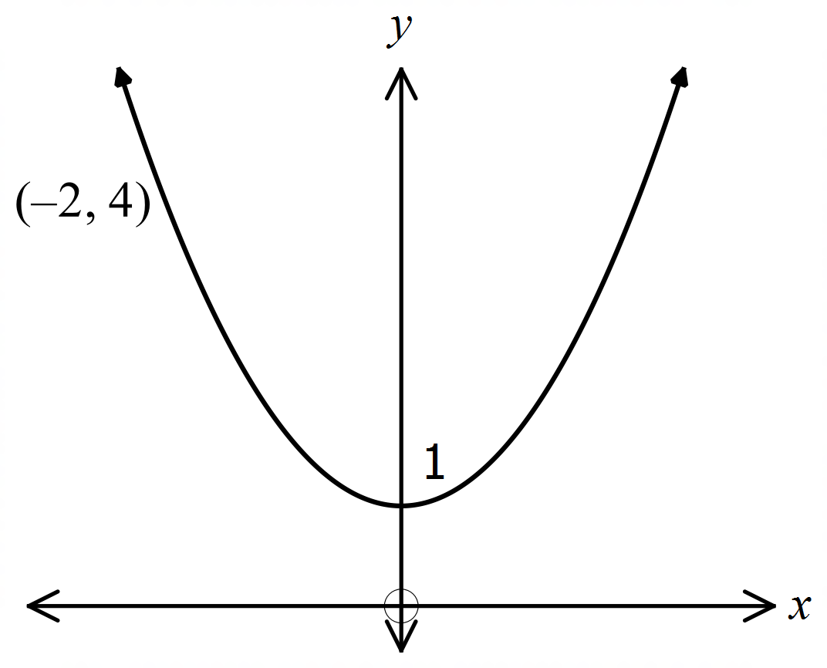 C. D.

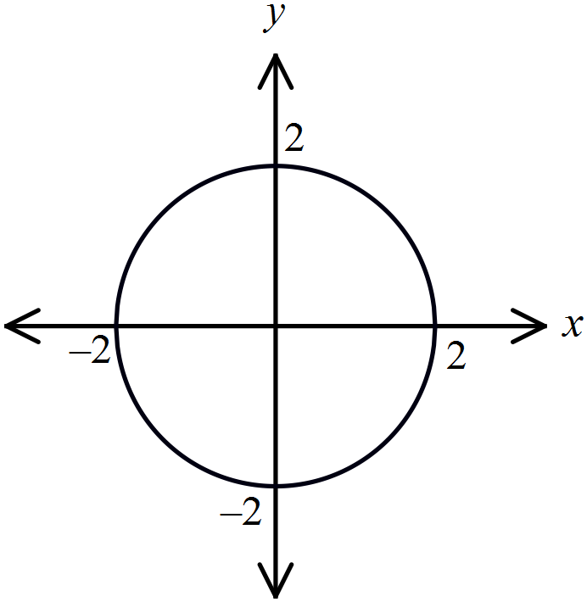Which equation could describe the graph shown?

A. 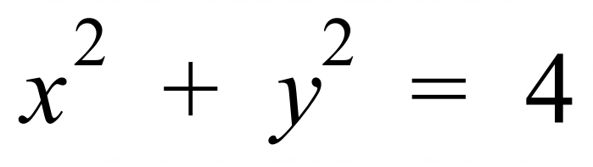

B. 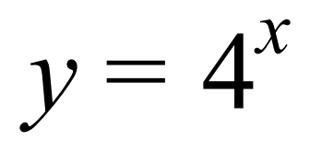

C. 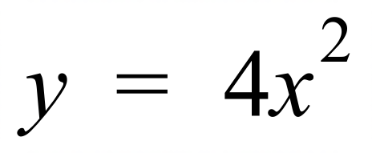

D. 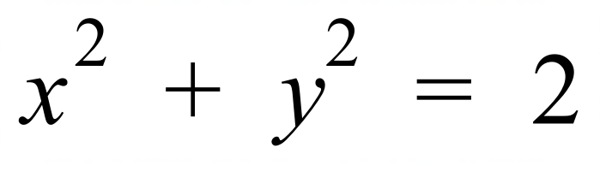

Which parabola has a vertex at 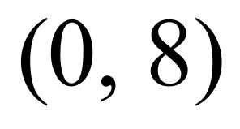?

A. 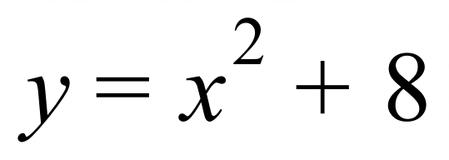 B. 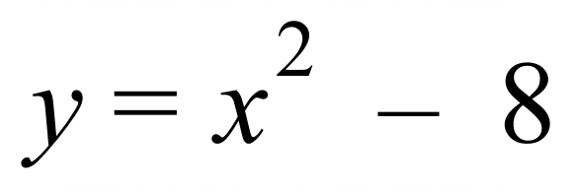 C. 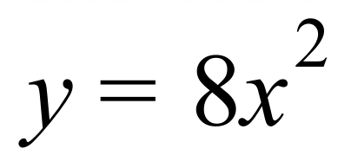 D. 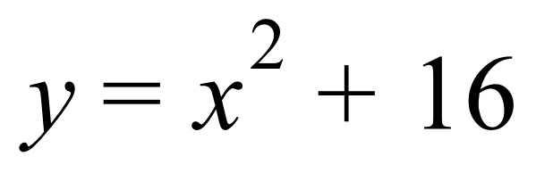

Which diagram below could be the graph of 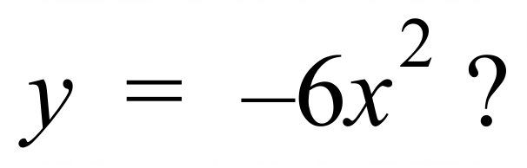

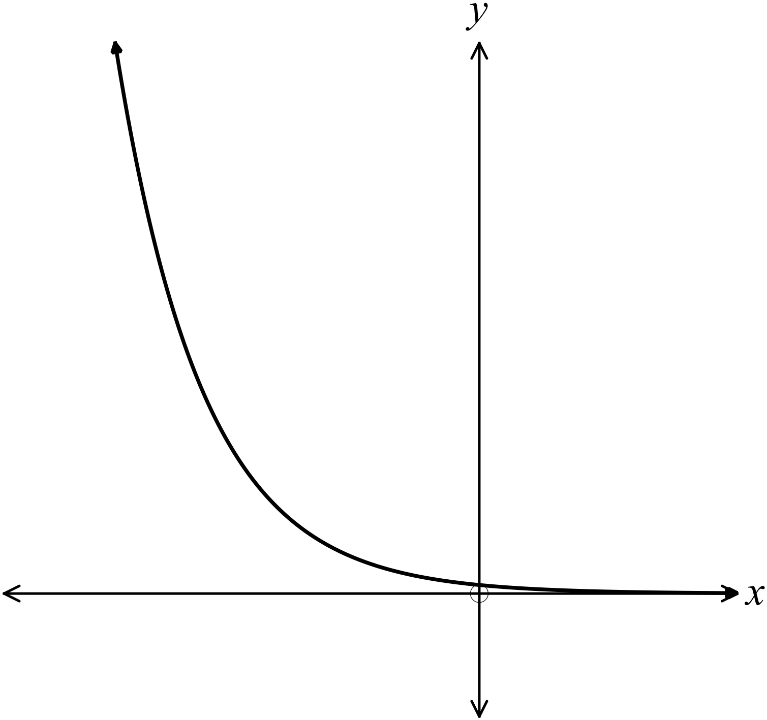A. B.
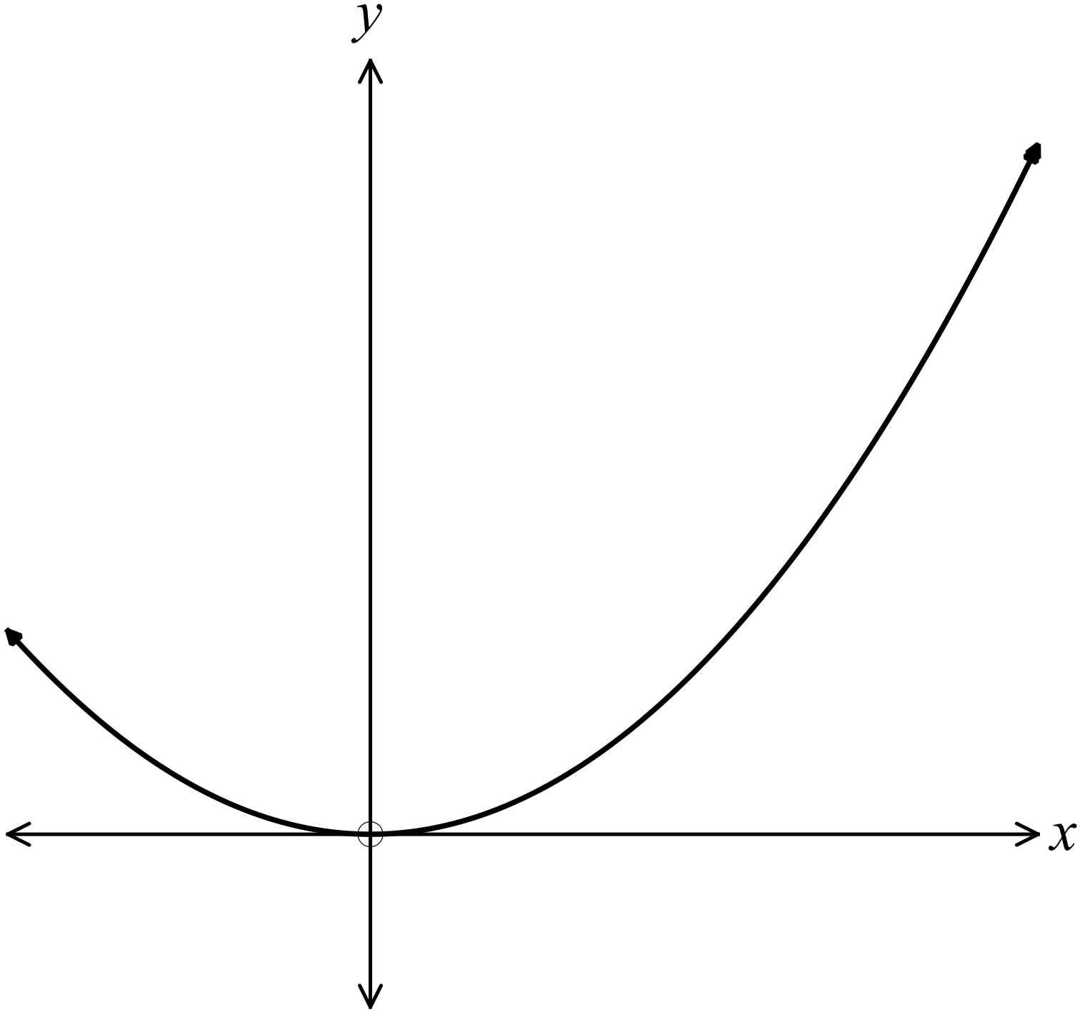

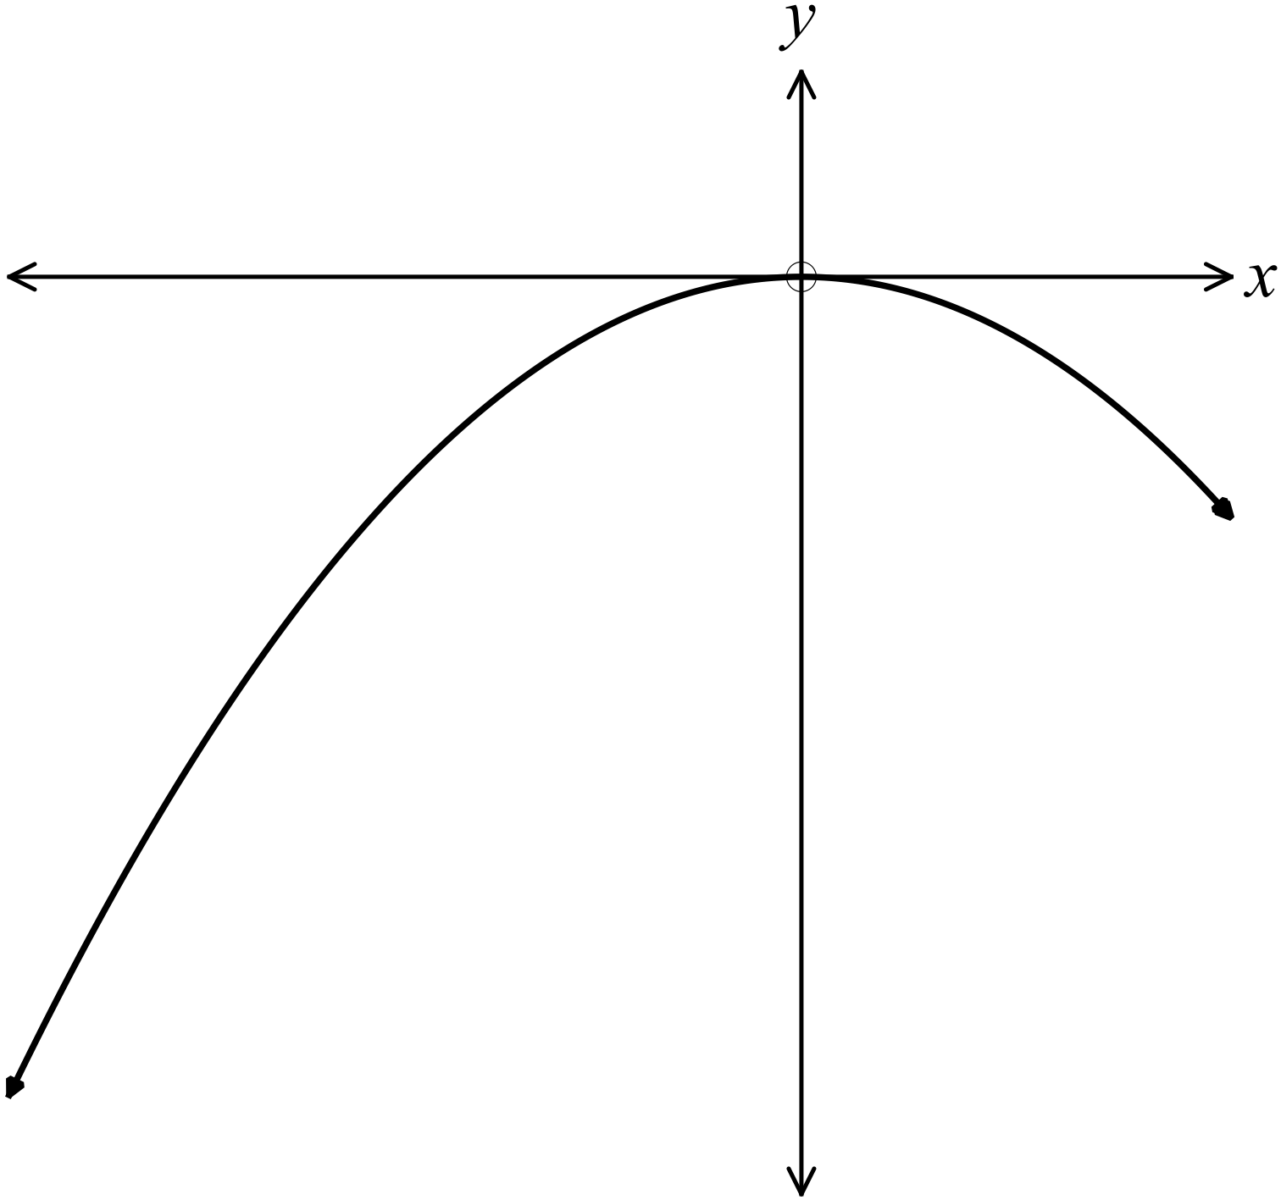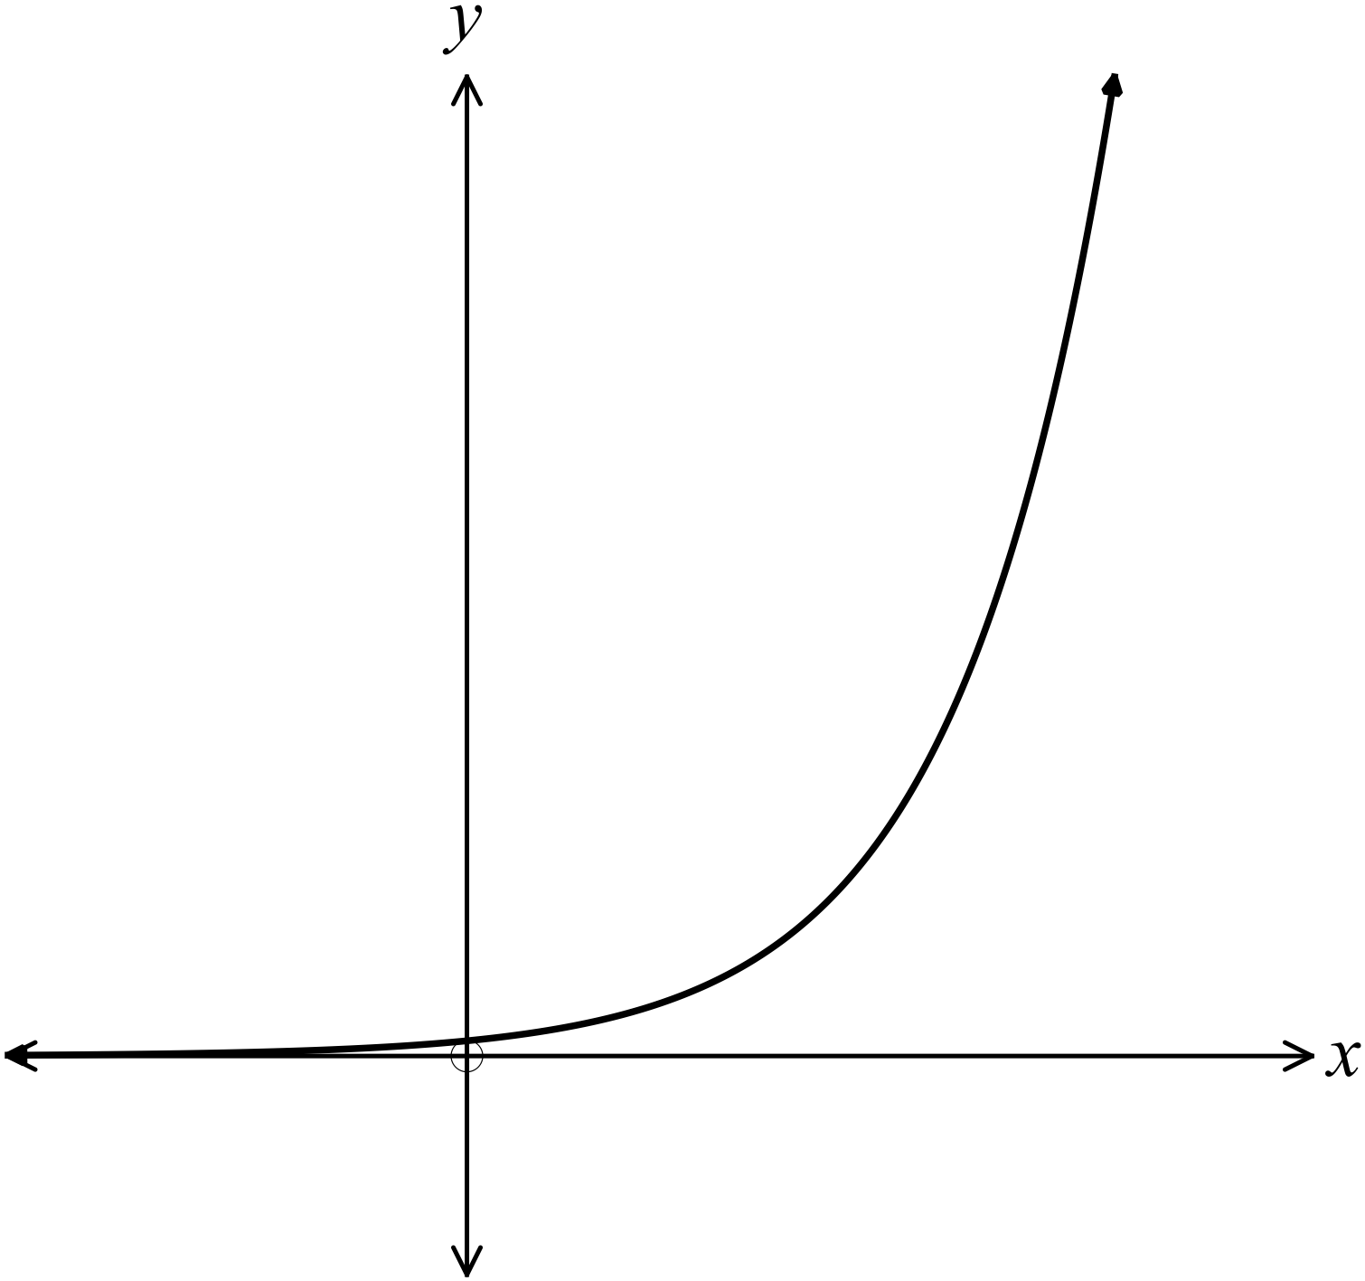C . D.

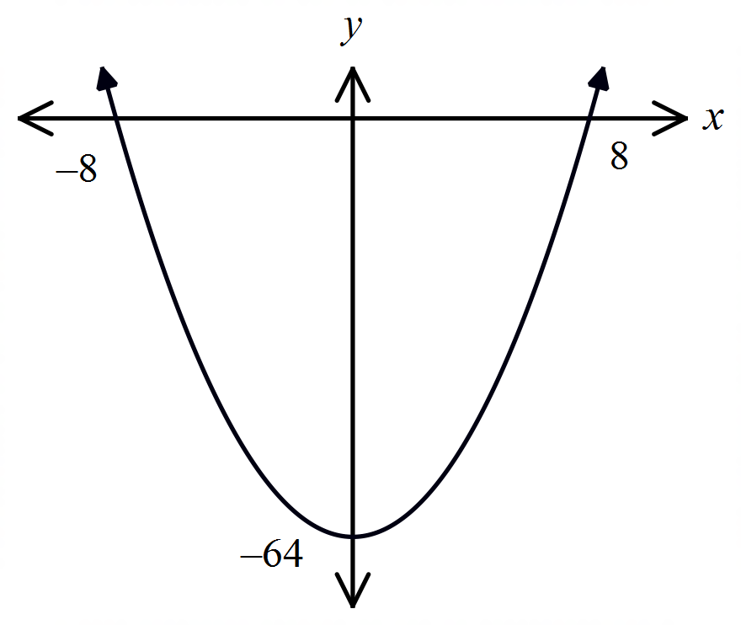What is the equation of the curve shown?

A. 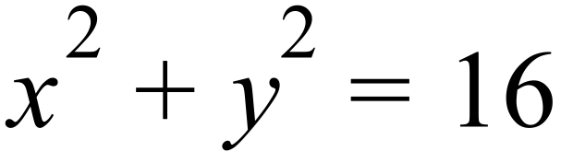
B. 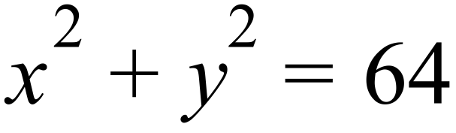
C. 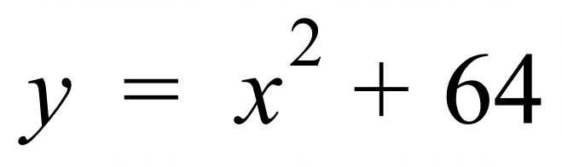
D. 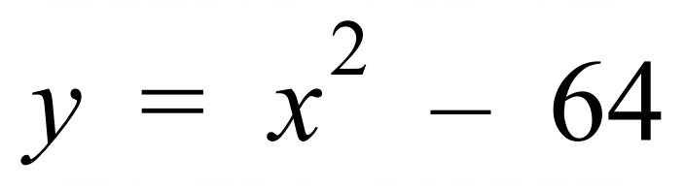

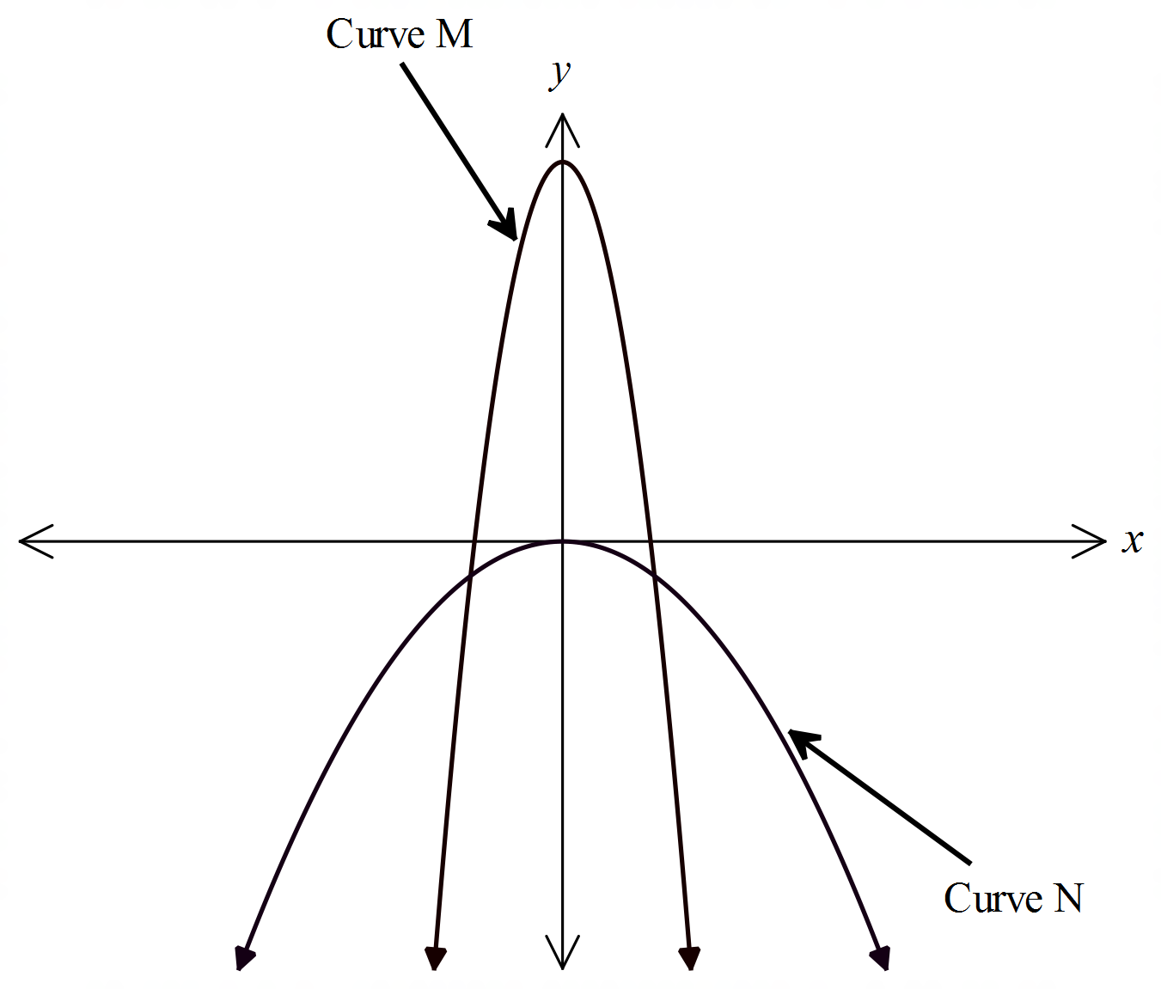The graphs of two curves are shown, labelled curves M and N.

Which statement is not true of both graphs?

A. Both curves are parabolas.
B. Both curves are concave down.
C. Both curves are symmetric about the y axis.
D. The origin is the vertex of both curves.

Which diagram shows the graph of 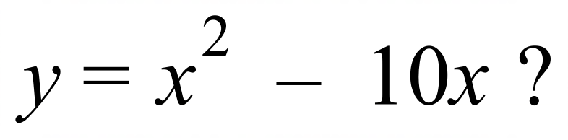
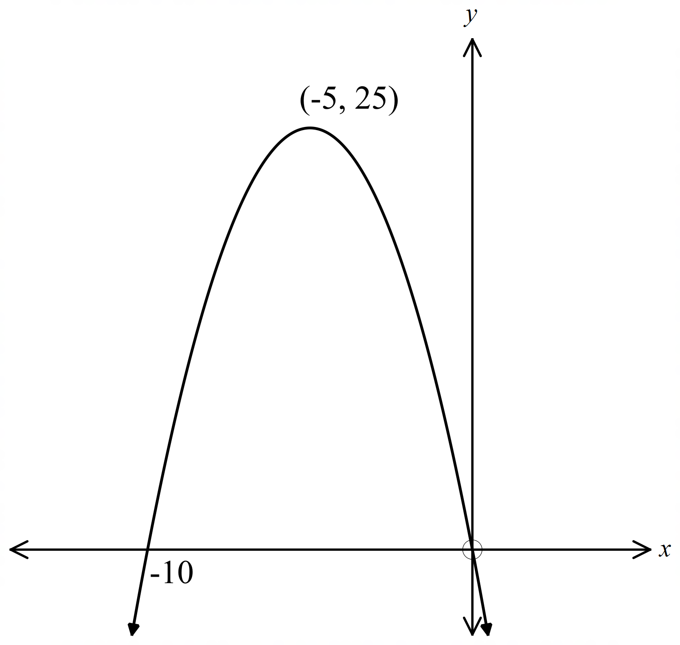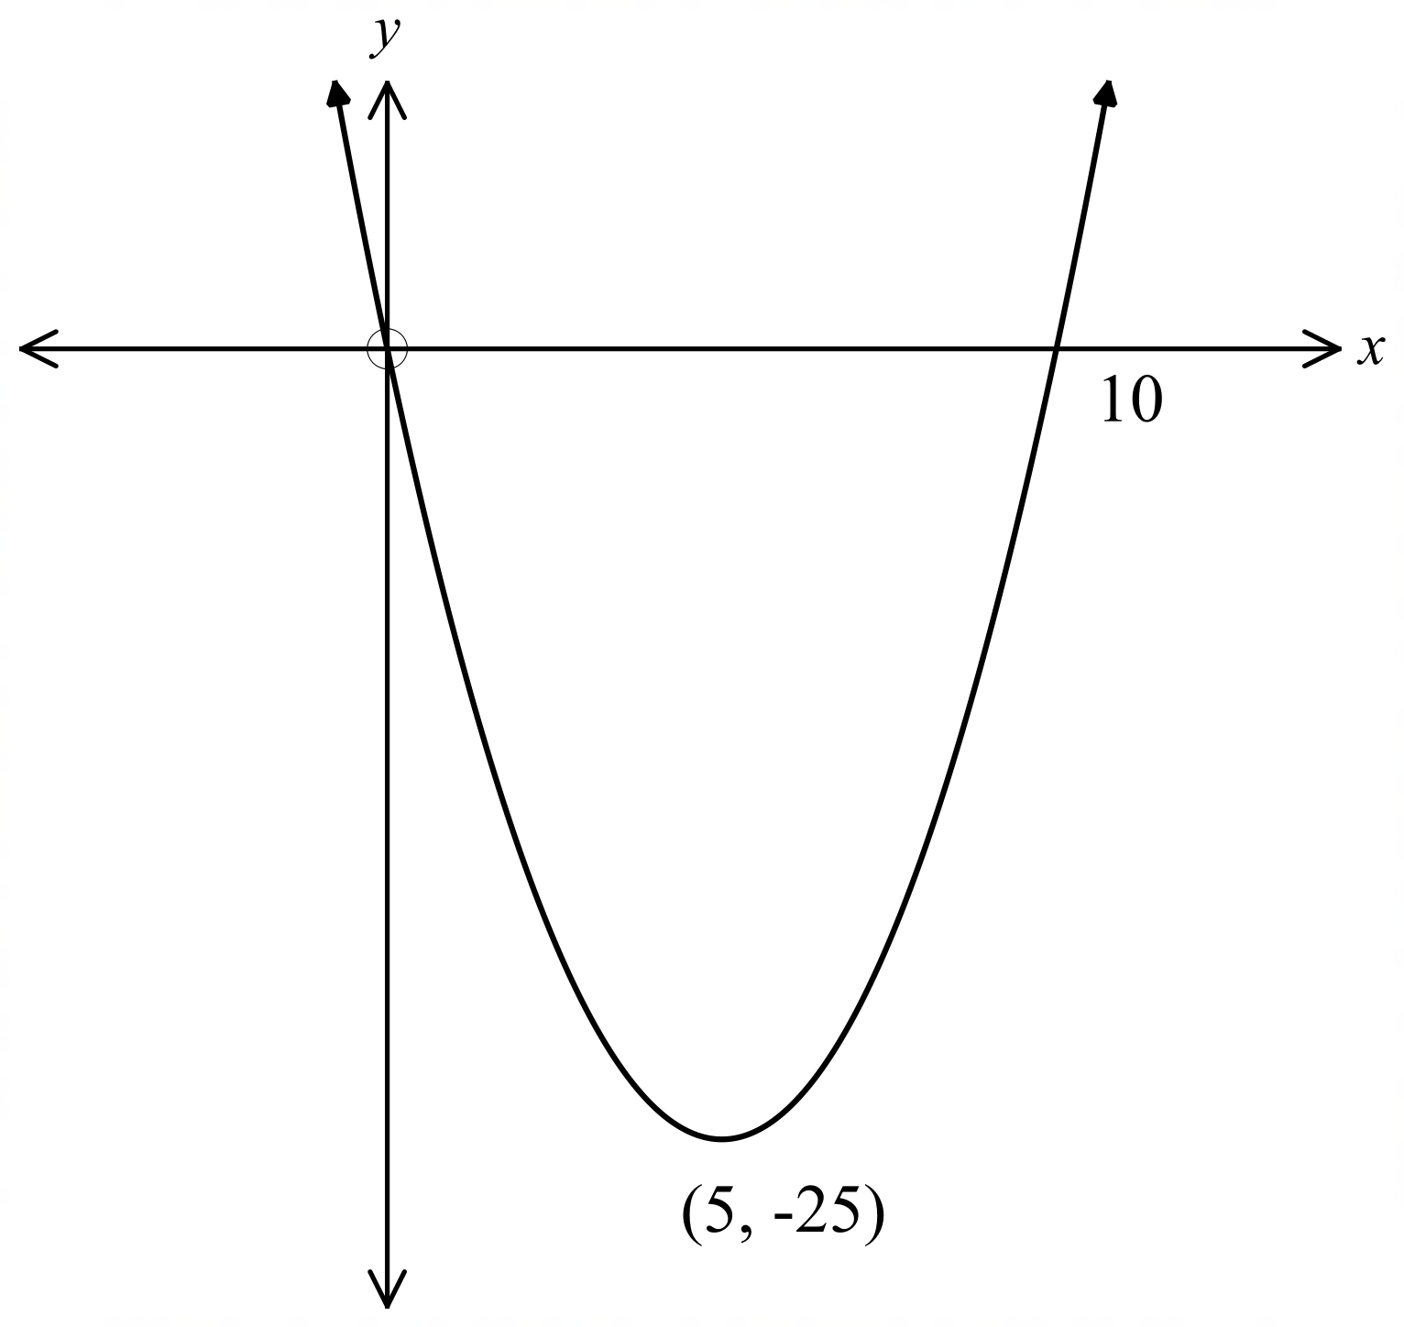
A. B.

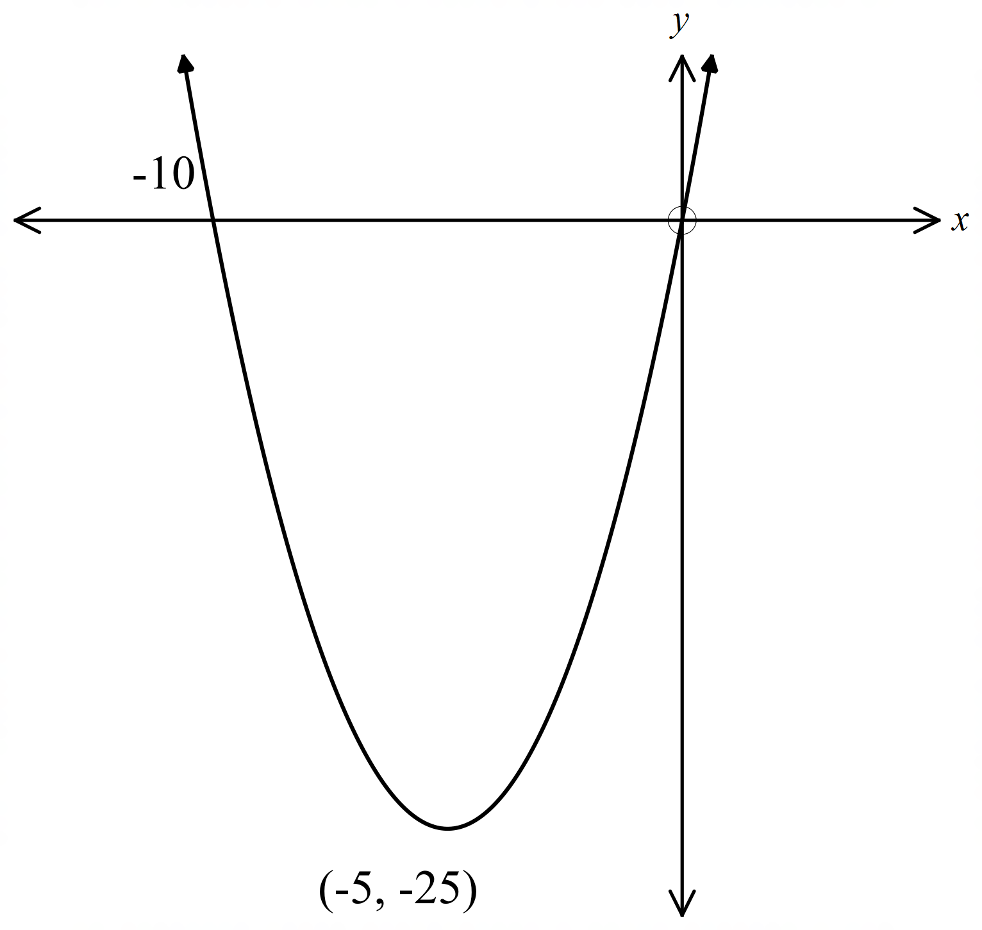 C. D.
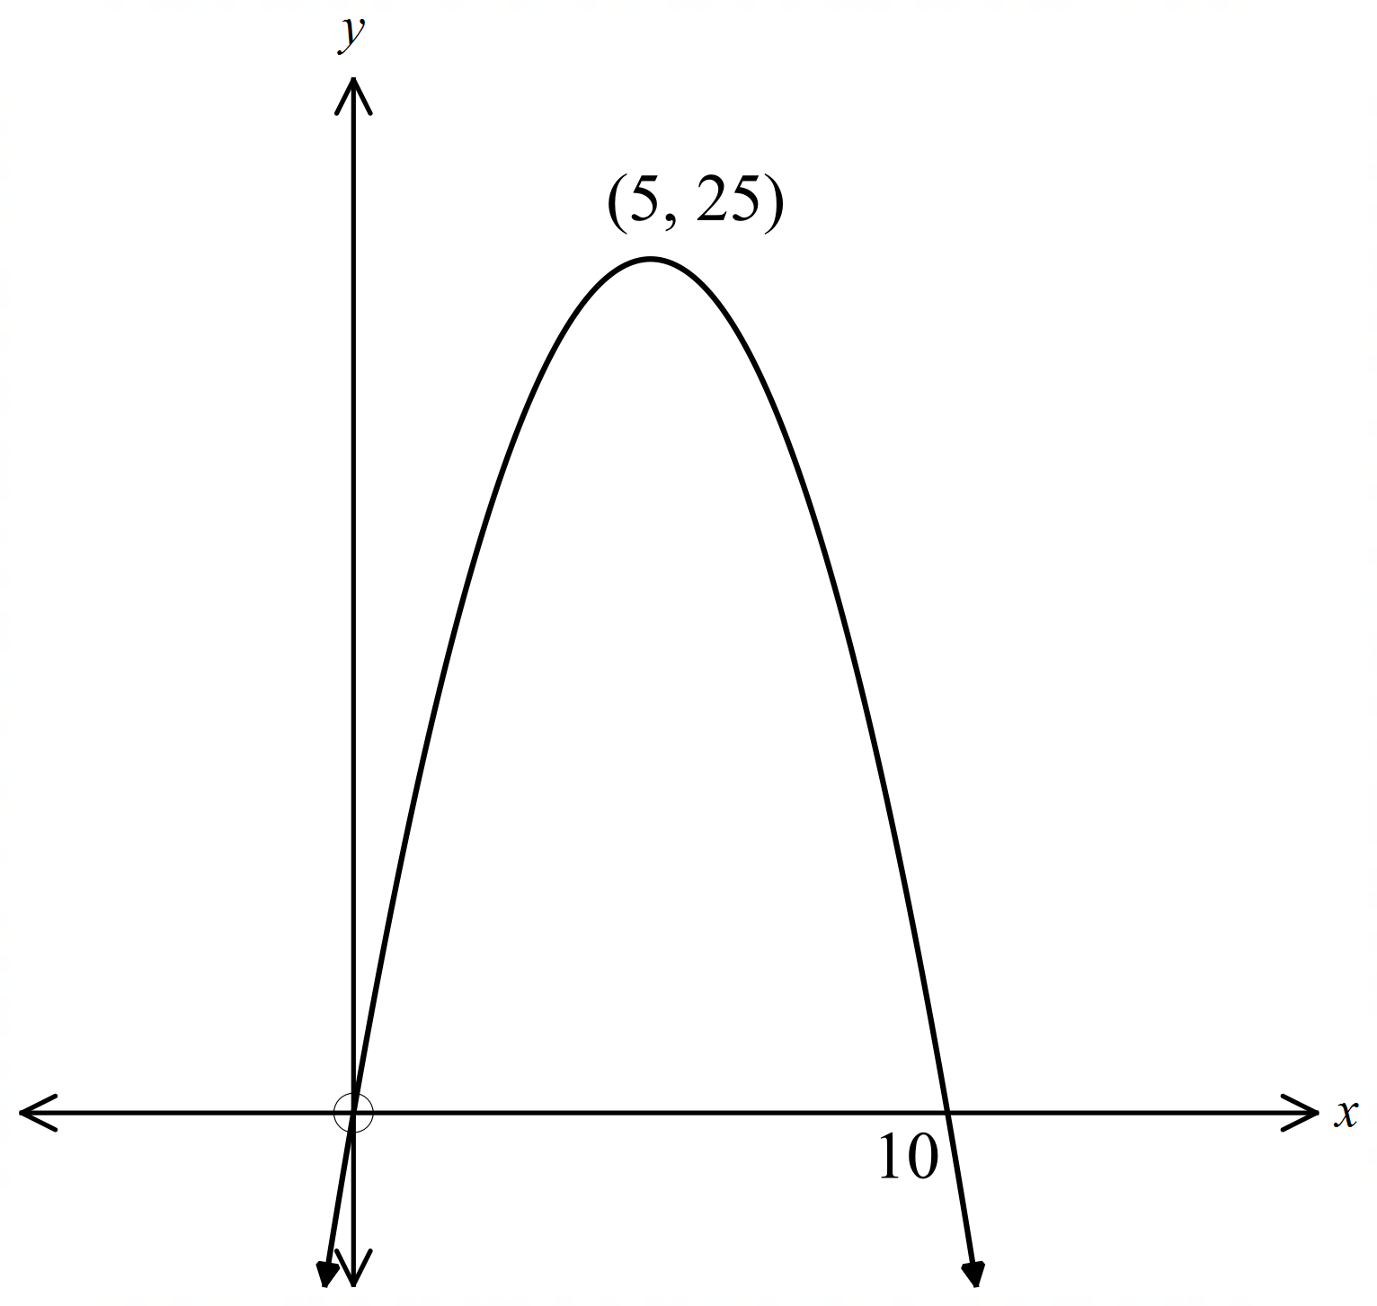

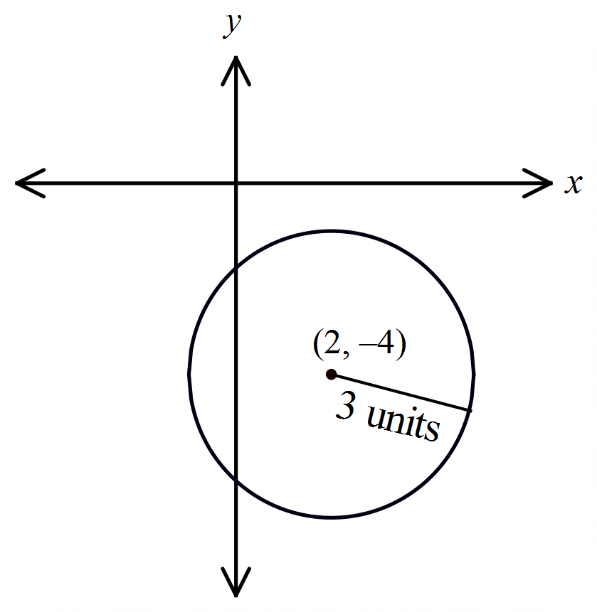What is the equation of the circle shown on the number plane?

A. 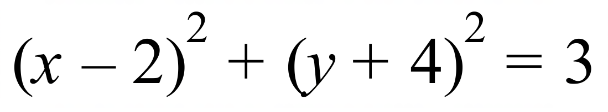
B. 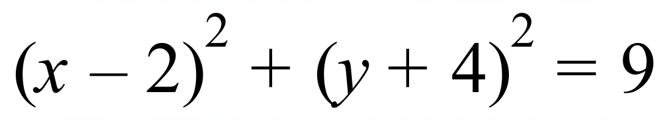
C. 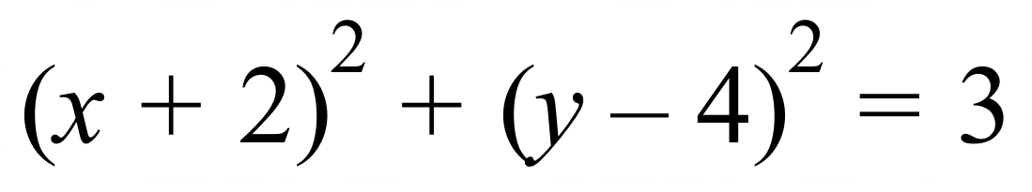
D. 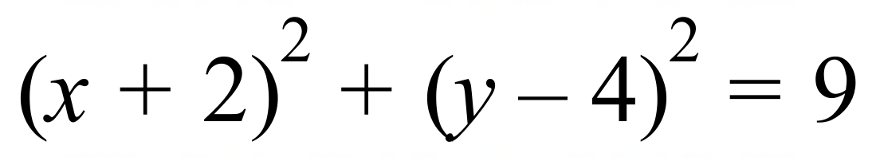

Which is the graph of 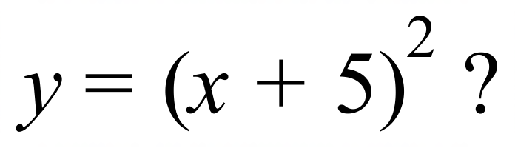

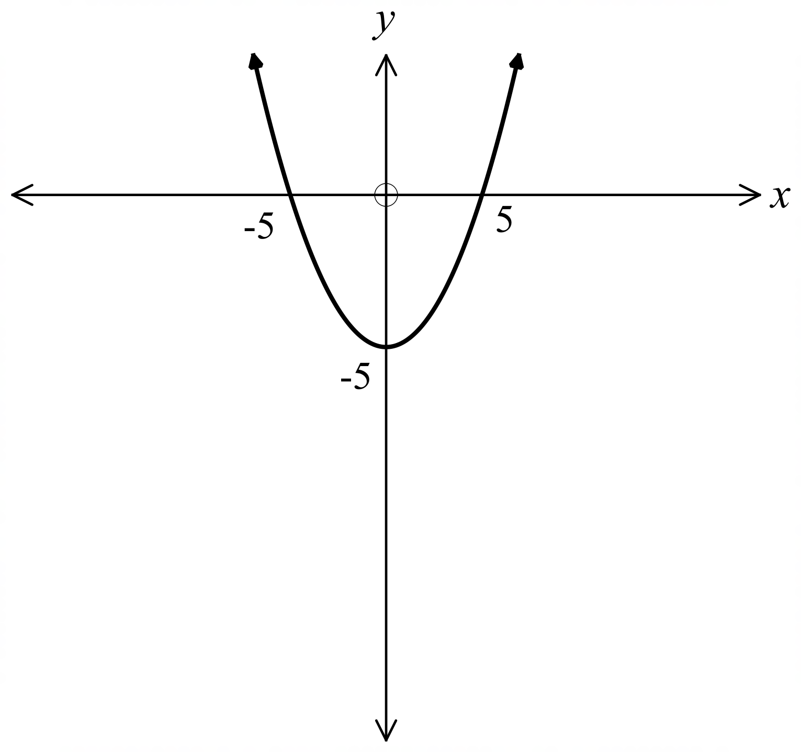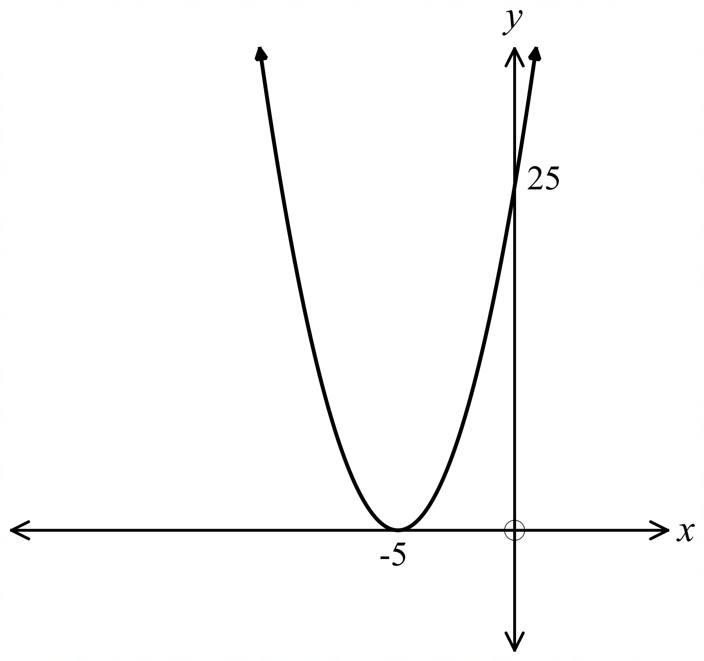A. B.

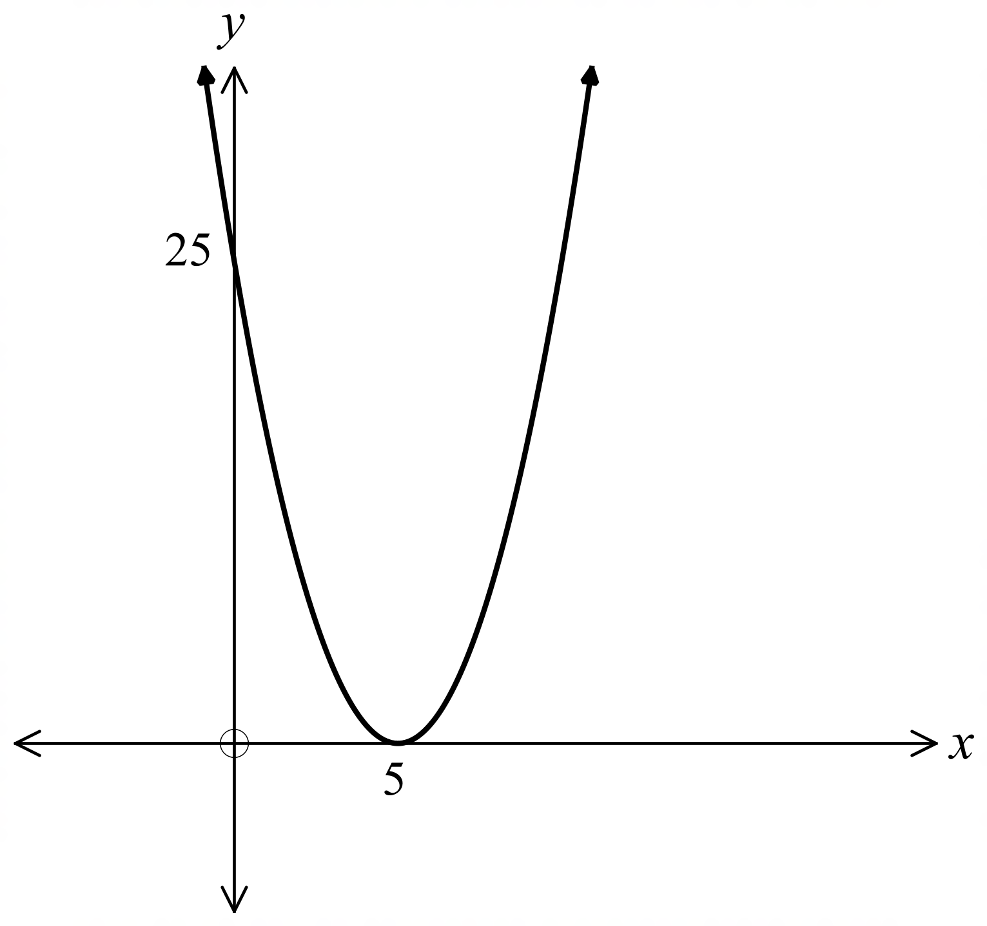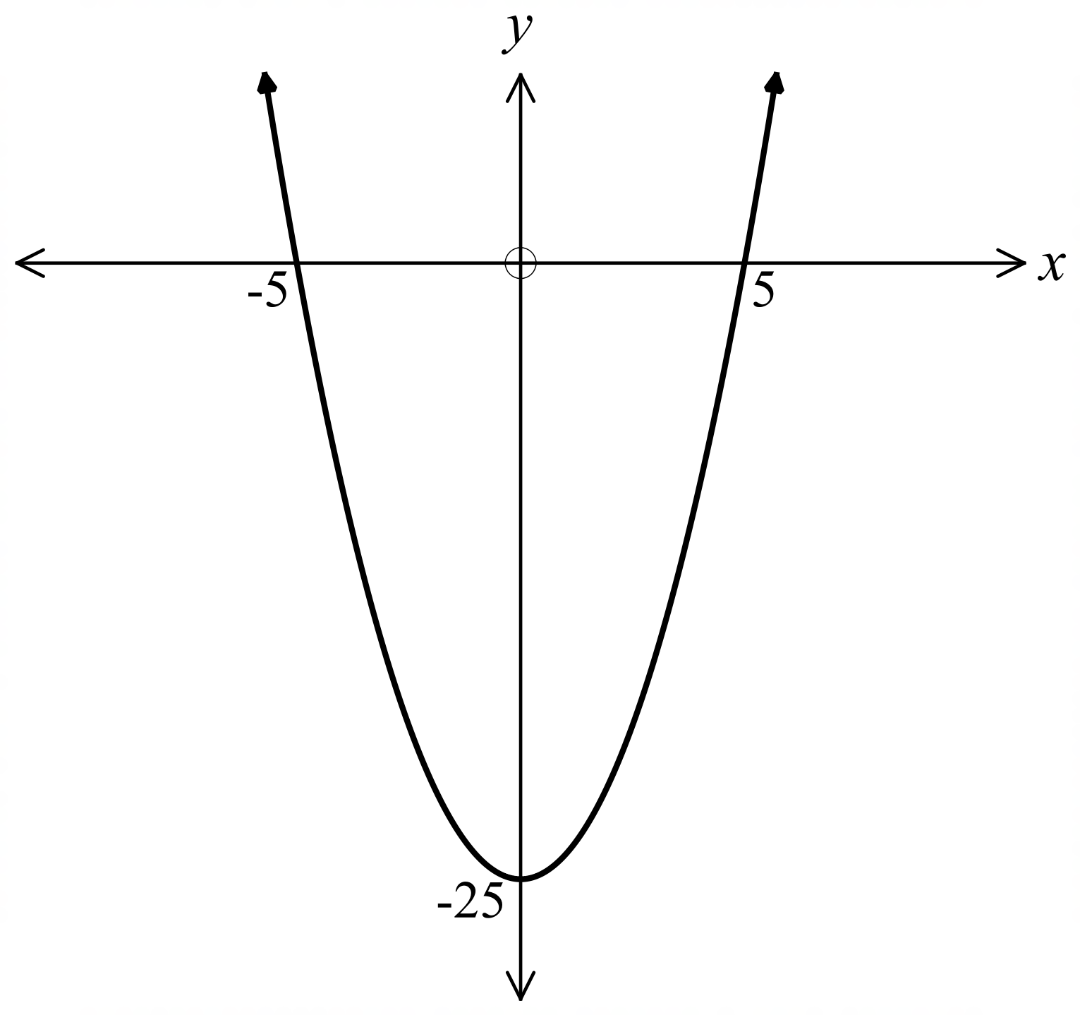C . D.

Which equation describes a circle with a radius of 9 units and centre at (5, – 7) ?

A. 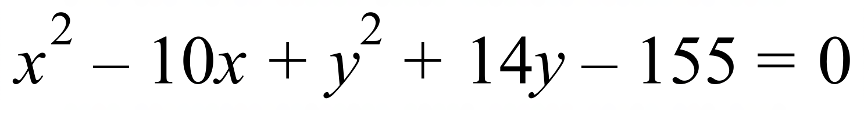 B. 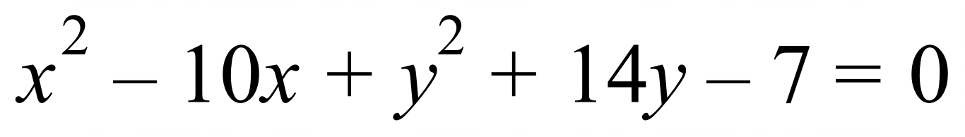

C. 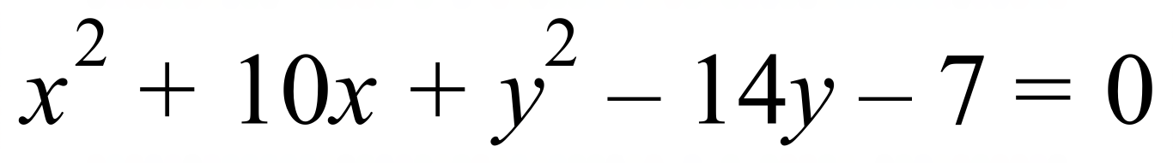 D. 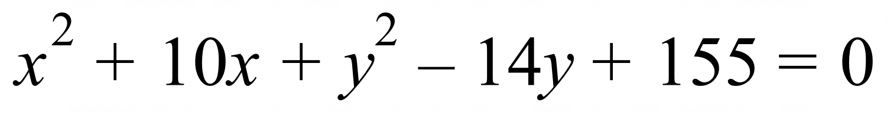

What is the y intercept of the curve 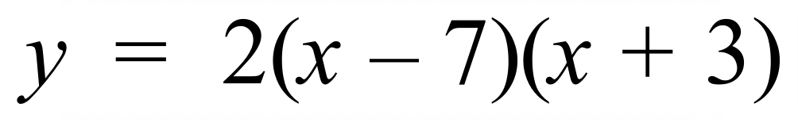 ?

A. 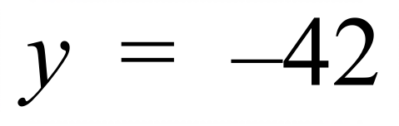 B. 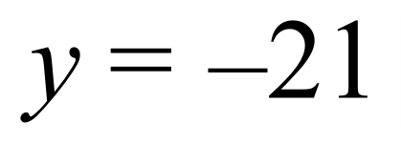 C. 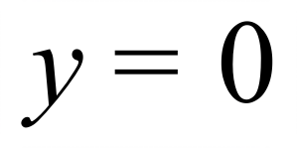 D. 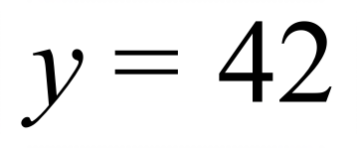
Which is the graph of 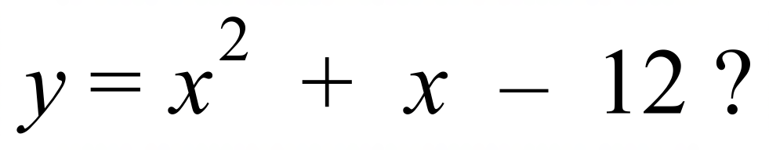

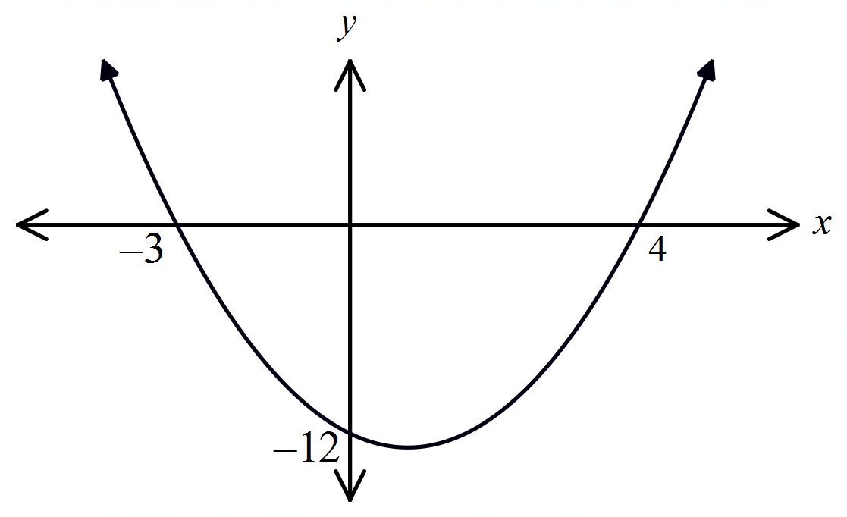 A. B.
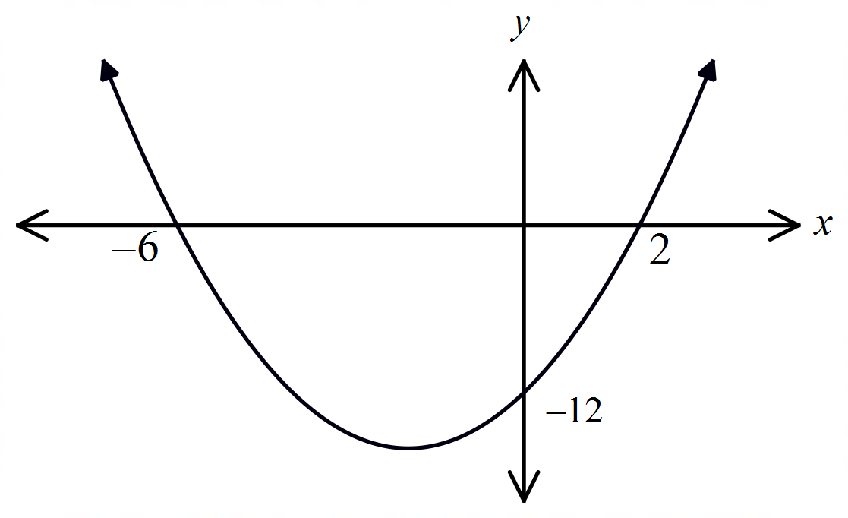

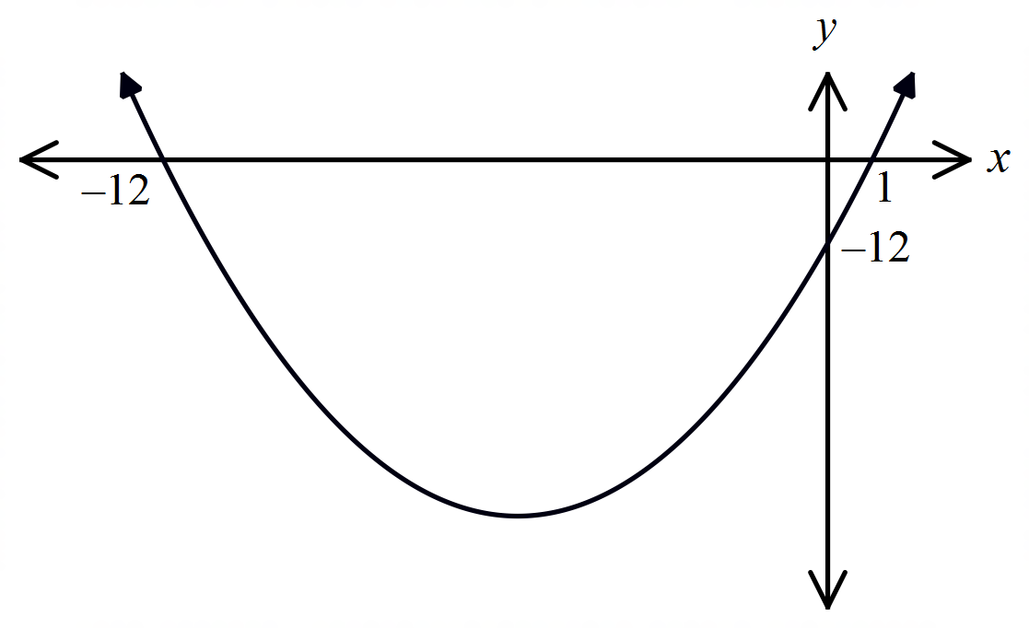 C. D.
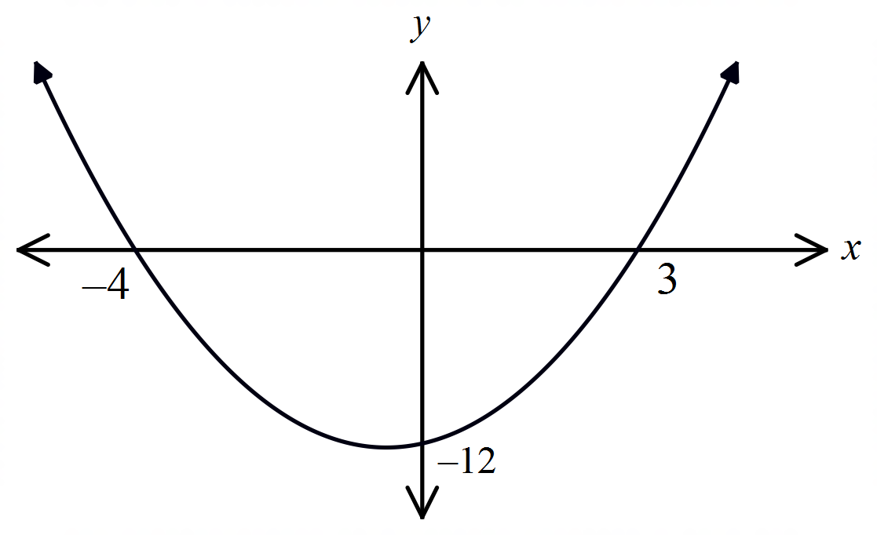

What is the vertex of the curve 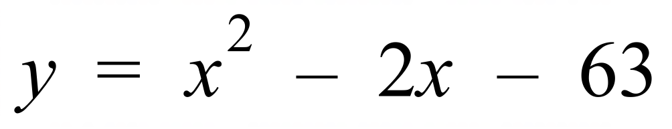 ?

A. 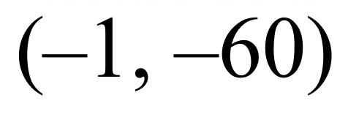 B. 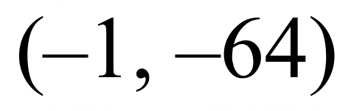 C. 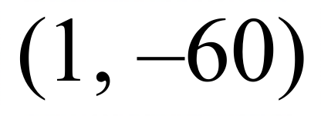 D. 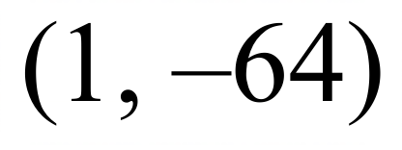
What are the intercepts on the x axis for the curve 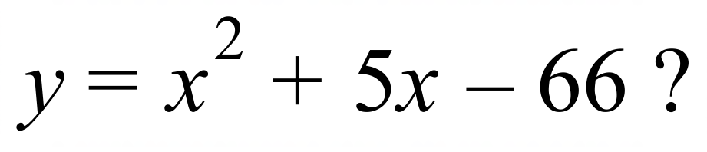

A. 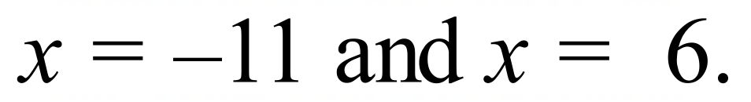 B. 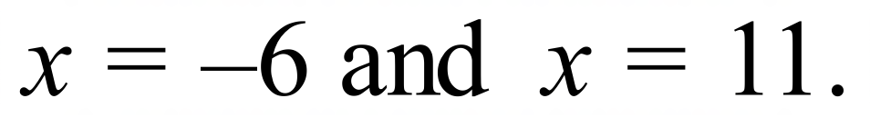
C. 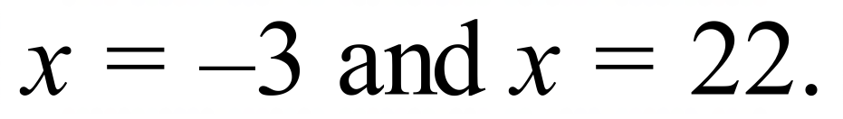 D. 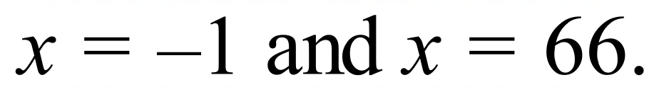
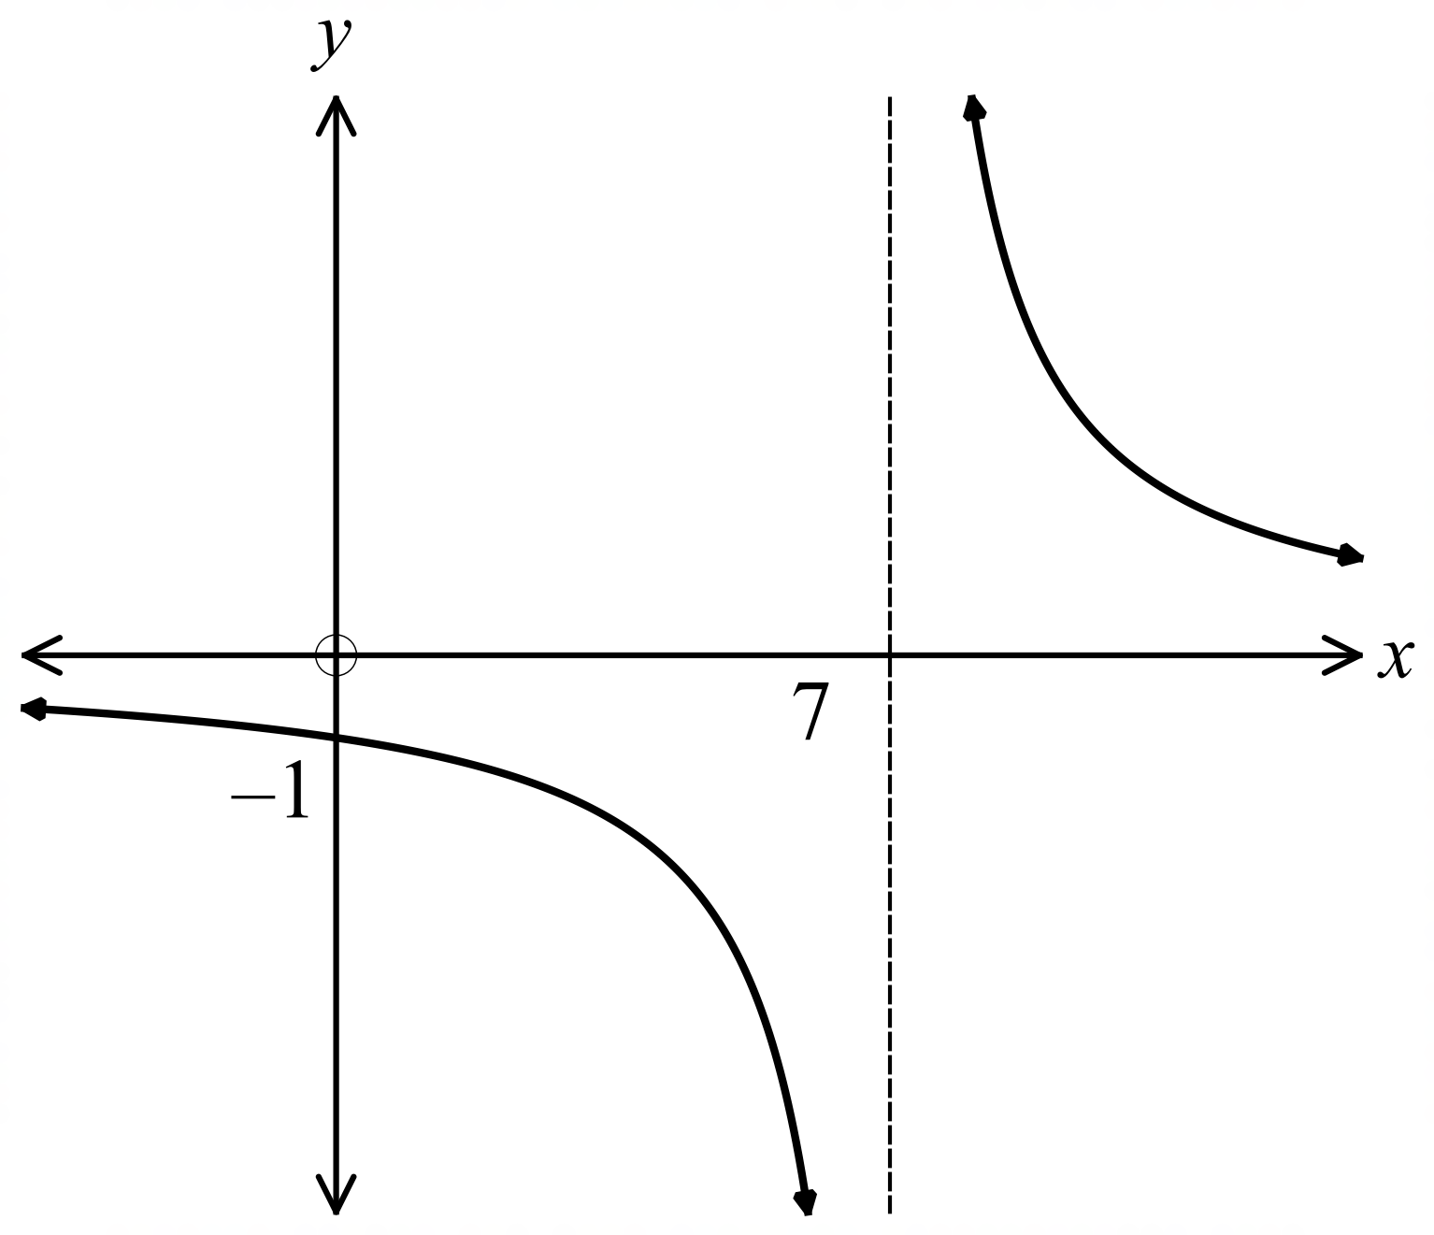Which equation could describe the graph shown?

A. 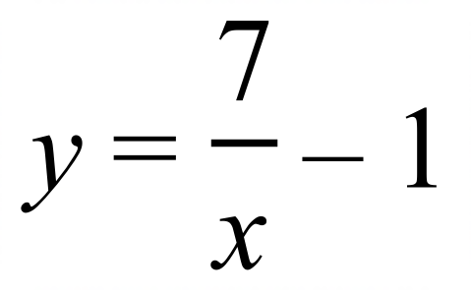

B. 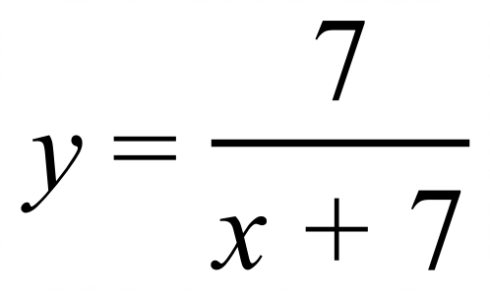

C. 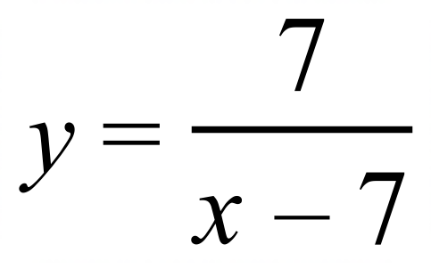

D. 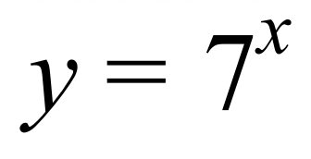

School Name
Mathematics Test 2017
Year 10 | Non-Linear Relations | Calculator Allowed
Year 10 | Non-Linear Relations | Name___________________
Section 3 Longer Answer Section
Write all working and answers in the spaces provided on this test paper.

 |  | Marks
1. | On the axes provided draw neat sketches of 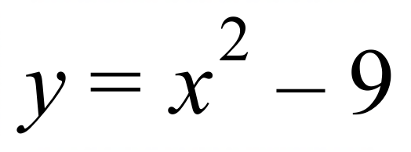 and 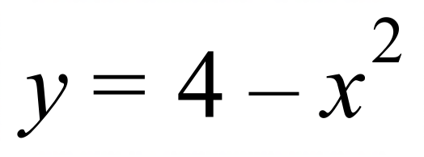.  Clearly mark the x and y intercepts and the vertex of each graph.  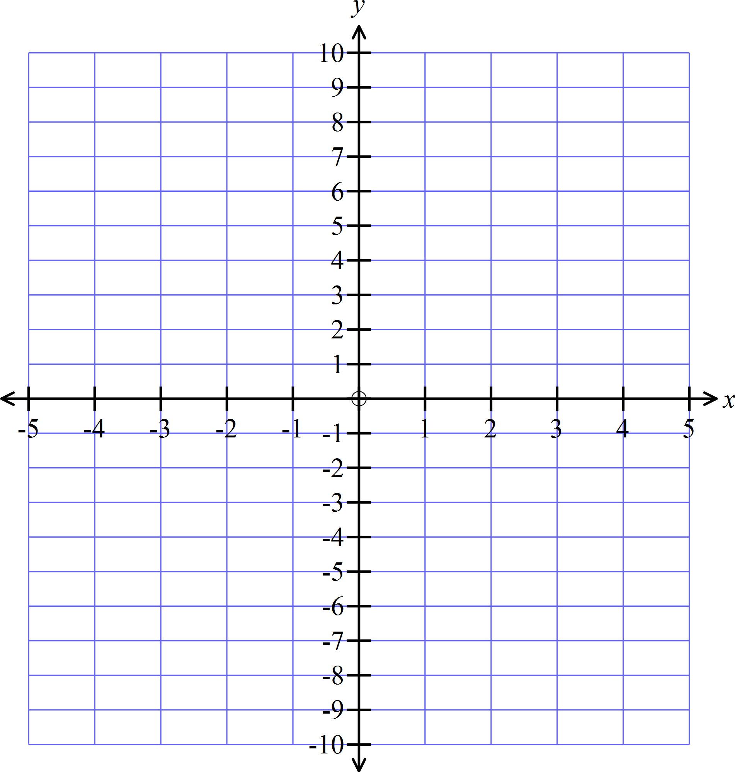 | 4
2. | On the axes provided draw neat sketches of 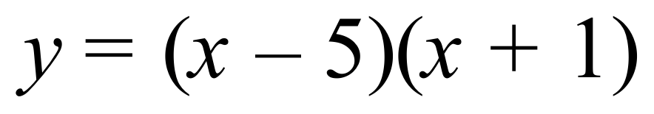 and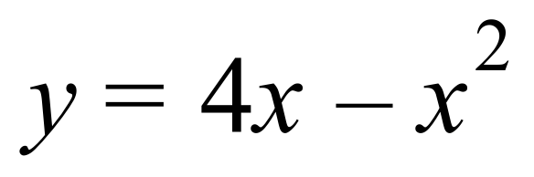.  Clearly mark the x and y intercepts and the vertex of each graph. | 4
3. | On the axes provided draw neat sketches of 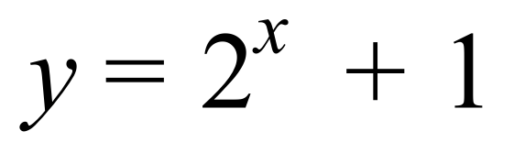 and 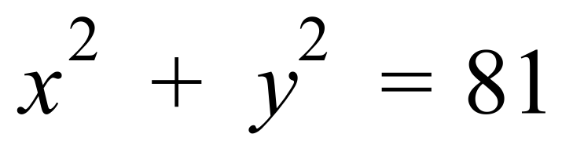.  Clearly mark the x and y intercepts of each graph.  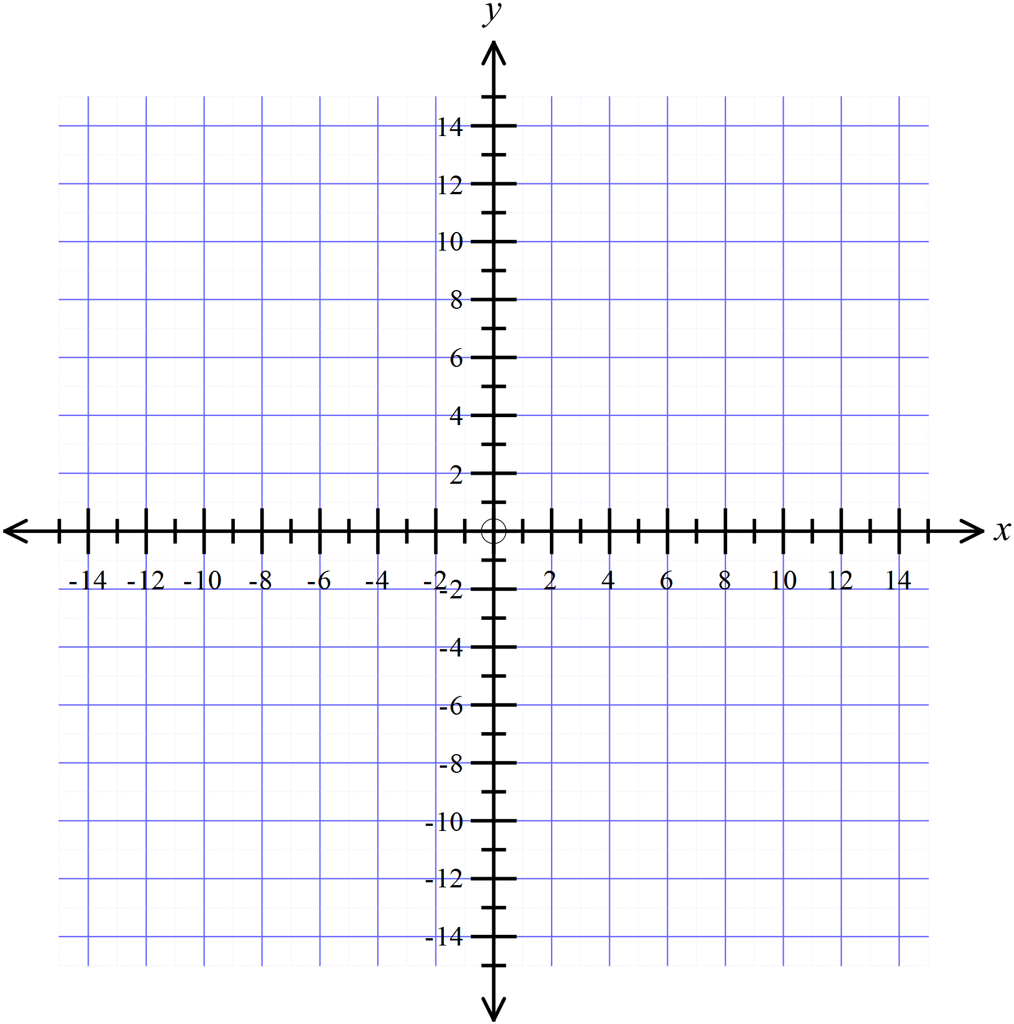 | 4
4. | On the axes provided draw neat sketches of 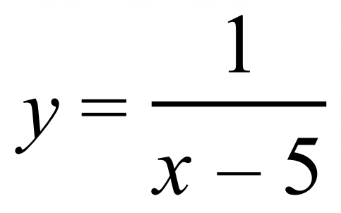 and 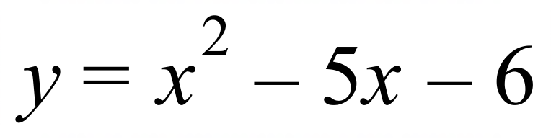.  Clearly mark the x and y intercepts and the vertex or asymptote (where appropriate) of each graph. | 4

School Name
Mathematics 2017
Multiple Choice Answer Sheet
Non-Linear Relations
Name _____________________________________________
Completely fill the response oval representing the most correct answer.
1. A B C D
2. A B C D
3. A B C D
4. A B C D
5. A B C D
6. A B C D
7. A B C D
8. A B C D
9. A B C D
10. A B C D
11. A B C D
12. A B C D
13. A B C D
14. A B C D
15. A B C D
16. A B C D
17. A B C D
18. A B C D

School Name
Mathematics Test 2017
Year 10 | Non-Linear Relations | Non Calculator Section
ANSWERS

Question | Working and Answer
 | 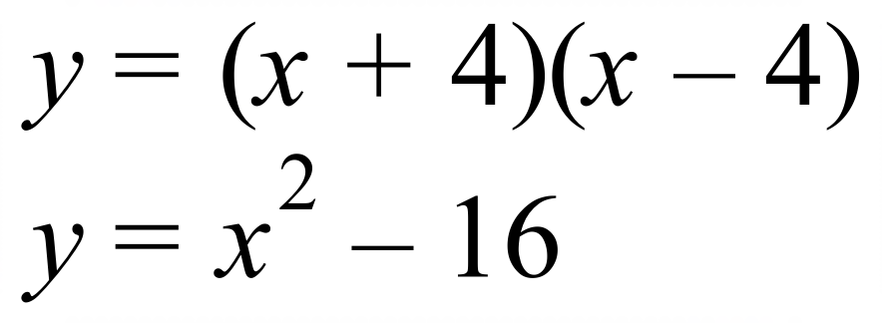
 | 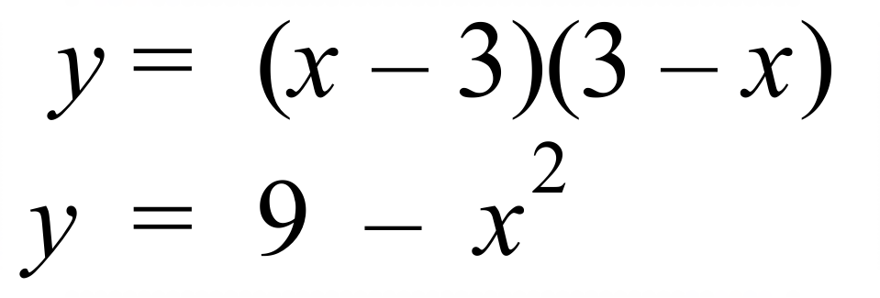
 | 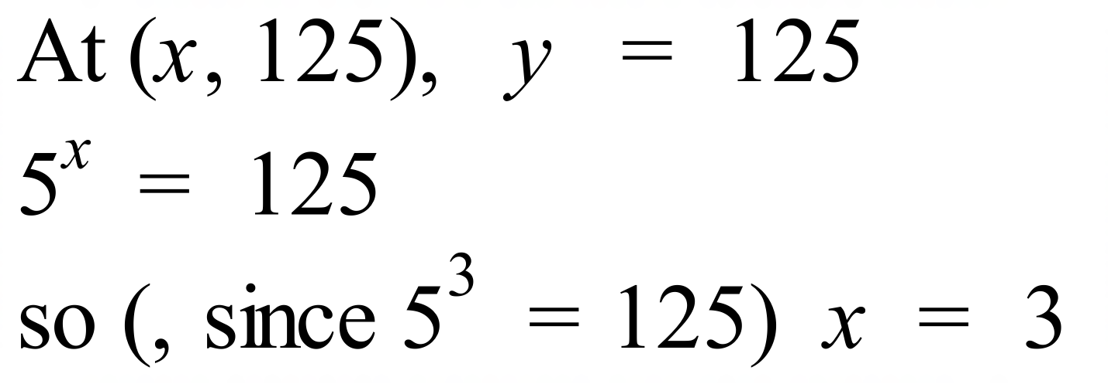
 | 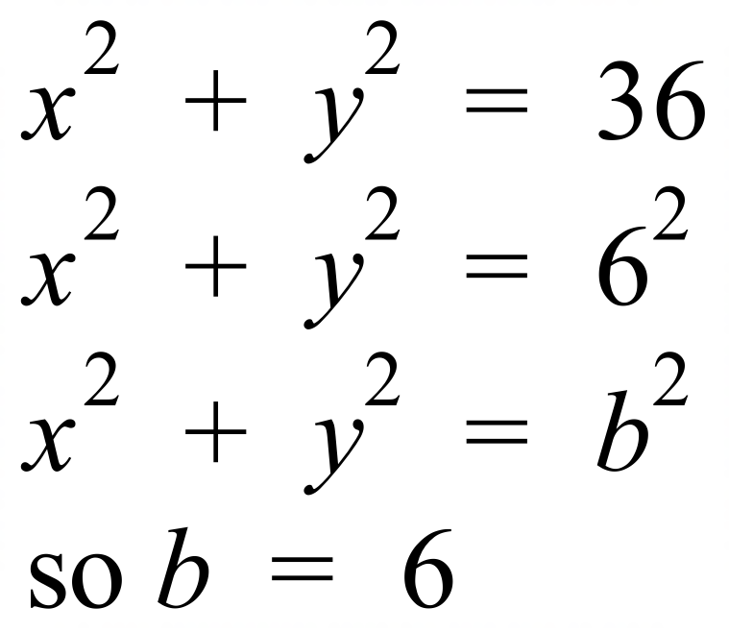
 | The broken line is as it is concave down, and the unbroken line is 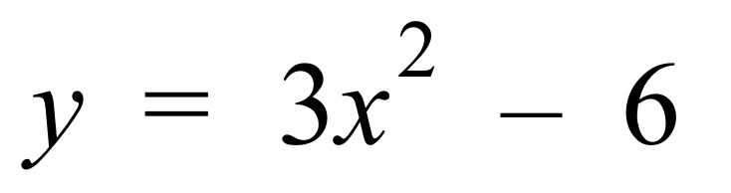
The y intercept occurs where x = 0.
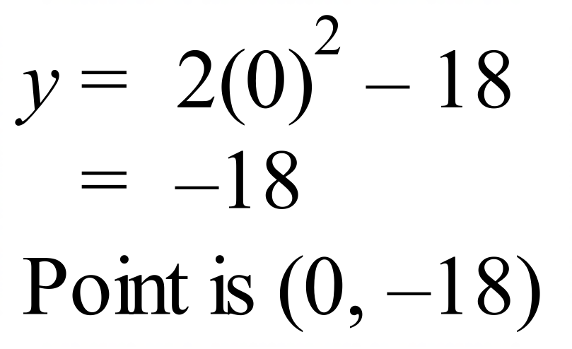
The x intercepts are where y = 0.
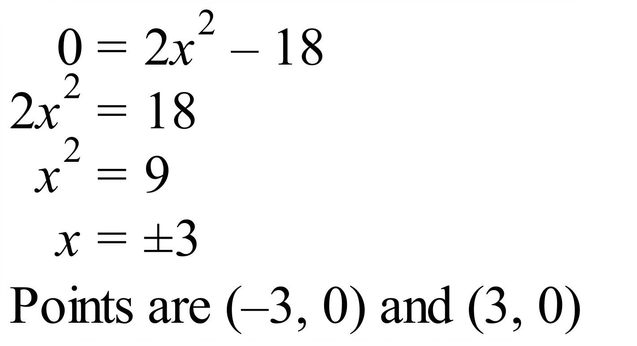
 | 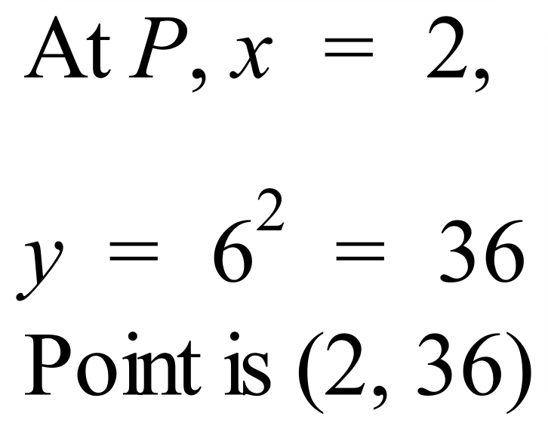
Radius of circle is 11 units and centre is the origin,
so its equation is 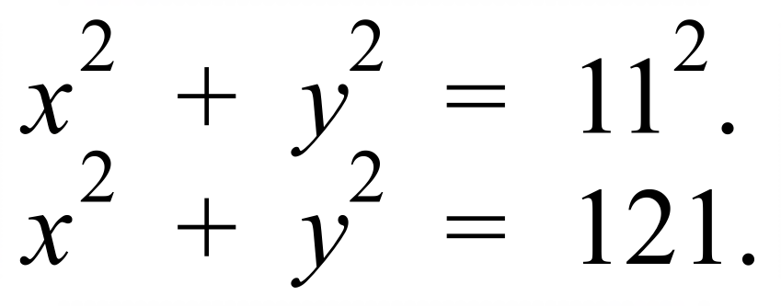
 | 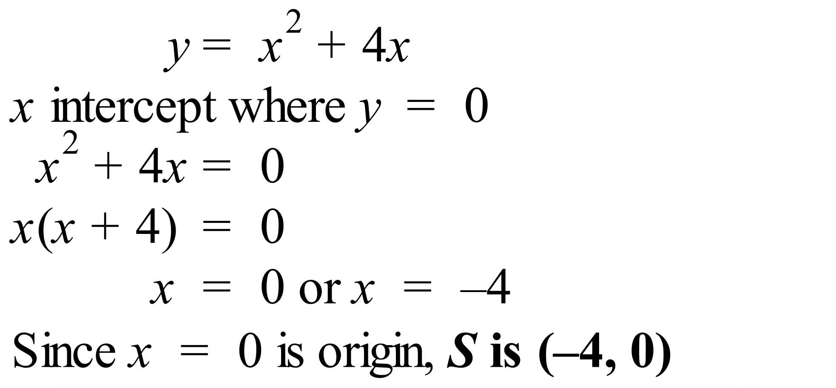
 | 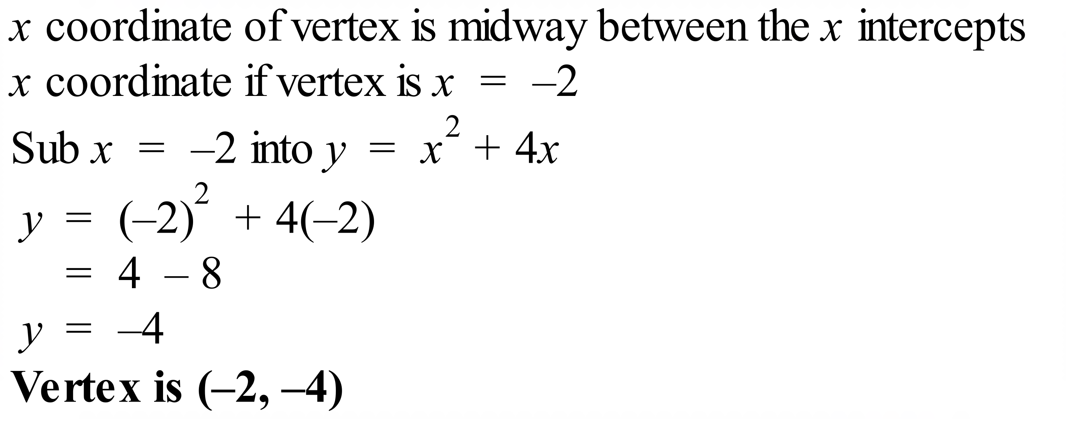
 | 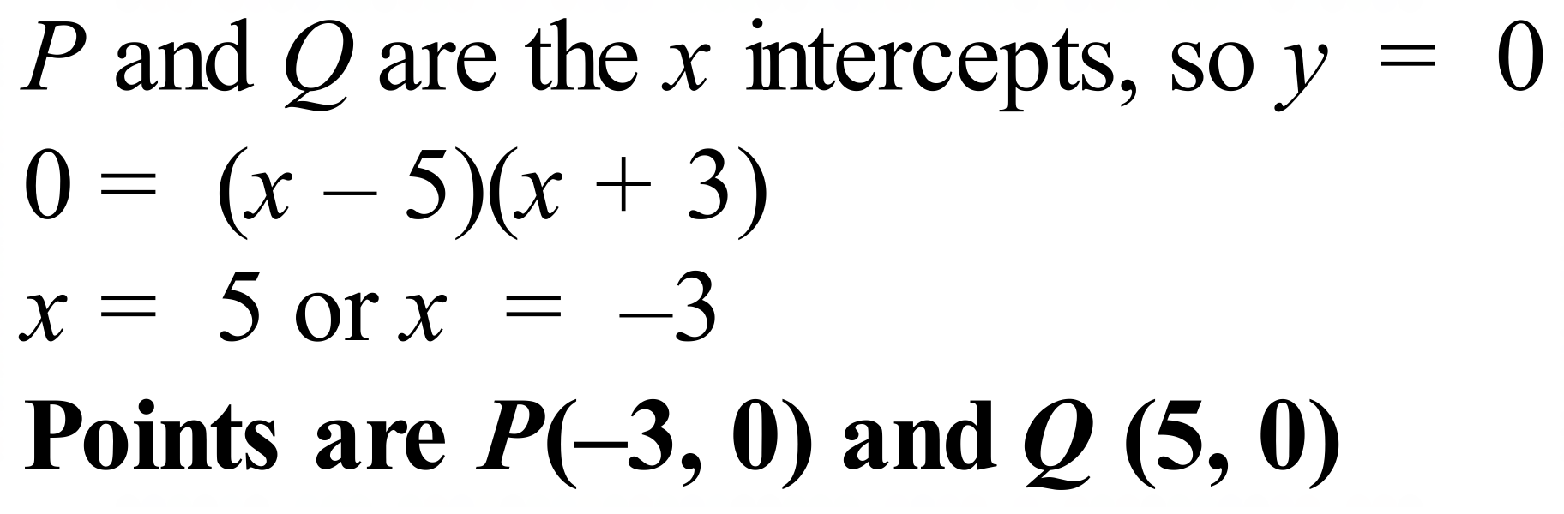
 | 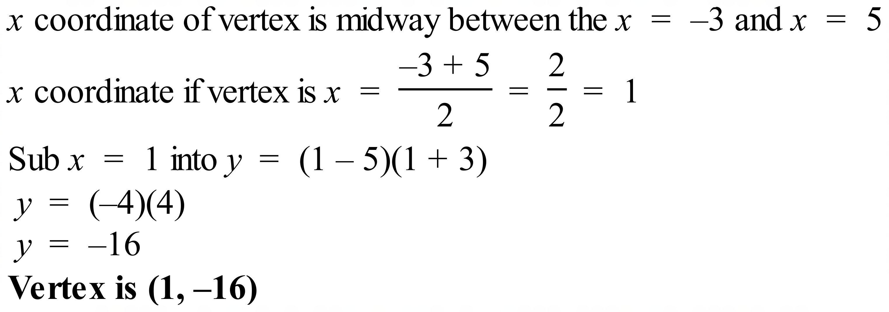
 | 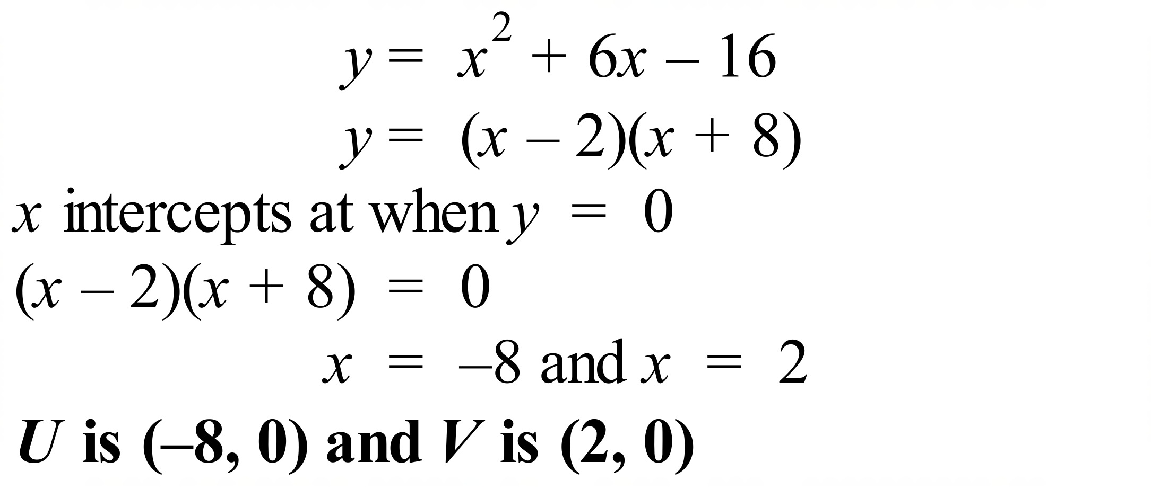
 | 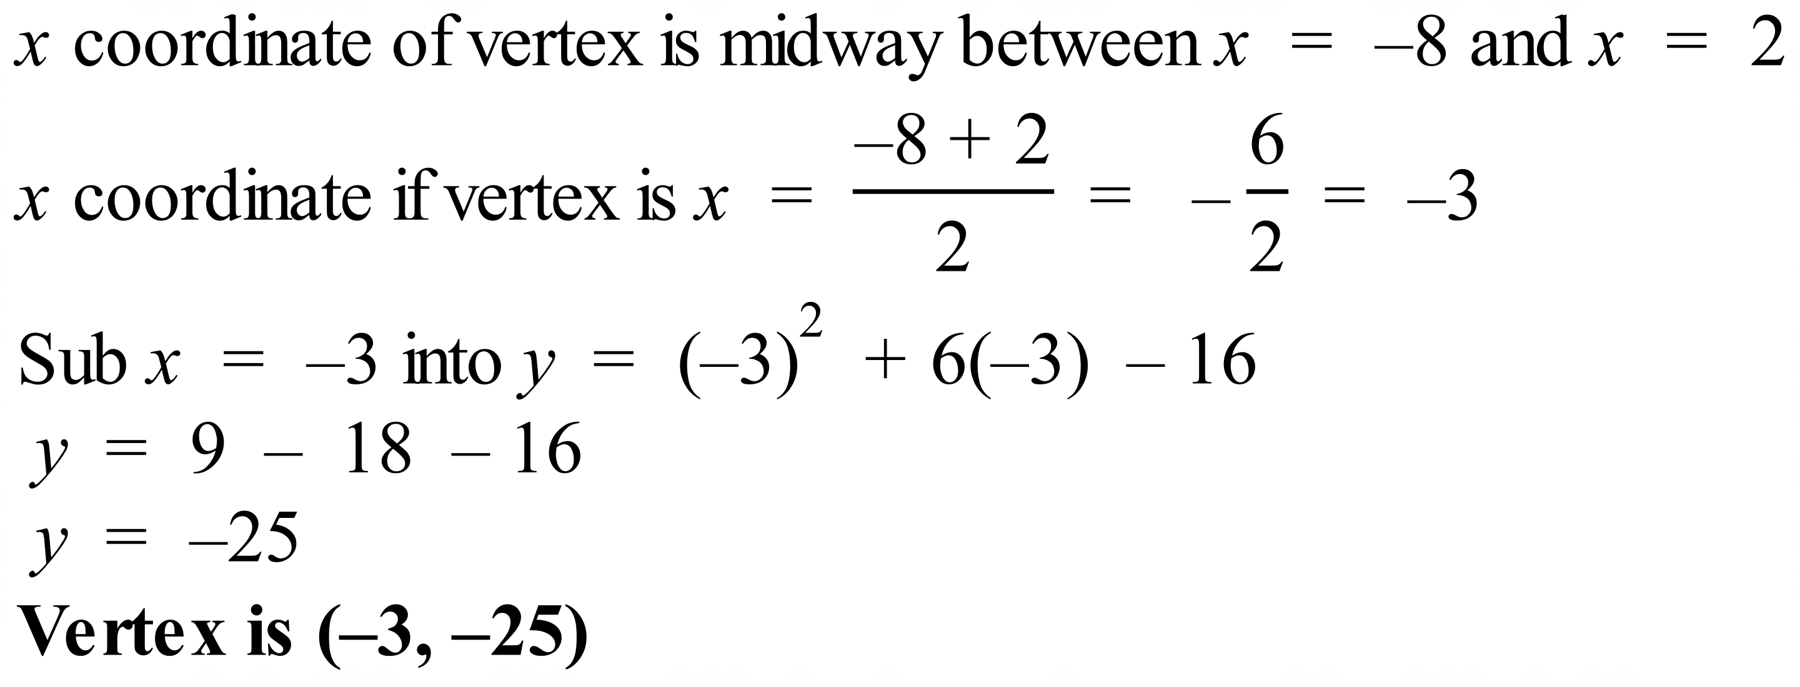
 | 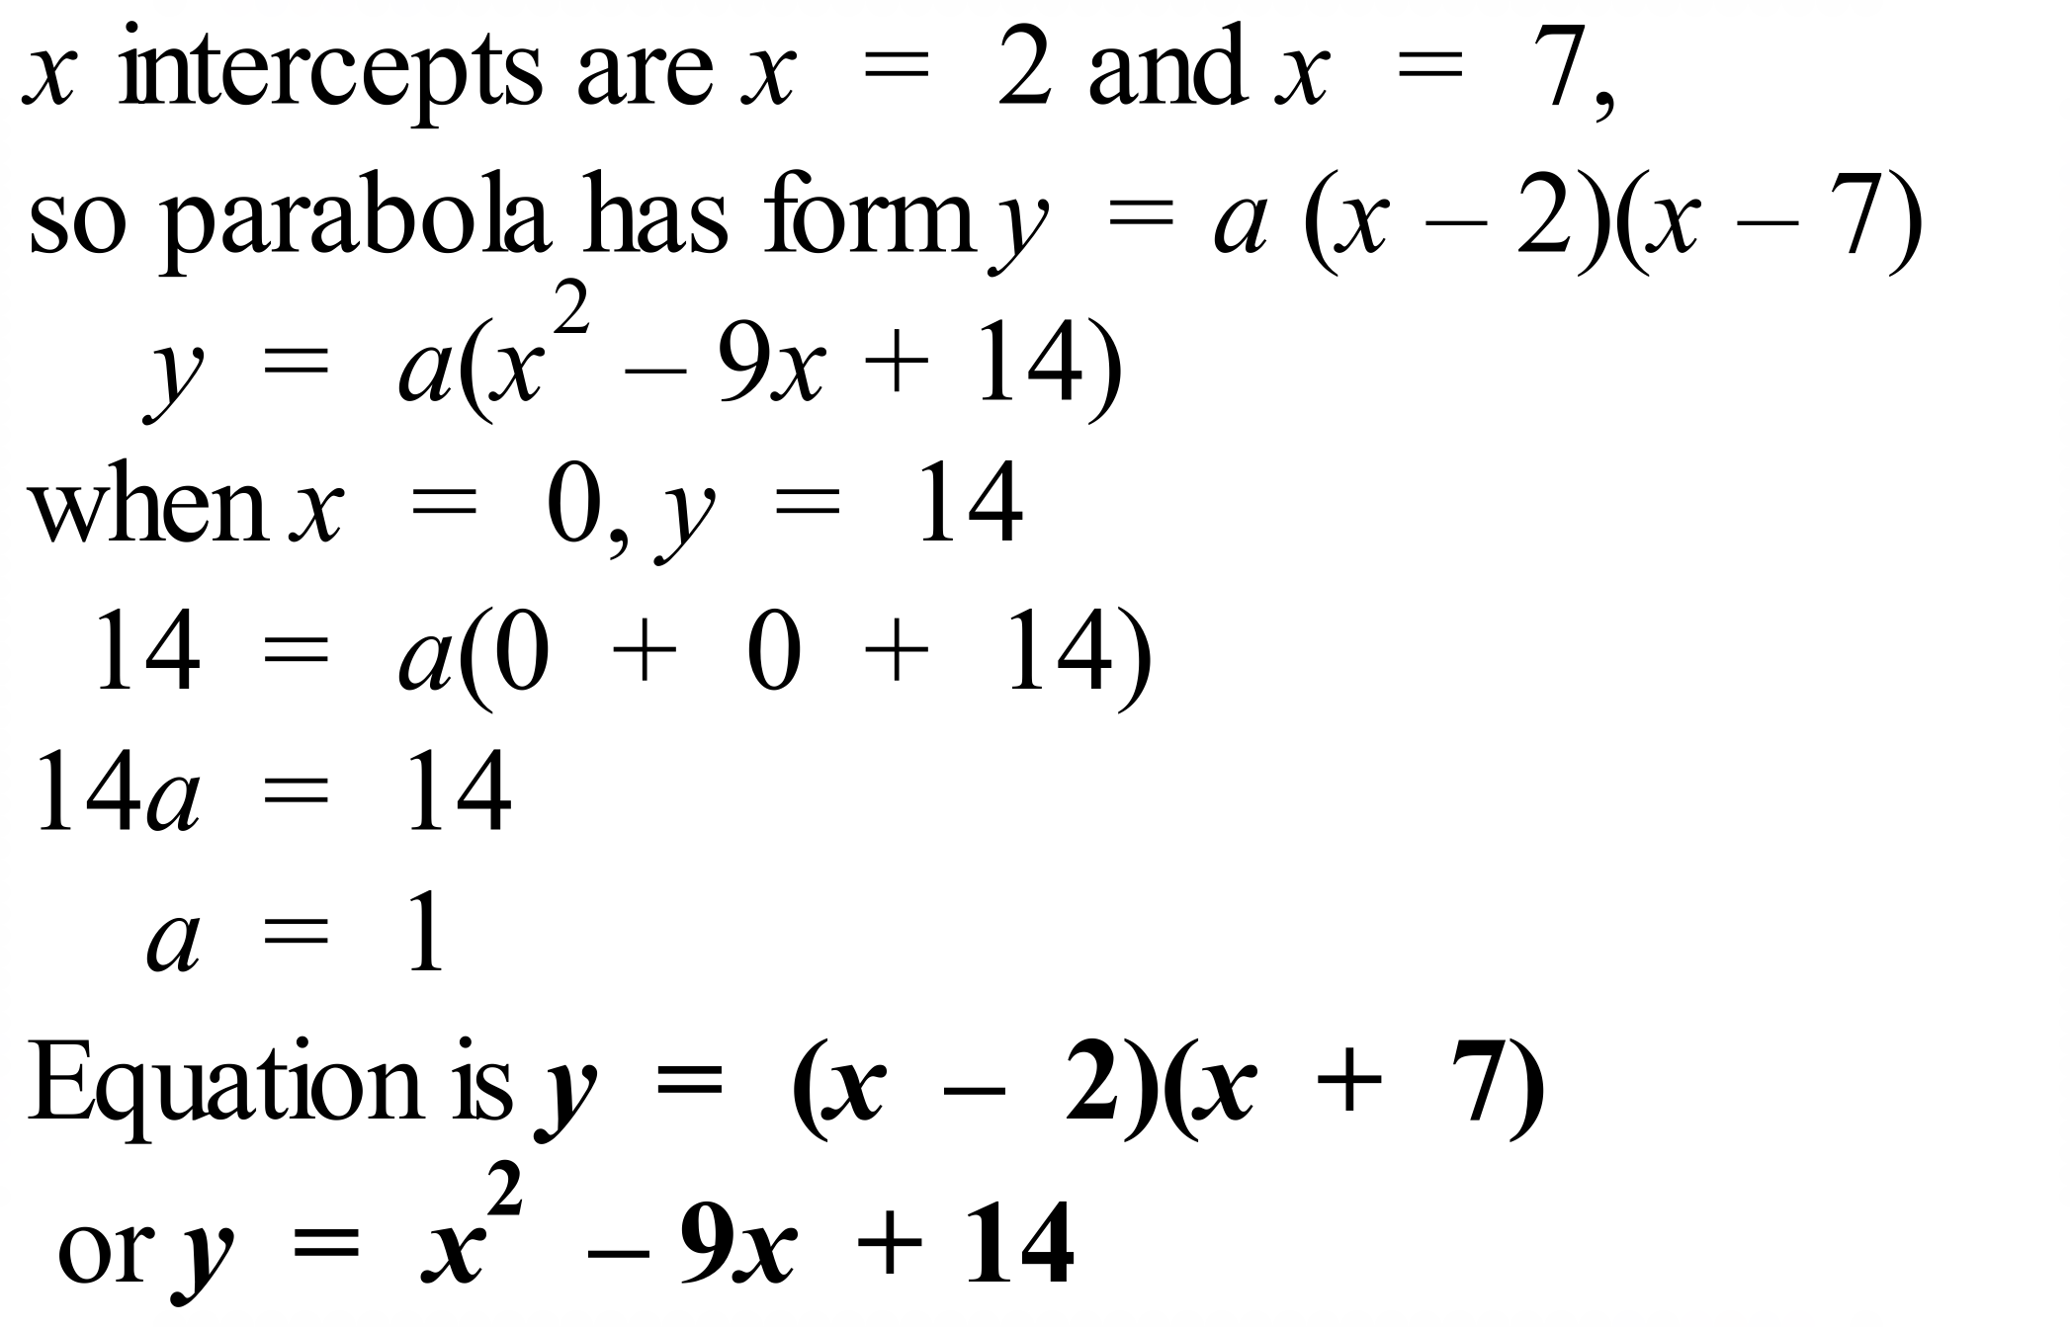
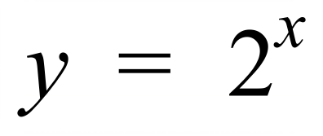 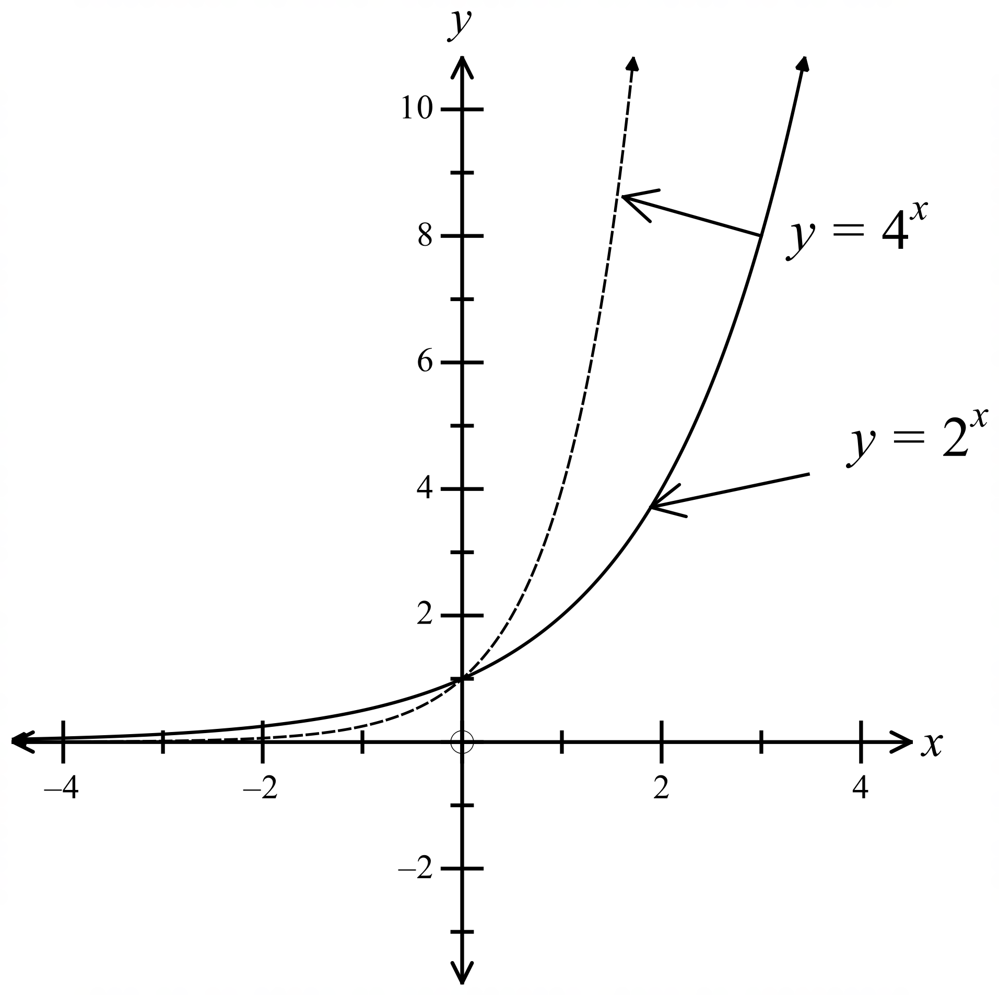should be below 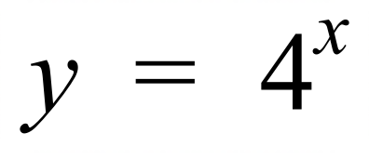 for x > 0 and
above for x < 0, both should cross y axis at y = 1.

School Name
Mathematics Test 2017
Year 10 | Non-Linear Relations | Calculator Allowed  Multiple Choice  Section

ANSWERS

Question | Working | M C Answer
 | 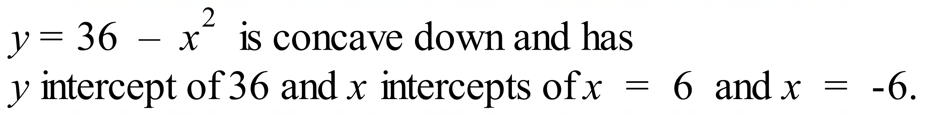 | D
 | 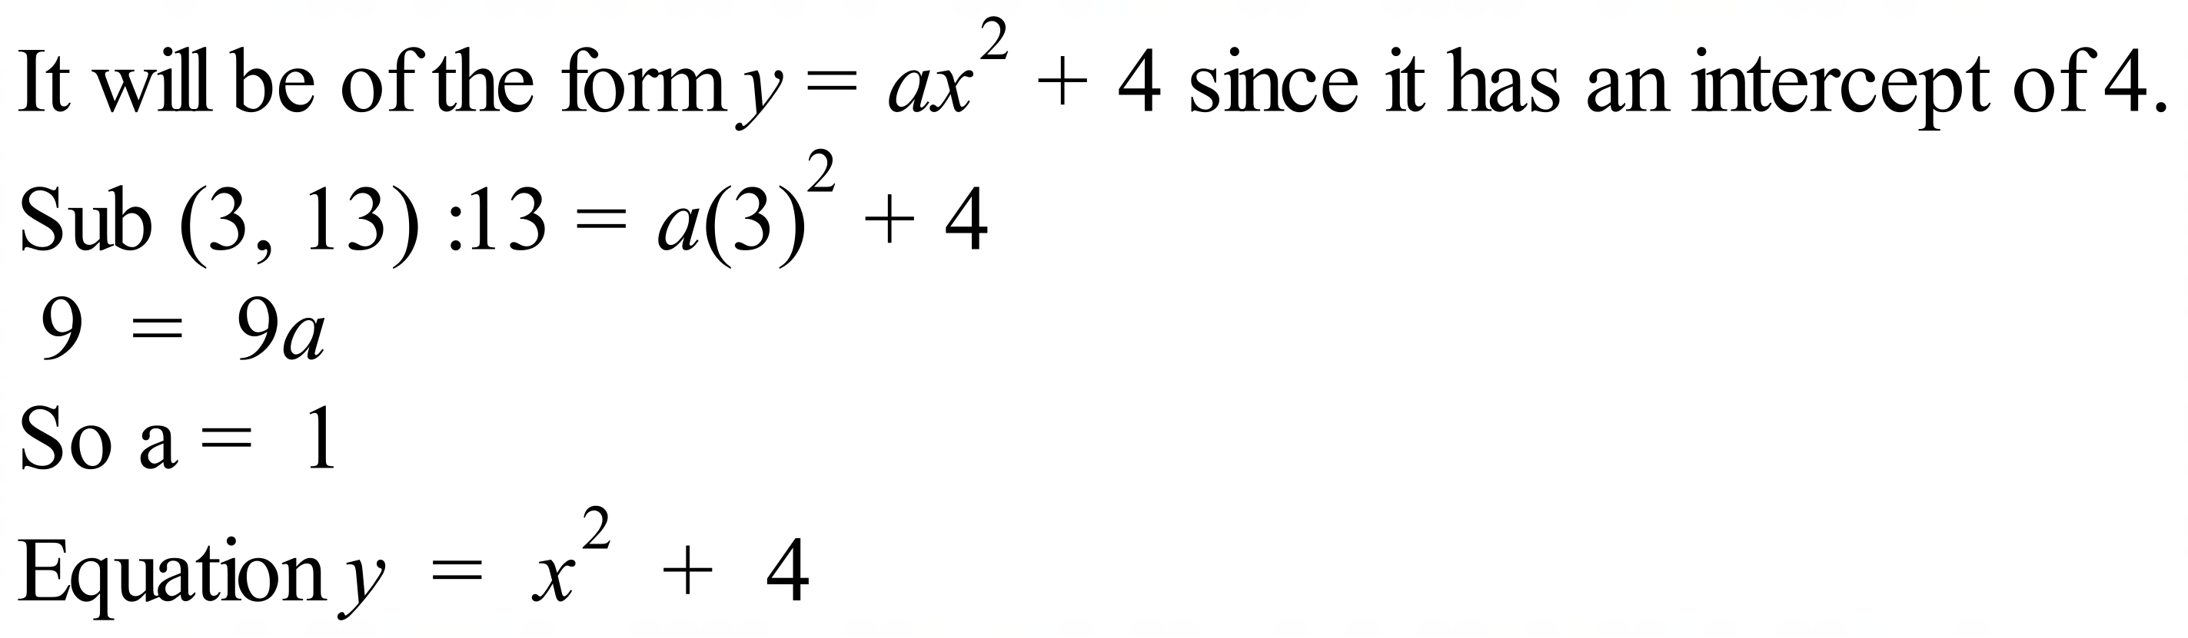 | B
 |  | C
 |  | B
 |  | A
 |  | A
 | Needs to be a parabola which is concave down and through the origin. | D
 | It is a parabola which is concave up and has a y intercept of -64, so equation is 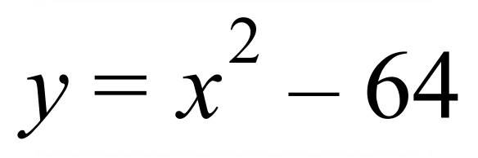 . | D
 | The first three statements apply to both curves, but curve M has its vertex above the origin on the y axis, so statement D is incorrect. | D
 | 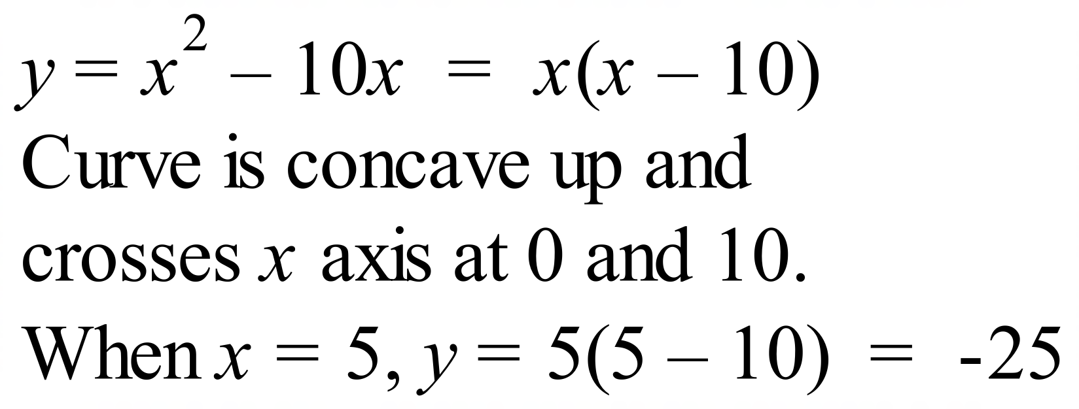 | A
 | Centre is (2, – 4) and radius = 3.  Equation is  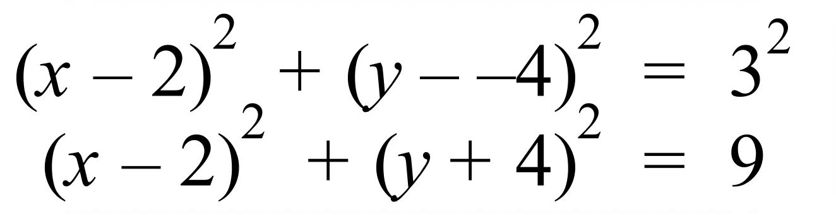 | B
 | 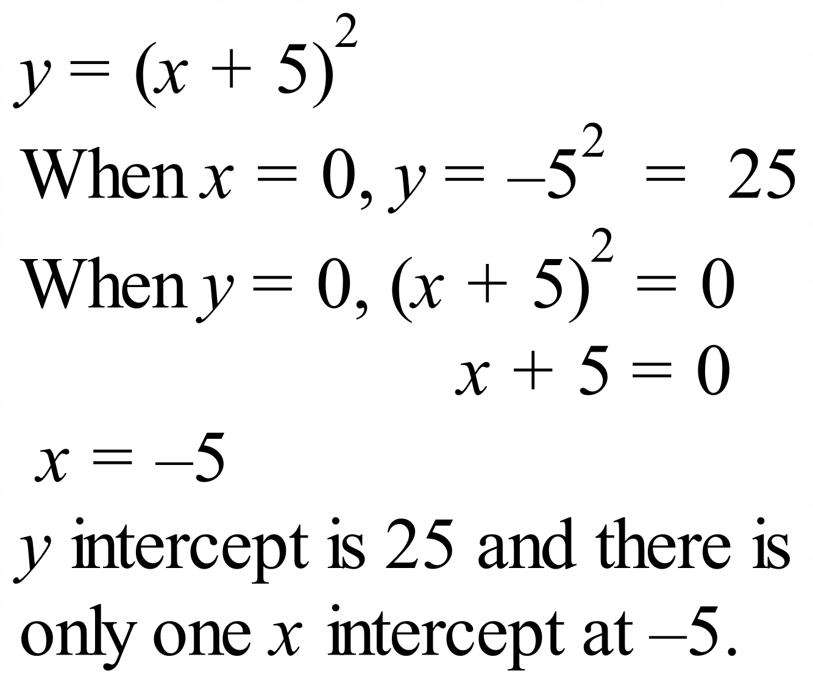 | B
 | Centre at (5, – 7) and radius 9 units gives equation  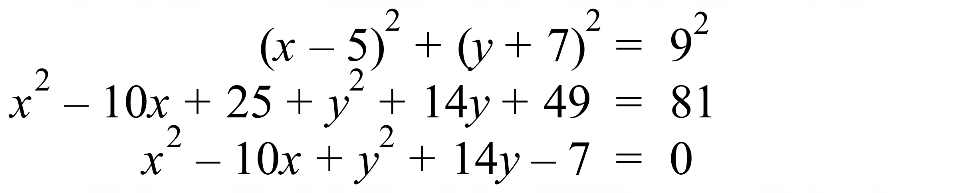 | B
 | y intercept is when x = 0  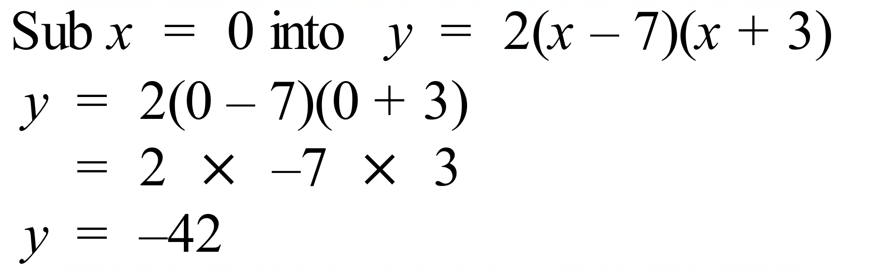 ?. | A
 | 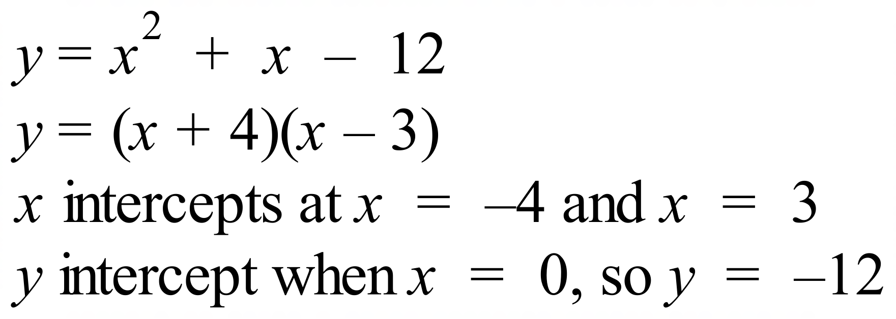 | C
 | 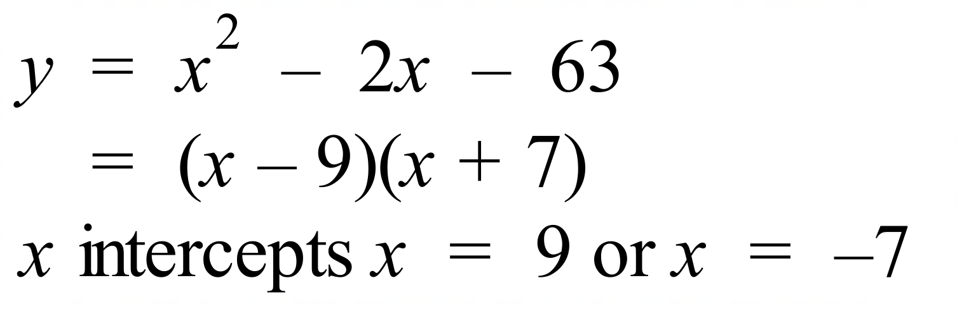  The intercepts are equally spaced either side of the vertex  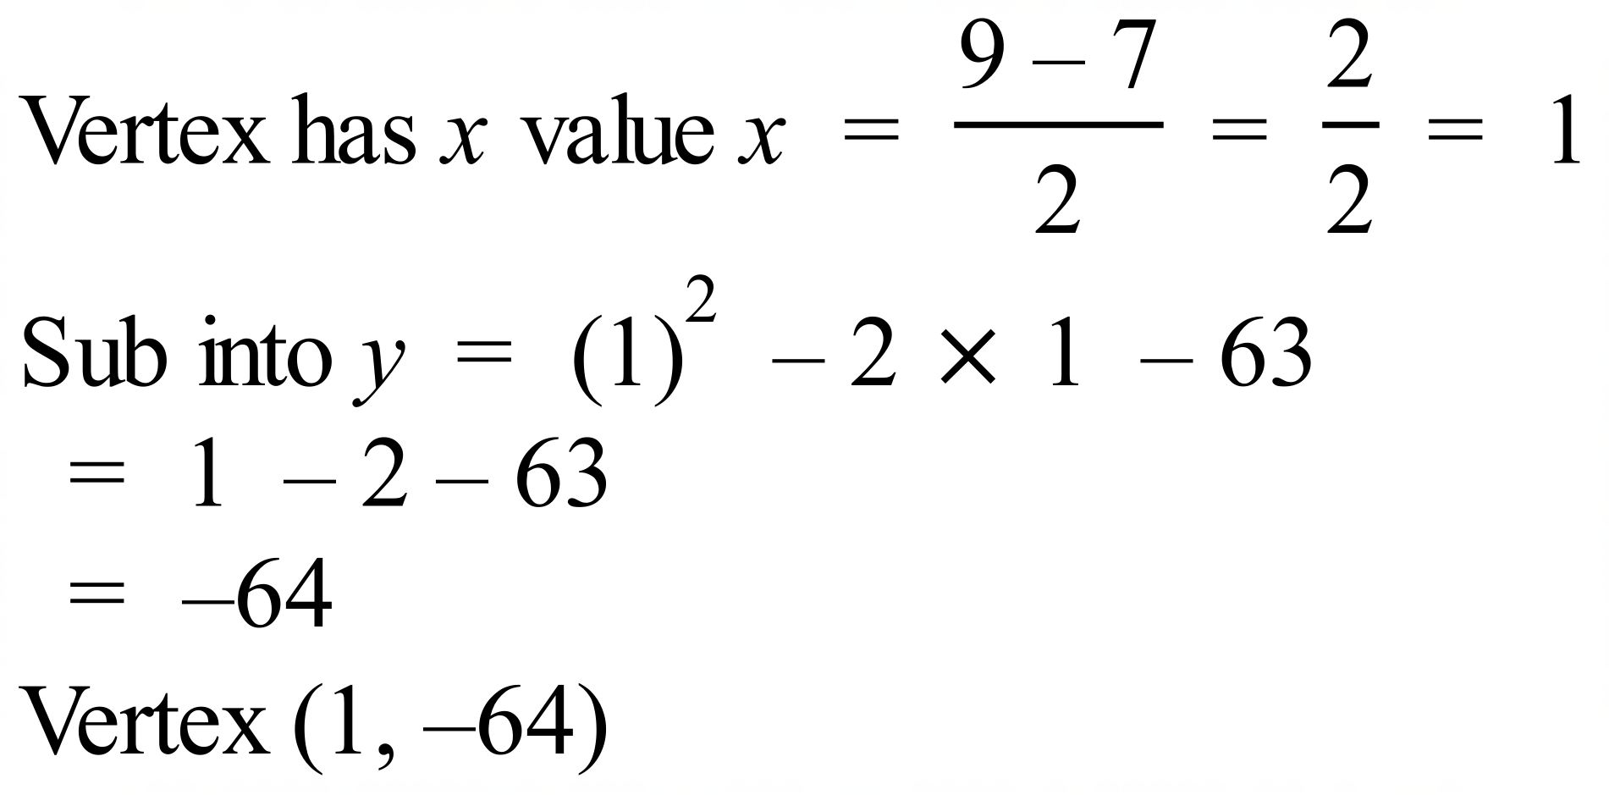 | D
 | 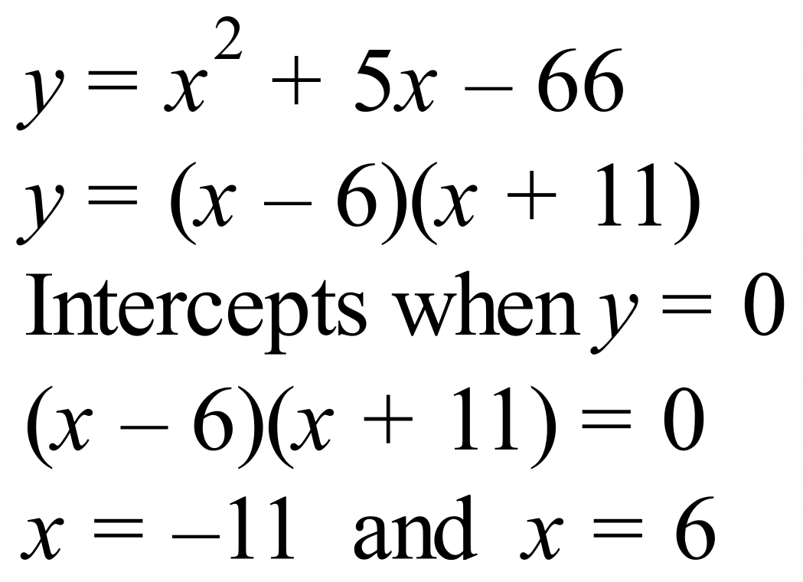 | A
 | Since two branches it is a hyperbola.  Because asymptote is at 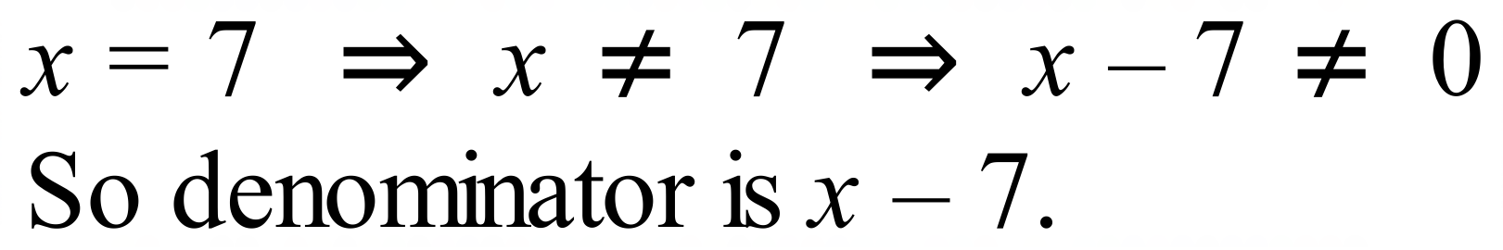  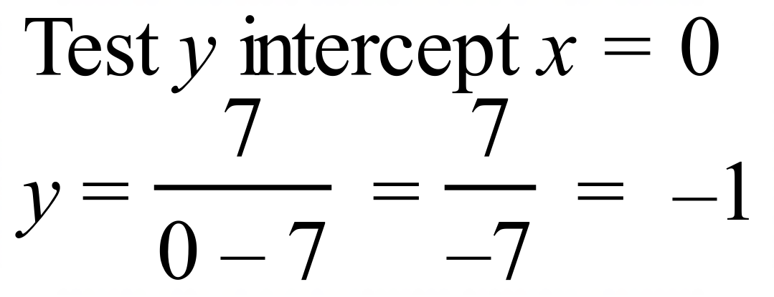 | C

School Name
Mathematics 2017
Multiple Choice Answer Sheet
Non-Linear Relations
Name _____________________________________________
Completely fill the response oval representing the most correct answer.
1. A B C D
2. A B C D
3. A B C D
4. A B C D
5. A B C D
6. A B C D
7. A B C D
8. A B C D
9. A B C D
10. A B C D
11. A B C D
12. A B C D
13. A B C D
14. A B C D
15. A B C D
16. A B C D
17. A B C D
18. A B C D

School Name
Mathematics Test 2017
Year 10 | Non-Linear Relations | Calculator Allowed  Longer Answer  Section
ANSWERS
Question | Working and Answer | Marks
1. | 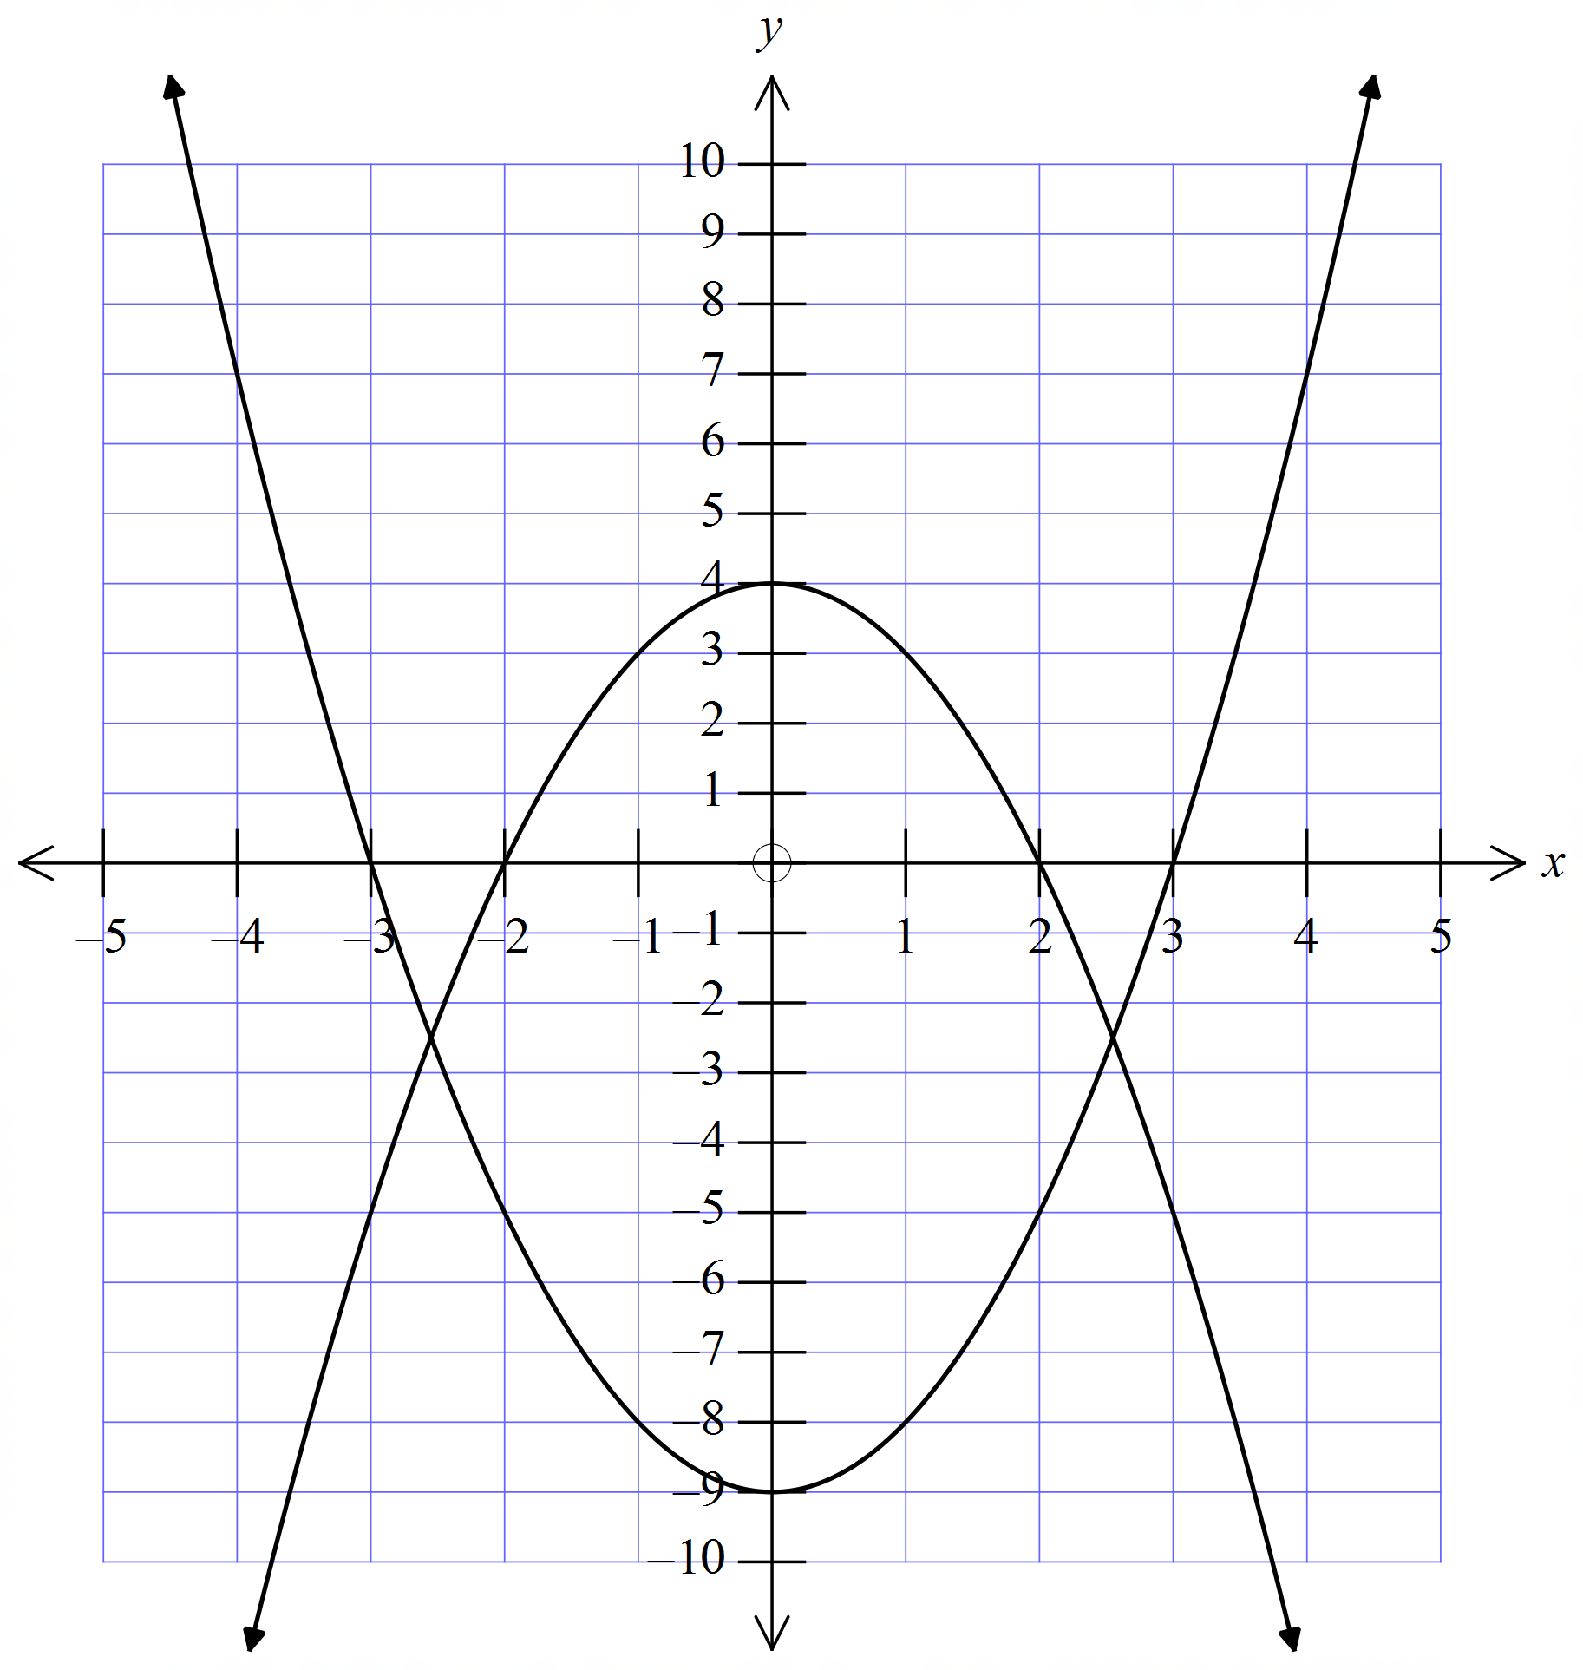 | 2 marks for each graph with correct x and y intercepts.  1 mark for either of the graphs with right shape but x or y intercepts incorrect.
2. | 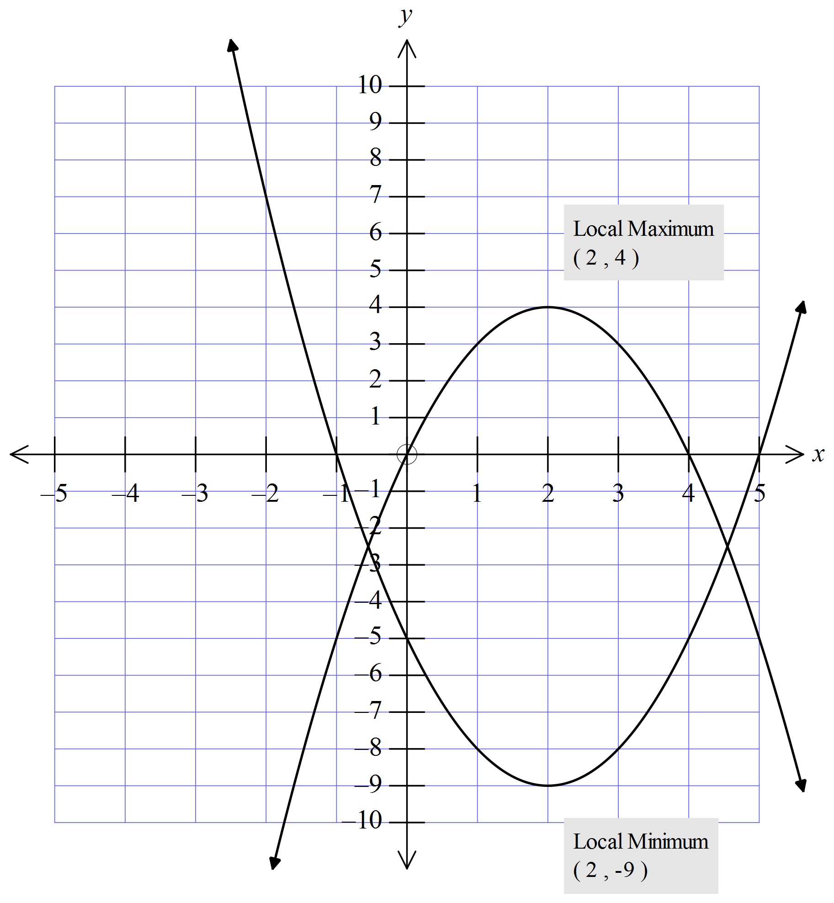 | 2 marks for each graph with correct x and y intercepts and vertex  1 mark for either of the graphs with right shape but x or y intercepts or vertex incorrect
3. | 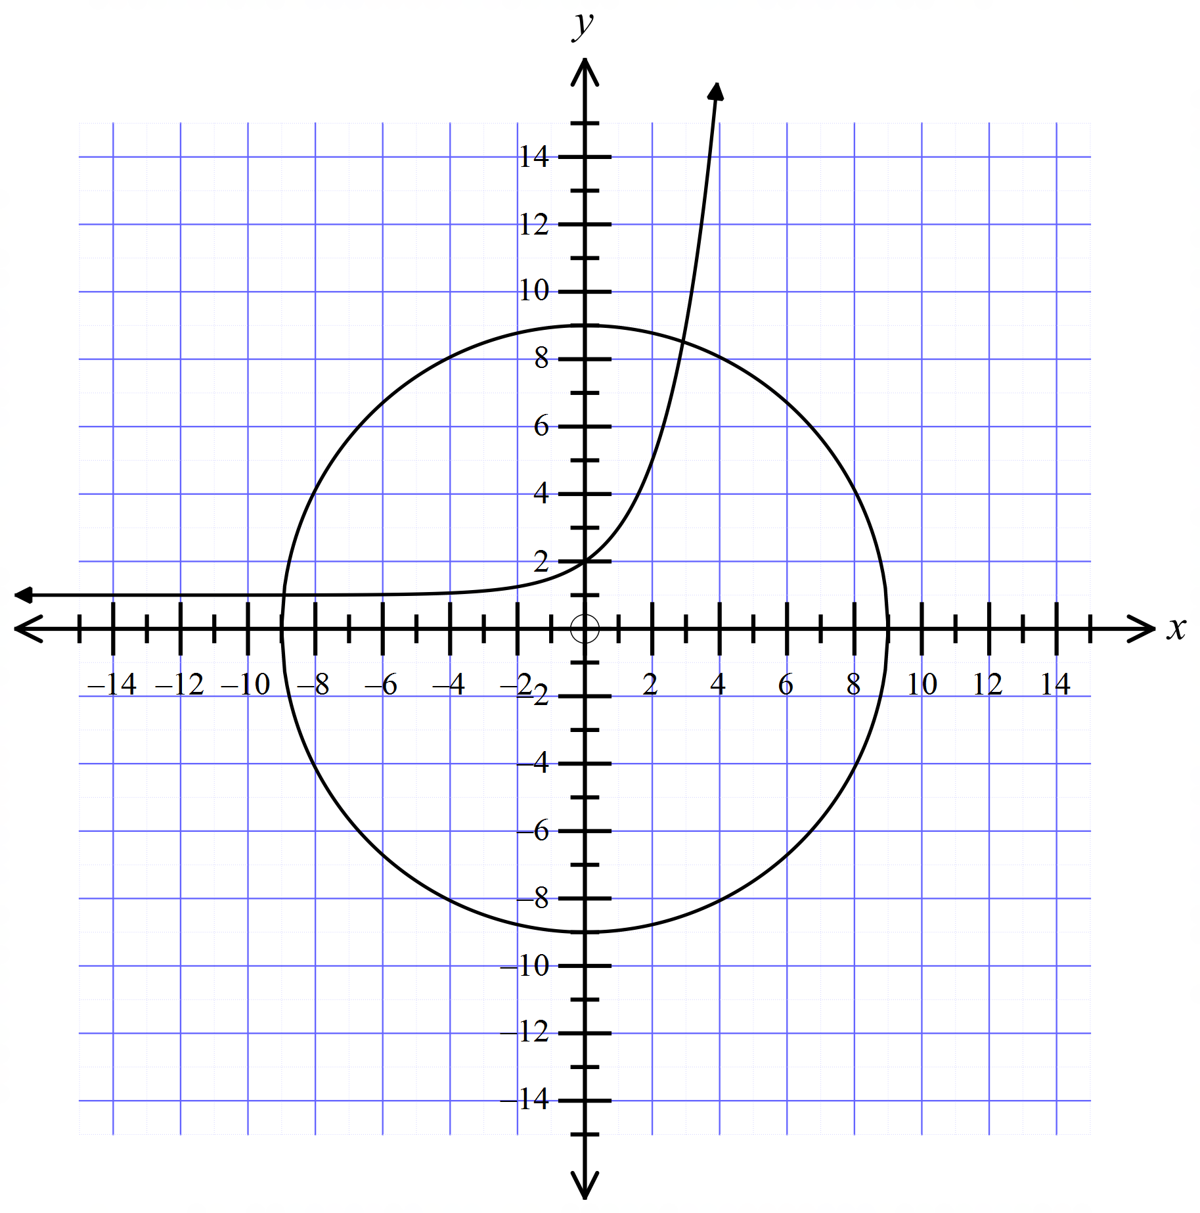 | 2 marks for each graph with correct x and y intercepts.  1 mark for either of the graphs with right shape but x or y intercepts incorrect.
4. | 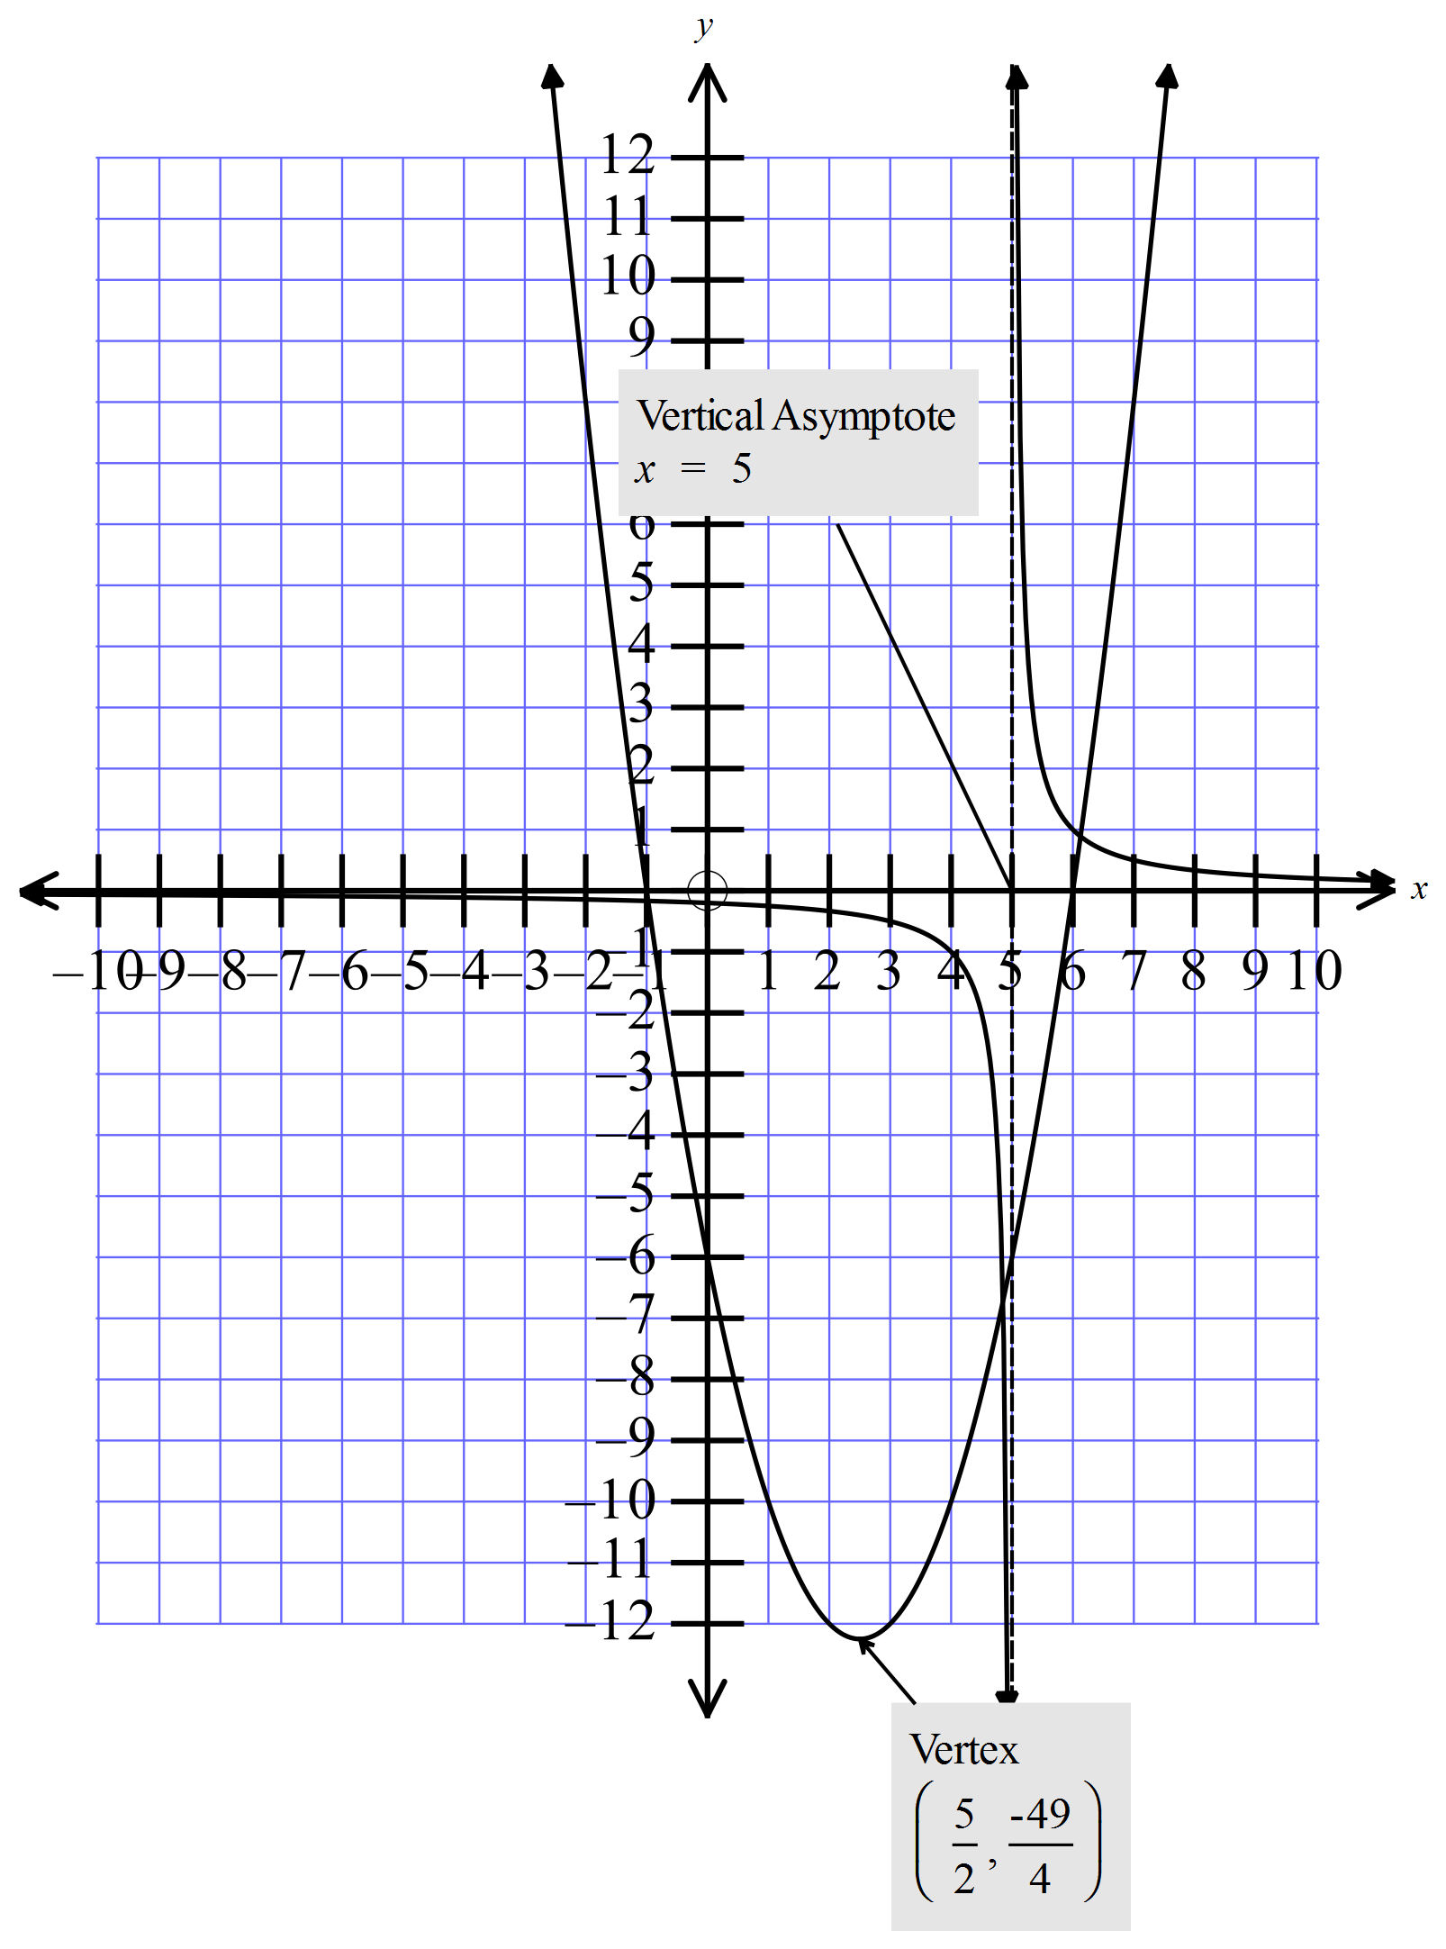 | 2 marks for each graph with correct x and y intercepts vertex or parabola and asymptote of hyperbola.  1 mark for either of the graphs with right shape but one of the other details incorrect.

